Phystech.International Olympiad in Biology
2021/22 academic year
Qualifying stage

TASKS FOR GRADUATING LEVEL

The Olympiad tasks are divided into three parts:
Part A: Tasks with one correct answer (29 tasks and 40 points in total)
Part B: Multiple Choice Questions (18 tasks and 54 points in total)
Part C: Matching Questions (9 tasks and 45 points in total)
Total: 139 points

Part A: Tasks with one correct answer

In all the tasks of this part, there is a condition at the beginning, and then four answer options (under the letters from A to D). Participants need to determine which one of the answer options is correct (fits the wording of the task). Each task can have only one correct answer. For each question, the number of points for the correct answer is indicated: there are two costs - 1 point each and 2 points each.

Grading system:
For each correct answer - 1 or 2 points
For each wrong answer - 0 points

Task ID 2 – 1 point
Common part of the question for all variants:
Look at the transverse section of one of the plant organs.
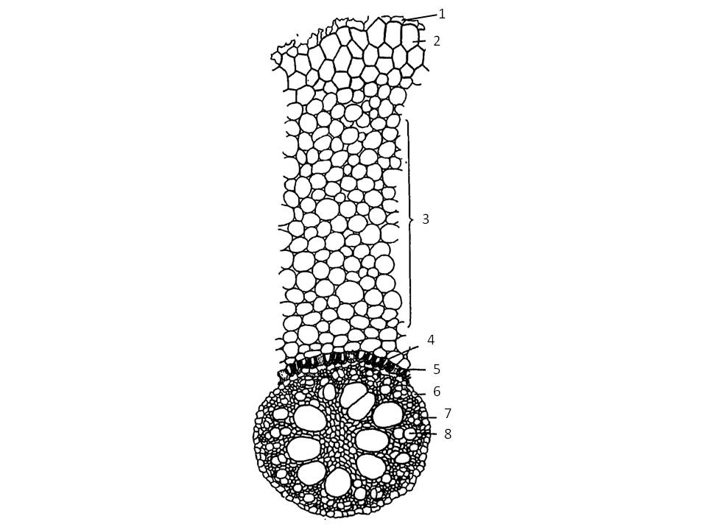
Identify an organ based on its anatomical structure:

Variant 1:
  - Root of a monocotyledonous plant;
  - Root of a dicotyledonous plant without secondary growth;
  - Stem of a monocotyledonous herbaceous plant;
  - Three-year-old branch of a woody plant living in seasonal climate;

Variant 2:
  - Root of a dicotyledonous plant with secondary growth;
  - Stem of a dicotyledonous herbaceous plant;
  - Root of a monocotyledonous plant;
  - Petiole of a monocotyledonous plant;

Variant 3:
  - Root of a dicotyledonous plant without secondary growth;
  - Stem of a dicotyledonous herbaceous plant;
  - Petiole of a dicotyledonous plant;
  - Root of a monocotyledonous plant;

Task ID 3 – 2 points
Common part of the question for all variants:
Look at the transverse section of a corn (Zea mays) stem in the figure 1 and schemes of different types of vascular bundles in the figure 2.
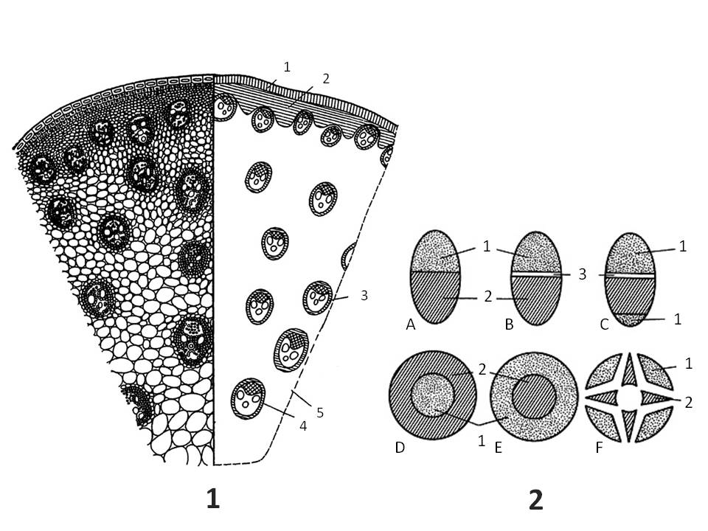
Legend.

Figure 1. The transverse section of a corn (Zea mays) stem:
1 – epidermis;
2 – mechanical tissue;
3 – vascular bundle;
4 – sclerenchyma surrounding of vascular bundle;
5 – parenchyma.

Figure 2. Types of vascular bundles:
A – closed collateral;
B – open collateral;
C – open bicollateral;
D – concentric amphivasal;
E – concentric amphicribral;
F – radial;
1 – phloem;
2 – xylem;
3 – cambium.

Choose the statement that is true for the corn stem:

Variant 1:
  - The stem can grow in width for a long time;
  - Vascular bundles are closed collateral;
  - Vascular bundles are radial;
  - Vascular bundles are open collateral;

Variant 2:
  - Vascular bundles are concentric amphivasal;
  - Vascular bundles are arranged in one ring;
  - Vascular bundles are closed collateral;
  - Cambium is actively functioning;

Variant 3:
  - Vascular bundles are closed collateral;
  - Vascular bundles are concentric amphicribral;
  - Vascular bundles are open collateral;
  - Cambium is actively functioning;

Task ID 5 – 1 point
Common part of the question for all variants:
Okroshka is a popular Russian summer dish. This is a cold soup based on kvass (a traditional fermented beverage commonly made from rye bread) with the addition of vegetables and herbs. Okroshka may include potatoes (Solanum tuberosum L., fig. 1), cucumber (Cucumis sativus L., fig. 2), green peas (Pisum sativum L., fig. 3), dill (Anethum graveolens L., fig. 4), radishes (Raphanus sativus var. Radicula Pers., fig. 5), horseradish (Armoracia rusticana G. Gaertn., B. Mey. & Scherb., fig. 6), mustard (Sinapis alba L., fig. 7) and onion (Allium cepa L., fig. 8). The photographs show the listed plants.

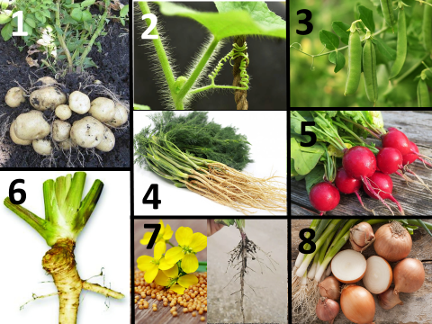

How many species of the plants mentioned in the recipe of okroshka have specialized shoots?

Variant 1:
- One;
- Two;
- Three;
- Four;

Variant 2:
- Four;
- Five;
- Six;
- Seven;

Variant 3:
- Two;
- Four;
- Six;
- Eight;

Task ID 6 – 2 points
Common part of the question for all variants:
Peter completed a geobotanical description of two forest areas (site 1 - control area, site 2 – deforested area) of his course research. He determined the spectra of life- forms of plants according to the Raunkiær plant life form system (1905) and presented the results in diagrams, using the absolute number of detected species.
Then he compared his results with the spectra in % of the total number of studied species, obtained by Robert Harding Whittaker (1980):
1. Tropical rainforest: phanerophytes - 96%, chamaephytes - 2%, cryptophytes - 2%;
2. Subtropical forest: phanerophytes - 66%, chamaephytes - 17%, hemicryptophytes - 2%, cryptophytes - 5%, terophytes - 10%;
3. Forest of temperate climatic zone: phanerophytes - 10%, chamaephytes - 17%, hemicryptophytes - 54%, cryptophytes - 12%, theophytes - 7%;
4. Desert: chamaephytes - 4%, hemicryptophytes - 17%, geophytes - 6%, theophytes - 73%;
5. Tundra: phanerophytes - 1%, chamaephytes - 22%, hemicryptophytes - 60%, cryptophytes - 15%, theophytes - 2%.
The figure below shows the structure of plants belonging to different life forms: Phanerophytes, Chamaephytes, Hemicryptophytes, Criptophytes, Therophytes; the spectra of life forms for the main terrestrial ecosystems, sites 1 and 2. The numbers indicate the number of plant species related to this life form.

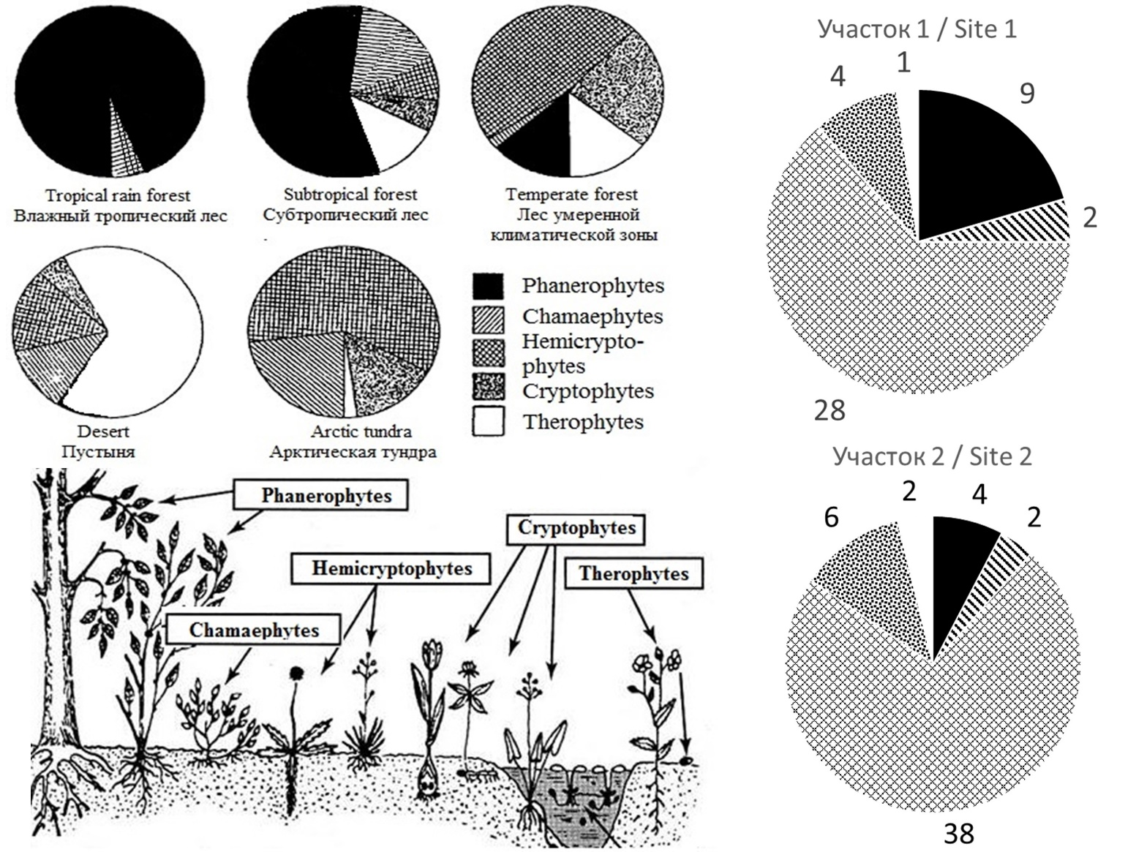

Help Peter analyze the data and make a conclusion about the environment of the researched sites. Choose the right statement:

Variant 1:
- Site 1 belongs to a climatic climax community for the Central Russian taiga zone;
- Site 2 has been subject to significant anthropogenic pressure for several decades because of the high proportion of annual plants in the spectrum;
- Site 2 has a higher biological productivity (biomass formation rate), than site1;
- The results of the study confirm that clear-cuts reduce the number of species in the phytocenosis;

Variant 2:
- Site 2 has fewer plant species than site 1;
- Human intervention is required to recovery site 2;
- Site 1 belongs to a climatic climax community for the Central Russian taiga zone;
- The yield of perennial medicinal herbs and berries in site 1 is higher than in site 2;

Variant 3:
- Sites 1 and 2 have the same number of plant species;
- Site 1 belongs to a climatic climax community for the Central Russian taiga zone;
- The increase in the share of perennial grasses in site 2 is explained by a decrease in interspecific competition in the herb layer;
- The nitrogen entering the soil during the decomposition of dead plant parts in site 1 is higher than in site 2;

Task ID 8 – 1 point
Common part of the question for all variants:
Which of the following arthropods has mandibles, maxillae and maxillipeds among its mouthparts?

Variant 1:
  - European mantis (Mantis religiosa);
  - Domestic house spider (Tegenaria domestica);
  - European lobster (Homarus gammarus);
  - Acorn barnacle (Balanus balanus);

Variant 2:
  - Emperor scorpion (Pandinus imperator);
  - Western honey bee (Apis mellifera);
  - European lobster (Homarus gammarus);
  - Water flea (Daphnia pulex);

Variant 3:
  - European lobster (Homarus gammarus);
  - European mantis (Mantis religiosa);
  - European house dust mite (Dermatophagoides pteronyssinus);
  - Water flea (Daphnia pulex);

Task ID 9 – 2 points
Common part of the question for all variants:
You are presented with a life cycle of a parasitic digenean trematode of the genus Schistosoma.

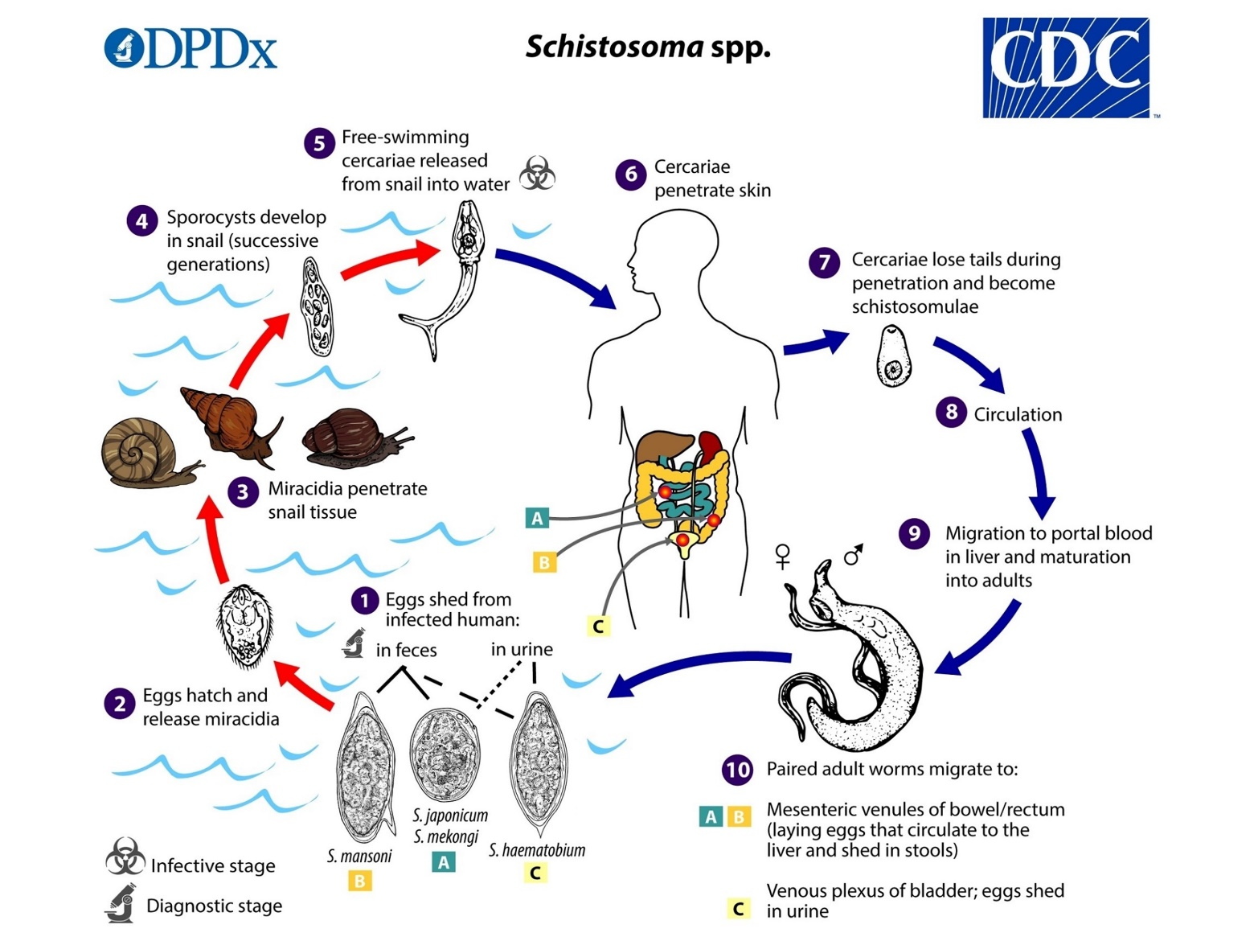

Which one of its life stages reproduces asexually?

Variant 1:
  - 10 - Adult worms in the veins of a definitive mammalian host;
  - 7 - Young schistosomulae that recently invaded a definitive host;
  - 4 - Sporocyst in an intermediate host – a gastropod mollusc;
  - 2 - Swimming miracidia larvae in search of an intermediate host;

Variant 2:
  - 1 - Developing eggs spread by the definitive host;
  - 4 - Sporocyst in an intermediate host – a gastropod mollusc;
  - 5 - Swimming cercaria stage spread by the intermediate host;
  - 10 - Adult males in the veins of a definitive mammalian host;

Variant 3:
  - 1 - Developing eggs spread by the definitive host;
  - 2 - Swimming miracidia larvae in search of an intermediate host;
  - 4 - Sporocyst in an intermediate host – a gastropod mollusc;
  - 10 - Adult females in the veins of a definitive mammalian host;

Task ID 11 – 1 point
Common part of the question for all variants:
Females of 8 species of moles, including the European mole (Talpa europaea), are intersexual. In recent studies (Real, 2020) scientists showed that 2 mutations are responsible for that.

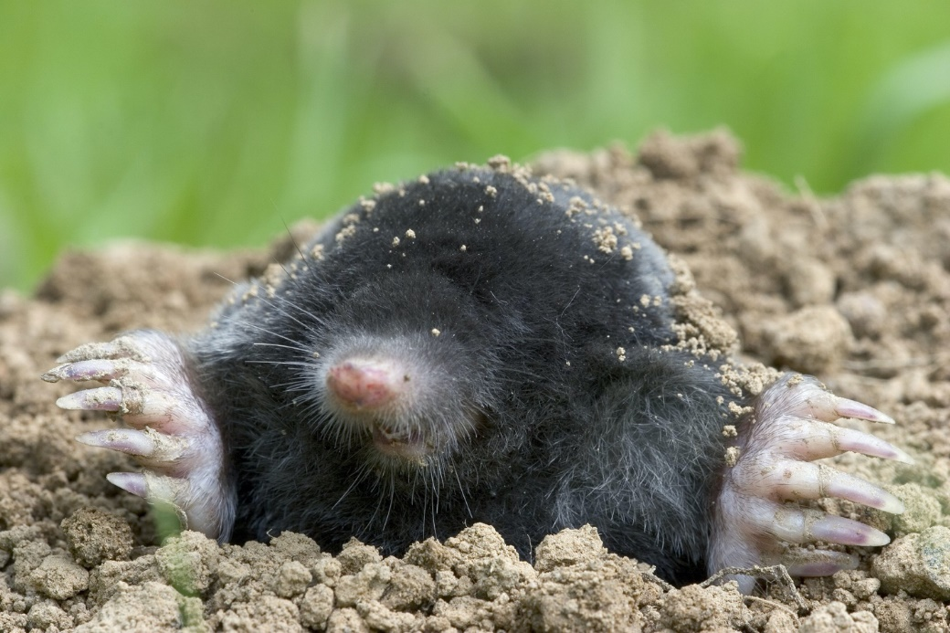

What is intersexuality?

Variant 1:
- Female moles have ovotestes instead of ovaries. Ovotestes are gonads that produce ovaries and male hormones (androgens) at the same time. As a consequence of increased androgen synthesis, female moles develop prominent muscles and aggressive behavior as an adaptation to a subterranean lifestyle;
- Female moles gonads produce both female and male gametes. When the number of males in population decreases, females produce sperm;
- This is a type of relationship between individuals, when females can have 2 or more sexual partners during the breeding season;
- This is when the females are larger than the males. In mammals, more often, males are much larger than females. But in moles, the situation is the opposite;

Variant 2:
- This is a type of reproduction when the egg does not need to be fertilized with sperm. This is an adaptation to constant darkness underground, since it is difficult to find a sexual partner in such conditions;
- That means that there is no difference between female and male moles;
- Female moles have ovotestes instead of ovaries. Ovotestes are gonads that produce ovaries and male hormones (androgens) at the same time. As a consequence of increased androgen synthesis, female moles develop prominent muscles and aggressive behavior as an adaptation to a subterranean lifestyle;
- This is a type of breeding where males mate with a large number of females.

Variant 3:
- Female moles have ovotestes instead of ovaries. Ovotestes are gonads that produce ovaries and male hormones (androgens) at the same time. As a consequence of increased androgen synthesis, female moles develop prominent muscles and aggressive behavior as an adaptation to a subterranean lifestyle;
- Female moles gonads produce both female and male gametes. When the number of males in population decreases, females produce sperm;
- That means that there is no difference between female and male moles;
- Female moles may refuse to breed and not participate in the breeding season;

Task ID 12 – 2 points
Common part of the question for all variants:
What is the number on the map below for the distribution area of the polar bear (Ursus maritimus)?

Variant 1:
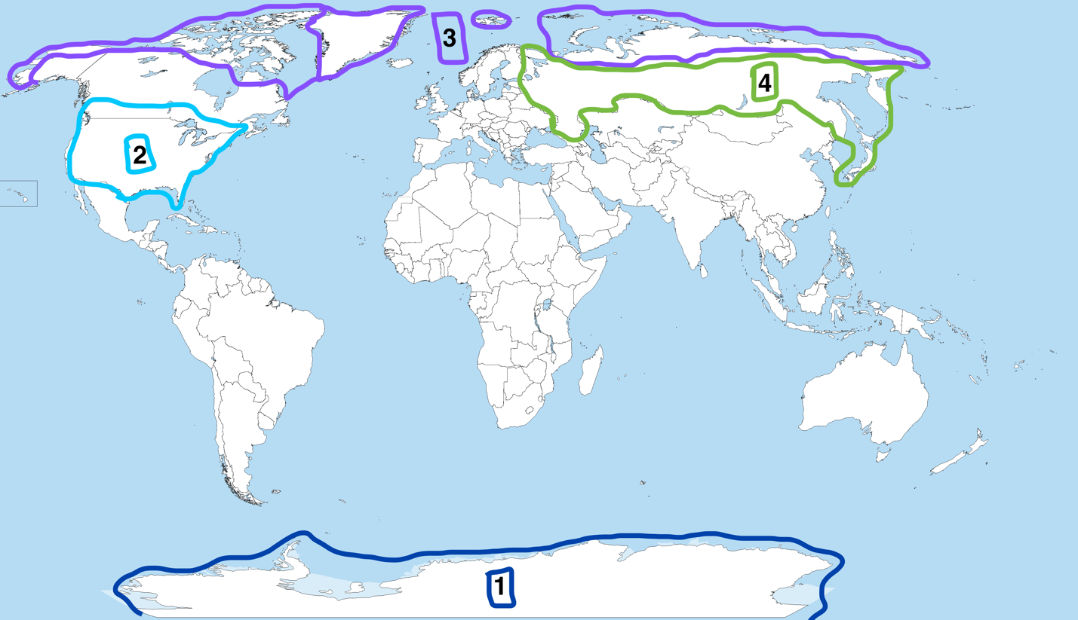

- 3;
- 4;
- 2;
- 1.

Variant 2:
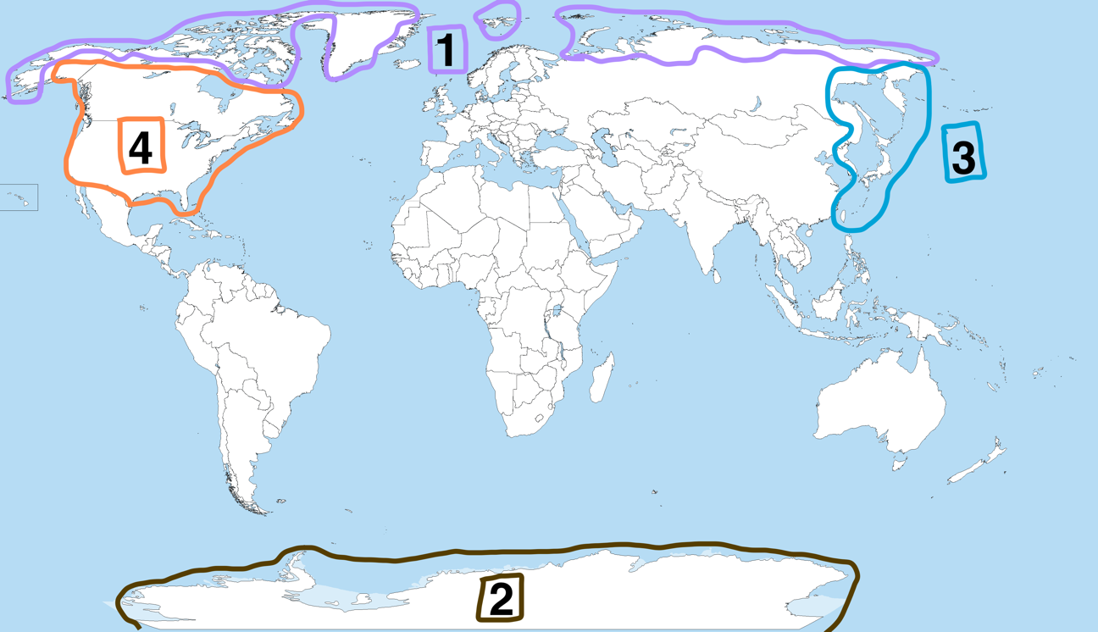

- 1;
- 2;
- 3;
- 4.

Variant 3:
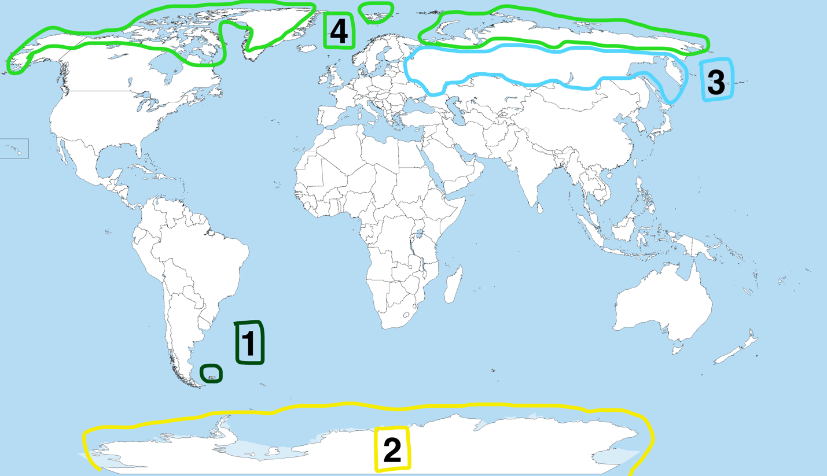

- 4;
- 1;
- 2;
- 3.

Task ID 13 – 1 point
Common part of the question for all variants:
When the skin of the outer edge of the sole is irritated in newborn children, reflex extension of the first toe is observed. In adults, this reflex is not normally manifested. The figure shows a diagram of the arc of this reflex.
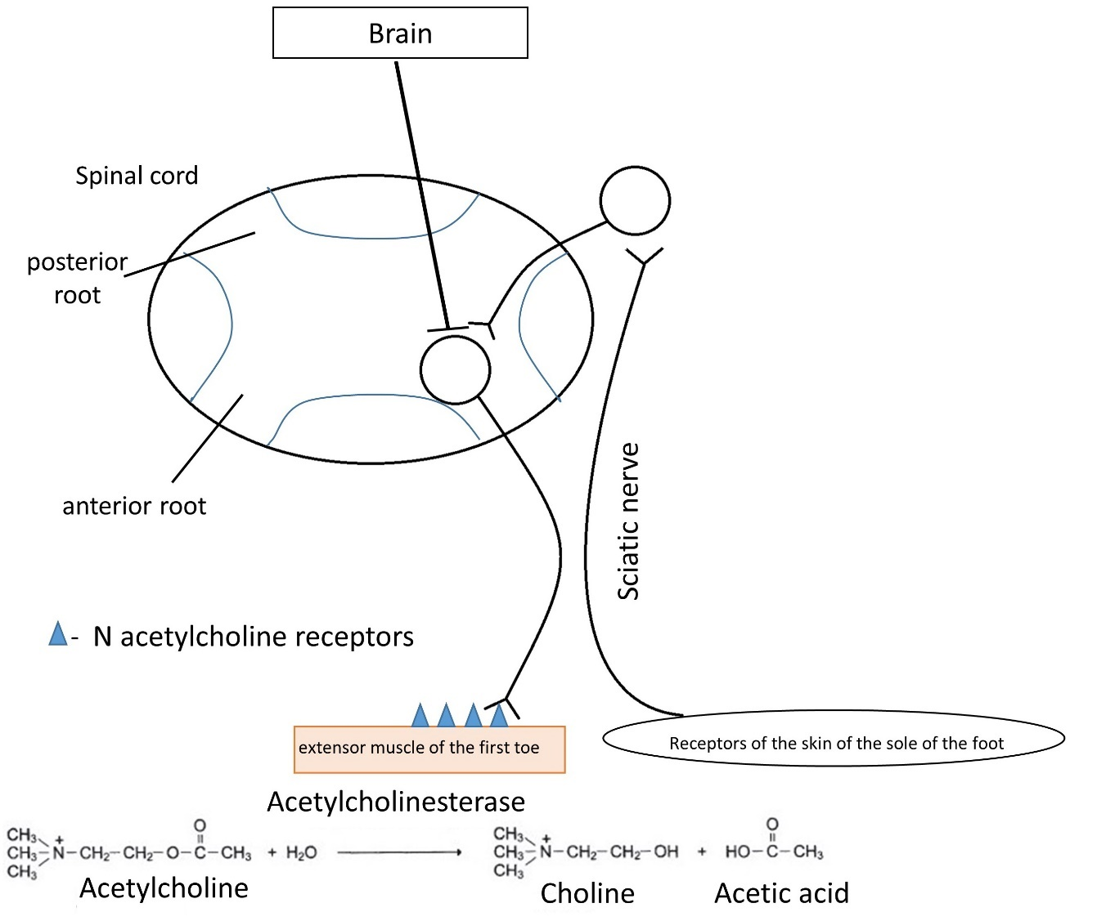
What disorder leads to pathological activation of this reflex in an adult?

Variant 1:
  - Lesion of the posterior roots of the spinal cord;
  - The death of neurons in the occipital lobe of the cerebral cortex;
  - Death of neurons in the precentral gyrus of the cerebral cortex;
  - Deficiency of N-cholinergic receptors.

Variant 2:
  - Deficiency of N-cholinergic receptors;
  - Lesion of the anterior roots of the spinal cord
  - The death of neurons in the temporal lobe of the cerebral cortex;
  - Death of neurons in the precentral gyrus of the cerebral cortex.

Variant 3:
  - Lesion of the posterior roots of the spinal cord;
  - Death of neurons in the precentral gyrus of the cerebral cortex;
  - Dissection of the sciatic nerve;
  - Excess acetylcholinesterase.

Task ID 14 – 1 point
Common part of the question for all variants:
Syndrome of congenital adrenal hyperplasia is a group of hereditary diseases, one of the possible causes of which is a mutation in the gene encoding the enzyme for the synthesis of cortisol, which leads to a decrease in the concentration of cortisol in the blood of the fetus. The diagram shows the scheme of regulation of the development of the reproductive system by the adrenal glands in the embryonic period.
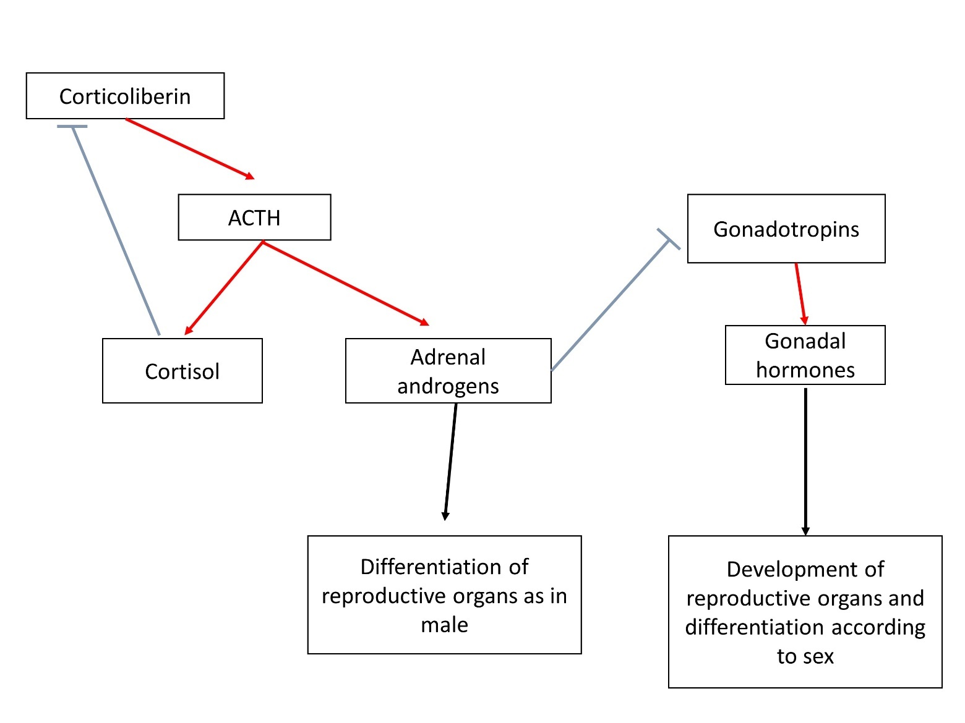
Red arrows indicate activating influences, blue ones - inhibiting ones, ACTH - adrenocorticotropic hormone, LH - luteinizing hormone, FSH - follicle-stimulating hormone. What are the consequences of this?

Variant 1:
  - To the differentiation of secondary genital organs in girls according to the male type;
  - To a decrease in ACTH production;
  - To excess secretion of LH;
  - To the development of reproductive organs in boys according to the female type;

Variant 2:
  - To a reduction of adrenal androgen production;
  - To an excess secretion of FSH;
  - To the differentiation of secondary genital organs in girls according to the male type;
  - To an increase in the size of the testes in boys;

Variant 3:
  - To an enhancement the negative feedback mechanism of ACTH production;
  - To the differentiation of secondary genital organs in girls according to the male type;
  - To reduce the size of the adrenal glands;
  - To an increase in the size of the ovaries in girls;

Task ID 15 – 2 points
Common part of the question for all variants:
Alcohol entering the human body stimulates the dopaminergic and serotonergic systems of the brain, provoking its further consumption and stimulating the development of addiction. At the same time, in the liver, by the enzyme alcohol dehydrogenase (ADH), it turns into a more toxic acetaldehyde, which causes painful symptoms of intoxication. Acetaldehyde, in turn, under the influence of the enzyme aldehyde dehydrogenase (ALDH) is converted into acetic acid, which is easily excreted from the body. In humans, there are several variants of these enzymes of different activity, which creates variability in the population in the degree of intoxication and the strength of the hangover, which in turn determines the tendency to form dependence on alcohol. Check the correct statement:

Variant 1:
- Higher ALDH activity compared to ADH contributes to severe hangover;
- One of the methods to combat alcoholism is to inhibit ADH;
- Pharmacological blockade of ALDH can make a person averse to alcohol;
- Activating mutations in the gene responsible for the reuptake of serotonin from the synaptic cleft increase the risk of alcoholism;

Variant 2:
- Pharmacological blockade of ALDH can make a person averse to alcohol;
- Higher ALDH activity compared to ADH contributes to severe hangover;
- One of the methods to combat alcoholism is to inhibit ALDH;
- Activating mutations of dopamine receptors, as a result of which alcohol saturation occurs faster, increase the risk of developing alcoholism;

Variant 3:
- Activating mutations in the gene of monoamine oxidase metabolizing bioamines increase the risk of alcoholism;
- Higher ADH activity compared to ALDH contributes to the onset of alcoholism;
- One of the methods to combat alcoholism is to inhibit ALDH;
- Pharmacological blockade of ALDH can make a person averse to alcohol;

Task ID 16 – 1 point
Common part of the question for all variants:
The figure below is an electronic micrograph of an endocrine cell.

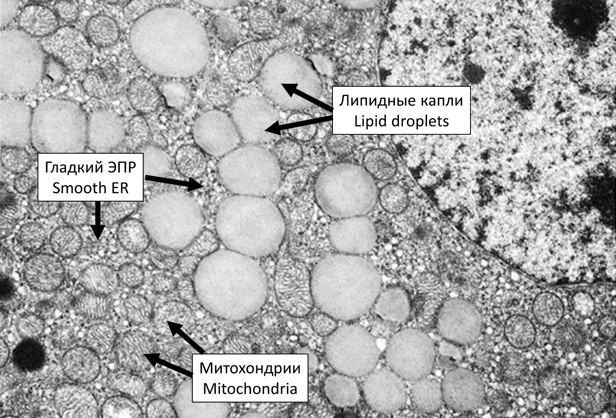

Which of the following hormones is most likely to be produced by this cell?

Variant 1:
  - Aldosterone;
  - Thyroxine;
  - Oxytocin;
  - Prolactin;

Variant 2:
  - Adrenaline;
  - Aldosterone;
  - Insulin;
  - Growth hormone;

Variant 3:
  - Prolactin;
  - Adrenaline;
  - Glucagon;
  - Aldosterone;

Task ID 17 – 1 point
Common part of the question for all variants:
Medial plantar nerve is a mixed nerve, i.e. it contains both sensory and motor fibers. A researcher stimulated the nerve and recorded electrical response of intrinsic plantar muscles using a needle electrode. After stimulus application, two peaks were registered on electromyogram (EMG – a graphical recording of muscle electrical activity): wave 1 appeared almost immediately after nerve stimulation, and wave 2 appeared after some latency period. In the second part of the study, the sciatic nerve was transected (medial plantar nerve can be viewed as one of terminal branches of the sciatic nerve) and the same experiment was repeated (medial plantar nerve stimulation with simultaneous EMG recording). The figure below illustrates overall design of the study and EMG recordings before and after sciatic nerve transection.
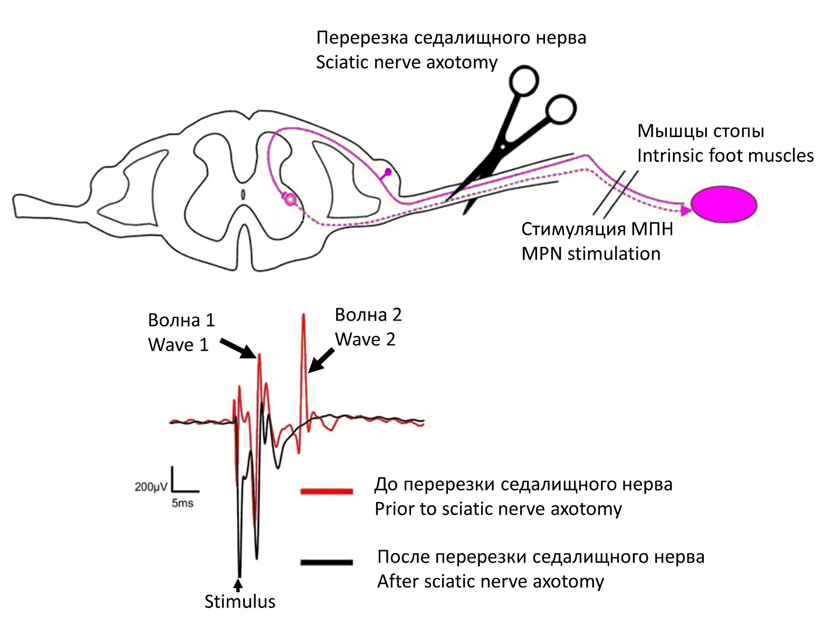
Below is the list of some other possible interventions. Which of them will not affect intrinsic foot muscle EMG recordings upon medial plantar nerve stimulation (compared to intact animal, i.e. there will still be the same two waves on EMG)?

Variant 1:
- Selective transection of motor fibers in sciatic nerve;
- Transection of ventral roots of the corresponding spinal cord segment;
- Selective transection of sensory fibers in medial plantar nerve distal to stimulation point;
- All of the above;

Variant 2:
- Selective transection of sensory fibers in medial plantar nerve distal to stimulation point;
- Selective transection of sensory fibers in sciatic nerve;
- Transection of dorsal roots of the corresponding spinal cord segment;
- None of the above;

Variant 3:
- Selective transection of sensory fibers in sciatic nerve;
- Transection of ventral roots of the corresponding spinal cord segment;
- Selective transection of sensory fibers in medial plantar nerve distal to stimulation point;
- All of the above;

Task ID 18 – 2 points
Common part of the question for all variants:
Bile plays a key role in fat digestion in the small intestine. The so-called primary bile acids are one of the major components of bile and are synthesized from cholesterol in liver cells (hepatocytes). Below you can find some short notes on the regulation of bile acid biosynthesis as well as illustration of this process (BA – bile acid).
The first step in bile acid synthesis is 7-alpha-hydroxylation of cholesterol, catalyzed by CYP7A1 enzyme. This is a rate-limiting stage of the whole pathway and is under strict control (see below).
Only 5% of secreted bile acid pool is excreted in feces, whereas the remainder 95% is reabsorbed in ileum (distal part of small intestine) and returns to the liver. Within the epithelial cells of ileal mucosa reabsorbed bile acids bind to a receptor called farnesoid X receptor (FXR). This increases expression of the protein FGF15/19 which is one of key regulators of the bile acid turnover. FGF15/19 is secreted into portal system bloodstream and thereby reaches the liver, where it binds to receptors (FGFR4) in liver cell membrane and inhibits CYP7A1 expression. As a result, bile acid synthesis is reduced.

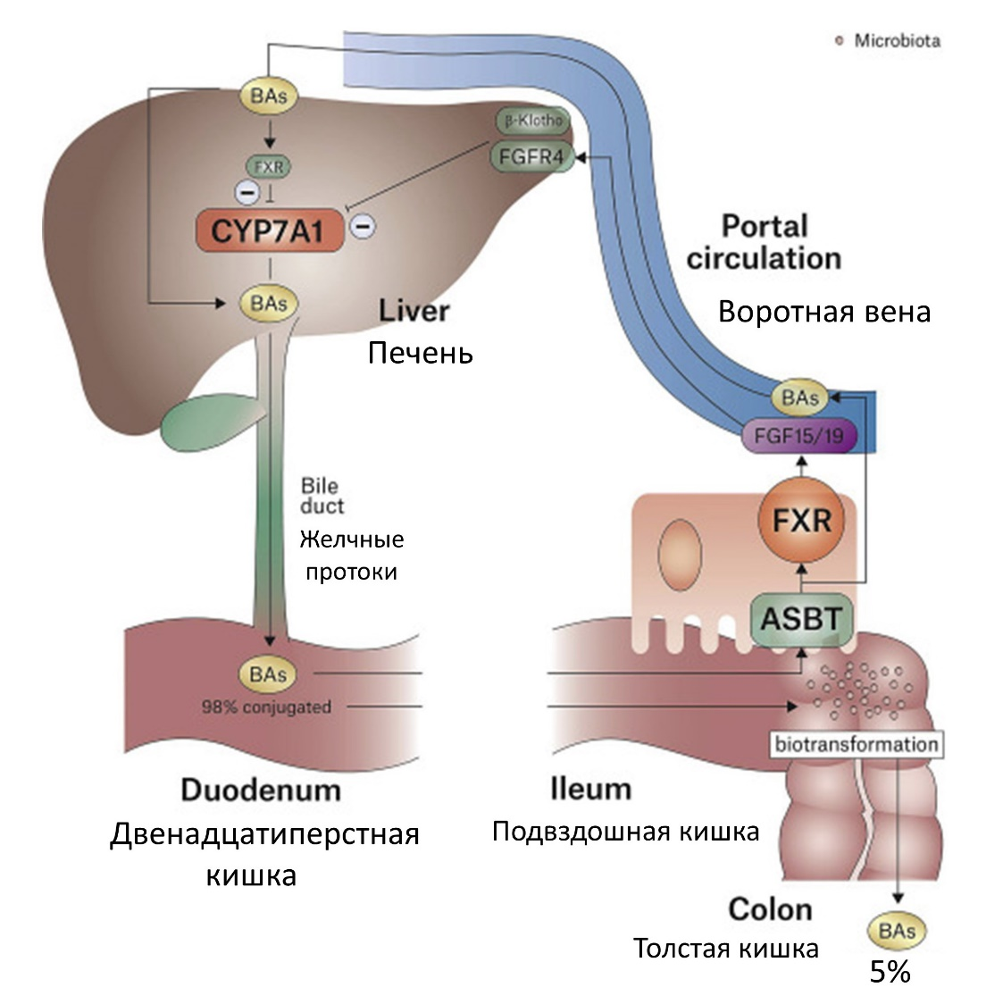
Which of the following statements are correct?

Variant 1:
- Surgical removal of ileum impairs dietary fat absorption, because ileum is a major site of fat digestion;
- If one blocks bile acid absorption using certain medications, this will lead to a decrease in FGF15/19 plasma concentration;
- During the day FGF15/19 secretion reaches maximum with prolonged fasting periods and is significantly reduced after meals;
- All of the above.

Variant 2:
- Blocking bile acid absorption using certain medications will stimulate bile acid synthesis in liver cells;
- Surgical removal of ileum will most likely significantly increase dietary fat absorption, because there will be no negative feedback loop controlling bile acid synthesis;
- During the day FGF15/19 secretion reaches maximum with prolonged fasting periods and is significantly reduced after meals;
- All of the above.

Variant 3:
- Surgical removal of ileum impairs dietary fat absorption, because ileum is a major site of fat digestion;
- Ingestion of fat-rich meals suppresses FGF15/19 secretion;
- Surgical removal of the ileum will stimulate bile acid synthesis in liver cells;
- All of the above.

Task ID 19 – 1 point
Common part of the question for all variants:
The picture below shows a pathway of a glucose breakdown. Enzymes involved in glycolysis are marked in blue. Some of the enzymes are hidden.

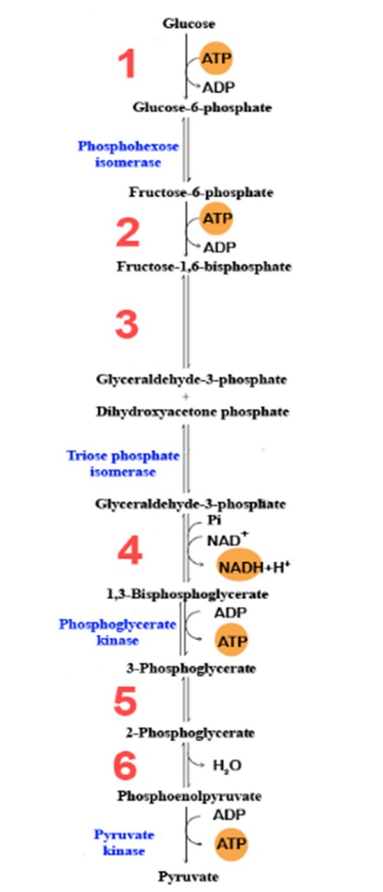

What enzymes are indicated by numbers? Choose the right combination of numbers and protein names.

Variant 1:
  - 1 – Hexokinase, 2 – Aldolase, 3 – Phosphofructokinase-1, 4 – Glyceraldehyde 3-phosphate dehydrogenase, 5 – Enolase, 6 – Mutase;
  - 1 – Mutase, 2 – Aldolase, 3 – Phosphofructokinase-1, 4 – Hexokinase, 5 – Enolase, 6 – Glyceraldehyde 3-phosphate dehydrogenase;
  - 1 – Hexokinase, 2 – Phosphofructokinase-1, 3 – Aldolase, 4 – Glyceraldehyde 3-phosphate dehydrogenase, 5 – Mutase, 6 – Enolase;
  - 1 – Aldolase, 2 – Hexokinase, 3 – Glyceraldehyde 3-phosphate dehydrogenase, 4 – Phosphofructokinase-1, 5 – Enolase, 6 – Mutase;

Variant 2:
  - 1 – Phosphofructokinase-1, 2 – Hexokinase, 3 – Mutase, 4 – Glyceraldehyde 3-phosphate dehydrogenase, 5 – Enolase, 6 – Aldolase;
  - 1 – Aldolase, 2 – Hexokinase 3 – Glyceraldehyde 3-phosphate dehydrogenase, 4 – Phosphofructokinase-1, 5 – Mutase, 6 – Enolase;
  - 1 – Hexokinase, 2 – Mutase, 3 – Phosphofructokinase-1, 4 – Glyceraldehyde 3-phosphate dehydrogenase, 5 – Enolase, 6 – Aldolase;
  - 1 – Hexokinase, 2 – Phosphofructokinase-1, 3 – Aldolase, 4 – Glyceraldehyde 3-phosphate dehydrogenase, 5 – Mutase, 6 – Enolase;

Variant 3:
  - 1 – Hexokinase, 2 – Phosphofructokinase-1, 3 – Aldolase, 4 – Glyceraldehyde 3-phosphate dehydrogenase, 5 – Mutase, 6 – Enolase;
  - 1 – Mutase, 2 – Aldolase, 3 – Phosphofructokinase-1, 4 – Hexokinase, 5 – Enolase, 6 – Glyceraldehyde 3-phosphate dehydrogenase;
  - 1 – Aldolase, 2 – Hexokinase 3 – Glyceraldehyde 3-phosphate dehydrogenase, 4 – Phosphofructokinase-1, 5 – Mutase, 6 – Enolase;
  - 1 – Phosphofructokinase-1, 2 – Hexokinase, 3 – Aldolase, 4 – Glyceraldehyde 3-phosphate dehydrogenase, 5 – Enolase, 6 – Mutase;

Task ID 20 – 1 point
Common part of the question for all variants:
Some of the structure presented in the picture below can be classified as hydrophilic, hydrophobic or amphipathic. Each structure is numerated from 1 to 6.
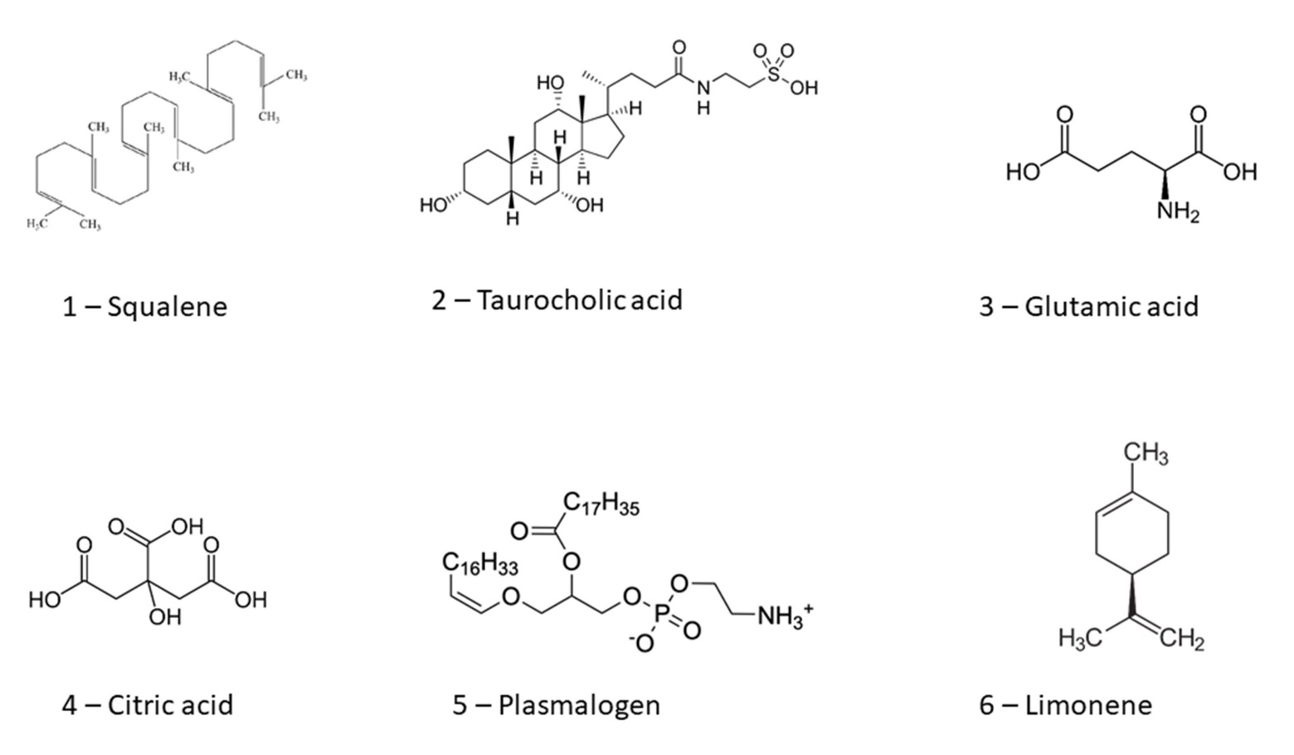
Choose the right combination of structures and their properties.

Variant 1:
  - 1 – Hydrophobic, 2 – Hydrophilic, 3 – Amphipathic, 4 – Hydrophilic, 5 – Amphipathic, 6 - Hydrophobic;
  - 1 – Hydrophobic, 2 – Amphipathic, 3 – Hydrophilic, 4 – Hydrophilic, 5 – Amphipathic, 6 - Hydrophobic;
  - 1 – Hydrophilic, 2 – Amphipathic, 3 – Hydrophilic, 4 – Hydrophilic, 5 – Hydrophobic, 6 - Hydrophobic;
  - 1 – Hydrophilic, 2 – Гидрофобное, 3 – Amphipathic, 4 – Hydrophilic, 5 – Hydrophobic, 6 - Hydrophilic;

Variant 2:
  - 1 – Hydrophobic, 2 – Hydrophilic, 3 – Amphipathic, 4 – Hydrophilic, 5 – Hydrophobic, 6 - Amphipathic;
  - 1 – Amphipathic, 2 – Amphipathic, 3 – Hydrophilic, 4 – Hydrophilic, 5 – Hydrophobic, 6 - Hydrophobic;
  - 1 – Hydrophobic, 2 – Amphipathic, 3 – Hydrophilic, 4 – Hydrophilic, 5 – Amphipathic, 6 - Hydrophobic;
  - 1 – Amphipathic, 2 – Hydrophobic, 3 – Hydrophilic, 4 – Amphipathic, 5 – Hydrophilic, 6 - Hydrophobic;

Variant 3:
  - 1 – Hydrophobic, 2 – Amphipathic, 3 – Hydrophilic, 4 – Hydrophilic, 5 – Amphipathic, 6 - Hydrophobic;
  - 1 – Hydrophobic, 2 – Hydrophilic, 3 – Amphipathic, 4 – Hydrophilic, 5 – Hydrophobic, 6 - Amphipathic;
  - 1 – Hydrophilic, 2 – Гидрофобное, 3 – Amphipathic, 4 – Hydrophilic, 5 – Hydrophobic, 6 - Hydrophilic;
  - 1 – Hydrophobic, 2 – Hydrophobic, 3 – Amphipathic, 4 – Amphipathic, 5 – Hydrophilic, 6 - Hydrophilic;

Task ID 21 – 2 points
Common part of the question for all variants:
One of the ways to store energy is to use compounds containing high-energy bonds (bonds hydrolyzed with the release of a significant amount of energy). The three structures shown in the figure contain the following links:
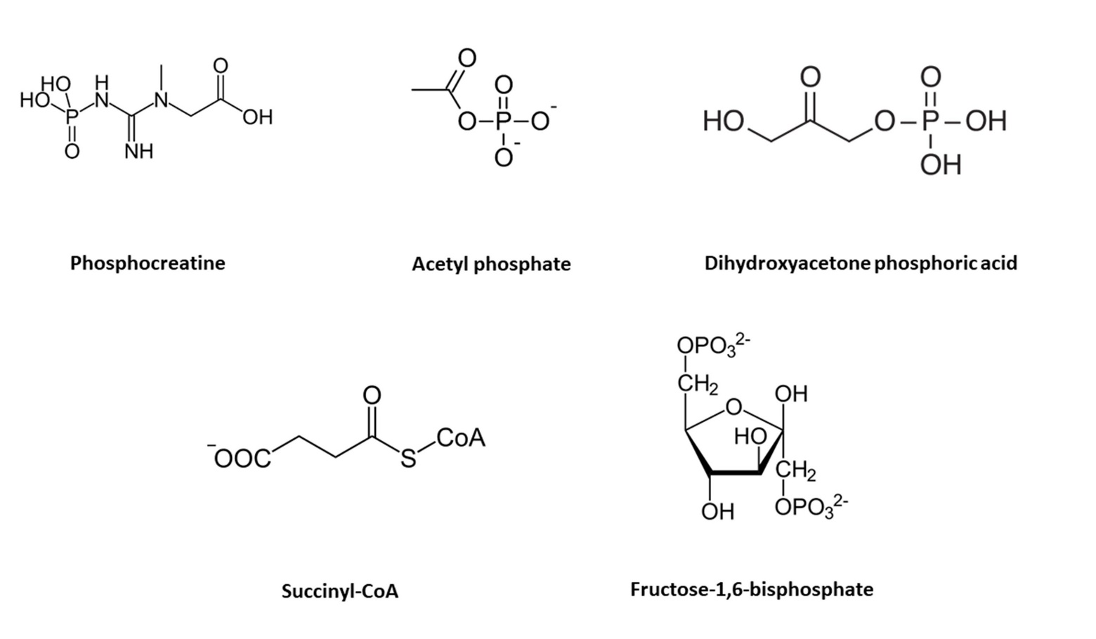
Choose the right combination of structures with high-energy bond:

Variant 1:
  - Phosphocreatine, succinyl-CoA, fructose-1,6-bisphosphate;
  - Phosphocreatine, acetylphosphate, succinyl-CoA;
  - Acetylphosphate, dihidroxyacetone phosphoric acid, fructose-1,6-bisphosphate;
  - Dihidroxyacetone phosphoric acid, succinyl-CoA, fructose-1,6-bisphosphate;

Variant 2:
  - Acetylphosphate, dihidroxyacetone, fructose-1,6-bisphosphate;
  - Phosphocreatine, acetylphosphate, dihidroxyacetone phosphoric acid;
  - Phosphocreatine, acetylphosphate, succinyl-CoA;
  - Acetylphosphate, succinyl-CoA, fructose-1,6-bisphosphate;

Variant 3:
  - Phosphocreatine, acetylphosphate, succinyl-CoA;
  - Acetylphosphate, dihidroxyacetone phosphoric acid, fructose-1,6-bisphosphate;
  - Acetylphosphate, succinyl-CoA, fructose-1,6-bisphosphate;
  - Phosphocreatine, dihidroxyacetone phosphoric acid, fructose-1,6-bisphosphate;

Task ID 22 – 1 point
Common part of the question for all variants:
The organization of chromosomes inside the cell nucleus is closely related to regulation of gene expression. Eukaryotic chromosomes are arranged in the form of isolated from each other compact regions — topologically associated domains (TADs). These domains are characterized by preferential chromatin interactions within them, and spatial separation of loci located in different domains. Thus there is a coordinated influence of genome regions on each other inside the TAD.
There are special sequences in the genome that control gene expression —enhancers and insulators. The regulation mechanism can be described by the following rules:
- An inactive gene makes the neighboring genes inactive;
- The enhancer (E) increases the activity of the neighboring genes and turns on inactive ones;
- The enhancer remains active when its sequence is inverted;
- An inactive gene and enhancers influence the neighboring genes within one TAD;
- The insulator (I) forms the border between the TADs;
Some times only a small chromosomal rearrangement leads to incorrect packing of chromosomes with dire consequences: the normal regulation of gene expression disrupts that results in cancer.
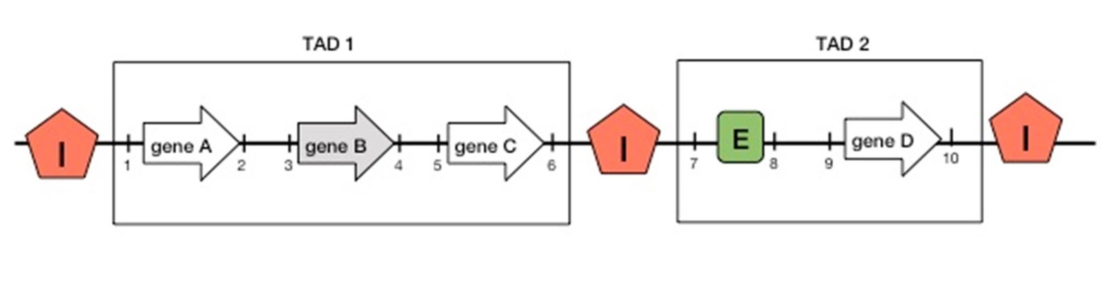
Consider the diagram above and choose the correct statement, provided that the gene B is normally inactive (marked in gray):

Variant 1:
- Genes A, C and D are normally active;
- When the region «6-8» is inverted, genes A, B, C are active while gene D is inactive;
- When the region «4-8» is deleted, gene D is active;
- When the region «6-7» is translocated to the site of the genome designated by the number «5», the C gene is inactive;

Variant 2:
- When the region «6-8» is deleted, genes A, B, C are inactive while gene D is active;
- When the region «6-7» is translocated to the site of the genome designated by the number «3», genes A and C are inactive;
- When the region «6-8» is inverted, genes A, B, C are active while gene D is inactive;
- When the region «6-8» is deleted, the gene D is active;

Variant 3:
- When the region «6-7» is translocated to the site of the genome designated by the number «5», the C gene is inactive;
- Genes A, C and D are normally active;
- When the region «6-8» is deleted, genes A, B, C are inactive while gene D is active;
- When the region «6-8» is inverted, genes A, B, C are active while gene D is inactive;
Task ID 23 – 1 point
Common part of the question for all variants:
Choose the correct statement regarding regulation of gene expression:

Variant 1:
  - The acetylated histones are generally associated with euchromatin (active chromatin);
  - The methylated histones are always associated with heterochromatin (inactive chromatin);
  - The chromatin remodeling is an ATP-independent process;
  - Enhancers of genes that encode antibodies are active in T lymphocytes;

Variant 2:
  - S-adenosylmethionine is released as a result of the reaction of histone methylation;
  - Methylation of the CpG sites of the genome leads to the activation of transcription in the corresponding regions;
  - There are no enzymes in the cell that “erase” the epigenetic label of histone acetylation;
  - The acetylated histones are generally associated with euchromatin (active chromatin);

Variant 3:
  - Expression of the target protein can be increased by cell transfection with siRNA which has a complementary sequence to mRNA that encodes it;
  - The acetylated histones are generally associated with euchromatin (active chromatin);
  - The methylated histones are always associated with heterochromatin (inactive chromatin);
  - Enhancers of genes that encode antibodies are active in T lymphocytes;

Task ID 24 – 2 points
Common part of the question for all variants:
Riboswitches are structured mRNA elements involved in gene regulation that respond to the intracellular concentration of specific small molecules. The figure shows the riboswitch structure in the mRNA of the add gene that encodes adenosine deaminase in E. coli. Regions P1 and P1* can interact with each other to form a hairpin and are highlighted in red. The binding of adenine (A) changes the structure of this riboswitch. SD – Shine-Dalgarno sequence (ribosome binding site), start – start codon (in this case, 5'-AUA-3').
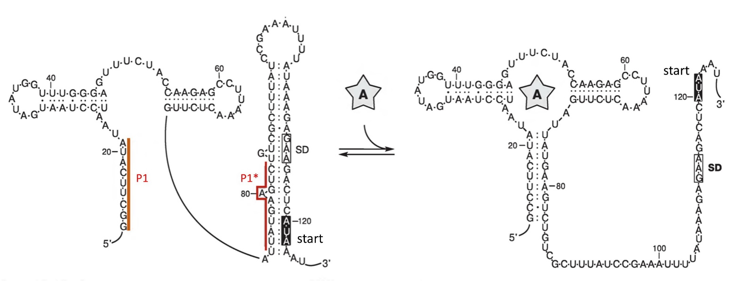
Consider the figure below and choose the correct statement:

Variant 1:
- The adenosine riboswitch promotes the metabolic negative feedback mechanism: the binding of adenine to this riboswitch leads to a decrease in the amount of adenine in the cell;
- This riboswitch regulates gene expression at the transcription stage;
- The binding of adenine to this riboswitch inhibits translation of this mRNA;
- The deletion of nucleotides from position 81 to 88 and from 111 to 117 activates translation of this mRNA;

Variant 2:
- The Shine-Dalgarno sequence (SD) is required for the interaction with 18S rRNA;
- The adenosine riboswitch promotes the metabolic negative feedback mechanism: the binding of adenine to this riboswitch leads to a decrease in the amount of adenine in the cell;
- In the absence of adenine, add mRNA is actively translated;
- Mutations destabilizing the hairpin between P1 and P1* regions will not affect this riboswitch functioning in any way;

Variant 3:
- The binding of adenine to this riboswitch inhibits translation of this mRNA;
- When nucleotides from position 1 to 20 are deleted, translation of the mRNA is still dependent on the presence of adenine;
- The adenosine riboswitch promotes the metabolic negative feedback mechanism: the binding of adenine to this riboswitch leads to a decrease in the amount of adenine in the cell;
- The Shine-Dalgarno sequence (SD) is required for the interaction with 18S rRNA;

Task ID 25 – 1 point
Common part of the question for all variants:
The bL33 protein is one of the proteins of the large subunit of the bacterial ribosome. A ribosome protein homologous to bL33 can be found in a eukaryotic cell. In which compartment of the eukaryotic cell the homologue bL33 accumulates?

Variant 1:
  - Nucleus;
  - Lysosome;
  - Mitochondrial matrix;
  - Cytoplasm;

Variant 2:
  - Vacuole.
  - Golgi apparatus;
  - Cytoplasm;
  - Mitochondrial matrix;

Variant 3:
  - ER;
  - Mitochondrial matrix;
  - Plasma membrane;
  - Vacuole.

Task ID 26 – 1 point
Common part of the question for all variants:
Cell biologists use trypsin to cultivate adherent eukaryotic cell cultures. Why?

Variant 1:
  - To destruct plasma membrane and extract protein fraction;
  - To disrupt cell junctions and to transfer cells to a suspended state;
  - To remove DNA from a sample;
  - To destruct cell walls of bacteria that infect a cell culture;

Variant 2:
  - To accelerate cell growth;
  - To remove RNA from a sample;
  - To disrupt cell junctions and to transfer cells to a suspended state;
  - To separate membrane and cytoplasmic fractions of cells;

Variant 3:
  - To disrupt cell junctions and to transfer cells to a suspended state;
  - To destruct plasma membrane and extract protein fraction;
  - To remove RNA from a sample;
  - To destruct glycogen reserves.

Task ID 27 – 2 points
Common part of the question for all variants:
V-type ATPase is a pump protein that pumps protons across the plasma membrane using ATP hydrolysis energy. It allows sustaining low pH level in some cell organelles. Which protein or protein complex requires a low pH to function?

Variant 1:
- Tubulin;
- ATP synthase;
- DNA polymerase;
- Cathepsin B;

Variant 2:
- Na/K-ATPase;
- Cathepsin B;
- Hexokinase;
- Histones;

Variant 3:
- Cathepsin B;
- Na/K-ATPase;
- Citrate synthase;
- Histones;

Task ID 28 – 1 point
Common part of the question for all variants:
The gene for eye color has two alleles: A for brown eyes and a for blue eyes. Two heterozygous people got married and gave a life for 3 children. What is a probability to have at least one brown-eyed child among this three (values are rounded off)?

Variant 1:
  - 0,156;
  - 0,875;
  - 0,984;
  - 0,5;

Variant 2:
  - 0,125;
  - 0,578;
  - 0,984;
  - 0,25;

Variant 3:
  - 0,984;
  - 0,422;
  - 0,75;
  - 0,125;

Task ID 29 – 1 point
The common part of the question for all variants:
Conjugation is a major method for genetic material exchange among bacteria. During the conjugation process the circle plasmid linearizes and sequentially moves into the recipient cell. In case of HFR strain the same mechanism works with a genome DNA.
When the interrupted mating technique was used with five different strains of Hfr bacteria, the following orders of gene entry and recombination were observed.

HFR strain | Gene order
1 | X Z K N O
2 | K N O Y S
3 | Y O N K Z
4 | Z X P T S

On the basis of these data, choose a map of the bacterial chromosome.

Variant 1:
- STPXZKNOY;
- XZKNOKZPT;
- ONKYSTPZX;
- NKYOZPTSX;

Variant 2:
- STPXZKNOY;
- XPTZKNYOS;
- YSTPKZXPNO;
- XZKOYTSPN;

Variant 3:
- STPXZKNOY;
- KNOZXPYST;
- YONKSTPZX;
- NPXZKTSYO;

Task ID 30 – 2 points
Common part of the question for all variants:
Four independently obtained arginine-dependent (unable to synthesize arginine on its own) Escherichia coli mutants were designated as argA, argB, argC and argD. Mutant cell suspensions were seeded in dashes into minimal media dishes supplemented with limited amount of arginin. This arginin concentration is enough for the slow growth of arg mutants. Dashes make square, but do not touch each other. At the end of some dashes the bacteria growth burst was observed. These areas are drawn in purple.
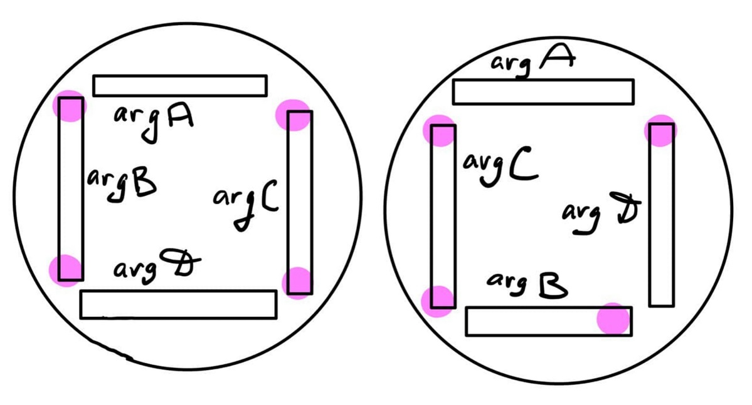
Consider arg biosynthesis pathway.

Variant 1:
  - argC -> argD -> argB-> argA;
  - argB -> argA -> argD-> argC;
  - argC -> argB -> argD-> argA;
  - argA -> argC -> argD-> argB;

Variant 2:
  - argC -> argA -> argD-> argB;
  - argC -> argB -> argD-> argA;
  - argB -> argD -> argA-> argC;
  - argD -> argB-> argA-> argC;

Variant 3:
  - argC -> argB -> argD-> argA;
  - argC -> argD -> argB-> argA;
  - argA -> argC -> argD-> argB;
  - argA -> argD -> argC-> argB;

Task ID 31 – 1 point
Common part of the question for all variants:
Which of the following statements does not apply to the struggle for existence?

Variant 1:
  - Elimination of some individuals of the species from reproduction due to lack of breeding grounds;
  - Selective death of some individuals in cold winter;
  - The death of the entire population as a result of a volcanic eruption;
  - The death of a part of the population as a result of competition for food;

Variant 2:
  - The death of some individuals unable to find food;
  - Elimination of individual males from breeding due to lack of females;
  - Selective death of some individuals from a predator;
  - The death of the entire population as a result of a volcanic eruption;

Variant 3:
  - The death of the entire population as a result of a volcanic eruption;
  - Suppression of individual plants as a result of shading by other species;
  - Elimination of individual males from reproduction due to high competition for the female;
  - Selective death of some individuals in drought;

Task ID 32 – 1 point
Common part of the question for all variants:
In what period did the representatives of the class that you see in the picture develop?

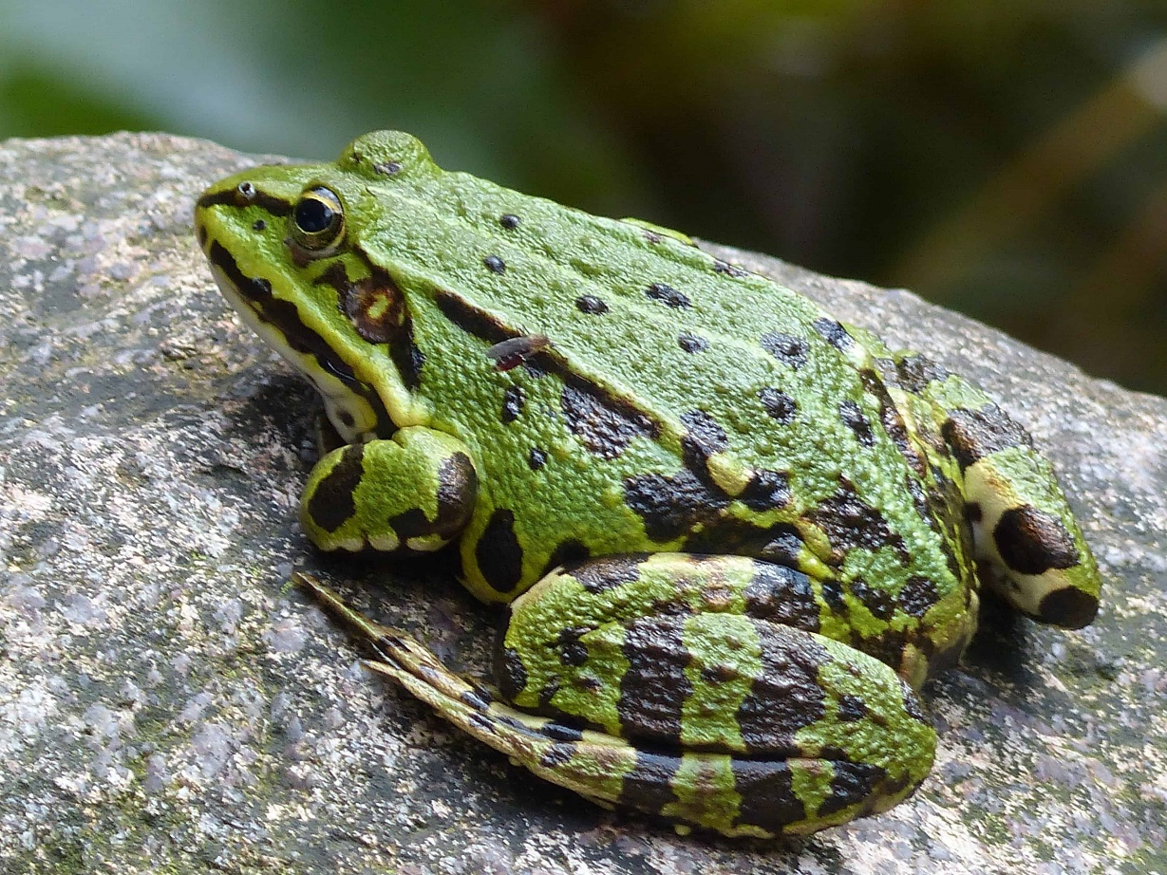

Variant 1:
  - Paleogene;
  - Devonian;
  - Silurian;
  - Ordovician;

Variant 2:
  - Mesozoic;
  - Cretaceous;
  - Devonian;
  - Permian;

Variant 3:
  - Cambrian;
  - Devonian;
  - Jurassic;
  - Triassic;

Task ID 33 – 2 points
Common part of the question for all variants:
Look at the cladogram and choose the correct statement:
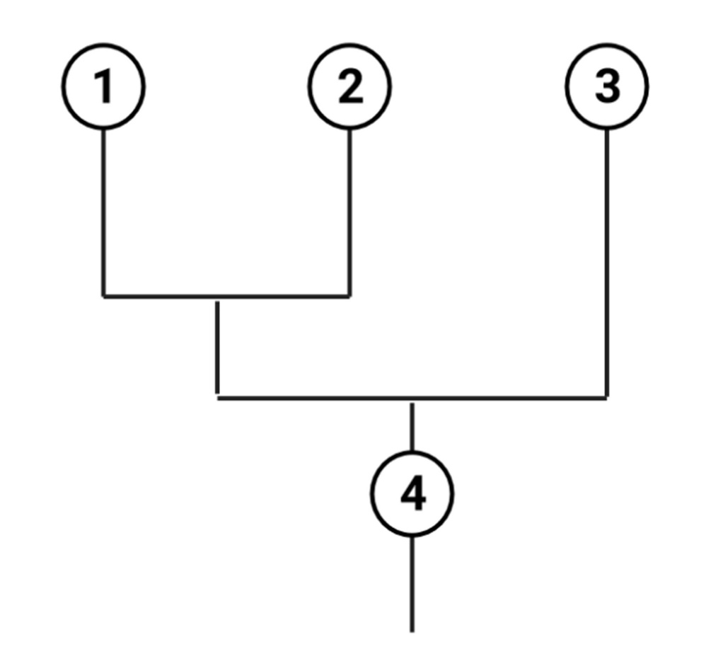

Variant 1:
- Group 4 is the ancestor of groups 1 and 2, but not 3;
- Group 3 will die out earlier than group 2;
- The separation of group 3 occurred earlier than the separation of groups 1 and 2;
- Group 3 is more related to group 2 than to group 1;

Variant 2:
- The separation of group 3 occurred earlier than the separation of groups 1 and 2;
- 3 more evolutionarily advanced group compared to 1 and 2;
- Group 3 is less adapted to living in modern conditions in comparison with 1 and 2;
- Group 2 will die out earlier than group 3;

Variant 3:
- The separation of group 3 occurred earlier than the separation of groups 1 and 2;
- 3 is a more primitive group than 2;
- Group 3 is more related to group 1 than to group 2;
- Group 4 is an ancestral form for group 3 only, but not for groups 1 and 2;

Part B: Multiple Choice Questions (True / False)

In all the tasks of this part, there is a condition at the beginning, and then six answer options (under the letters from A to F). Participants need to determine whether each of the answer options is correct (fits the problem statement) or incorrect (does not fit the job statement). Each task can have from 1 to 6 correct answers.

Grading system:
For each correctly marked statement, you can get 0.5 points
For each incorrectly marked statement - 0 points

Task ID 35 – 3 points
The common part of the question for all variants:
Look at the transverse section of the root.
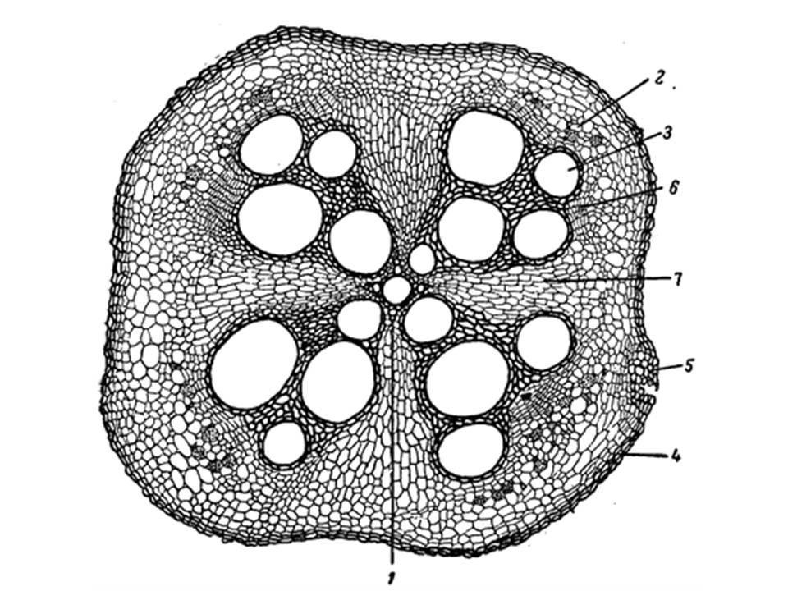
For each of the following statements, indicate whether it is true or false:

Variant 1:
  - This is the root of a monocotyledonous plant;
  - This root hasn't got a secondary growth;
  - This root has got a secondary growth
  - The root is covered by periderm;
  - Secondary xylem is marked with the number 3;
  - The number of rays of the primary xylem is 5;

Variant 2:
  - This is the root of a dicotyledonous plant;
  - This root hasn't got a secondary growth;
  - The root is covered by rhizoderm;
  - Primary xylem is marked with the number 1;
  - Secondary xylem is marked with the number 2;
  - The number of rays of the primary xylem is 4;

Variant 3:
  - This is the root of a dicotyledonous plant;
  - This root has got a secondary growth
  - The root is covered by rhizoderm;
  - Primary xylem is marked with the number 3;
  - Secondary xylem is marked with the number 2;
  - The number of rays of the primary xylem is 5;

Task ID 37 – 3 points
The common part of the question for all variants:
Clubroot is an infectious plant disease caused by Plasmodiophora brassicae Woronin. It affects important agricultural crops: cabbage (Brassica oleracea L.), turnips (Brassica rapa L.), mustard (Sinapis sp.) and other plants of the Family Cruciferae, or Brassicaceae. The figure below shows the life cycle of P. brassicae. "N" stands for haploid stage, "2N" stands for diploid stage, and "R!" - reduction division.
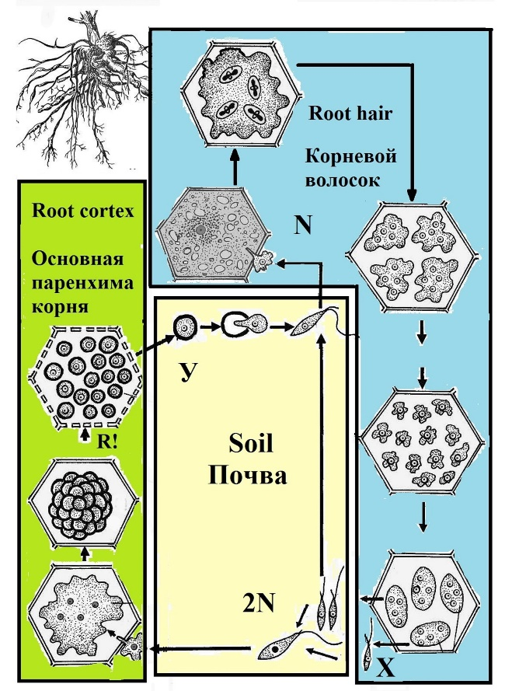
Analyze presented scheme and determine which of the statements are true or false:

Variant 1:
- P. brassicae is an intracellular parasite;
- P. brassicae and representatives of collar flagellates (Choanoflagellatea Cavalier-Smith) are evolutionarily more related to each other than to human (Homo sapiens L.);
- Infection of the plant with P. brassicae is always accompanied by the proliferation of cells of the primary cortex;
- There is always a sequential change of sexual and asexual reproduction in the life cycle of pathogen;
- P. brassicae gametes are formed in the cells of the root hair;
- The cyst of P. brassicae, indicated in the figure with the letter Y, is diploid;

Variant 2:
- P. brassicae and representatives of collar flagellates (Choanoflagellatea Cavalier-Smith) are evolutionarily more related to each other than to human (Homo sapiens L.);
- There is always a sequential change of sexual and asexual reproduction in the life cycle of pathogen;
- Structures X provide for both sexual and asexual reproduction of the organism;
- P. brassicae gametes are formed in the cells of the root hair;
- The cyst of P. brassicae, indicated in the figure with the letter Y, is diploid;
- High humidity is one of the factors that increase the incidence of clubroot;

Variant 3:
- The pathogen affects only the cells of the plant root system;
- There is always a sequential change of sexual and asexual reproduction in the life cycle of pathogen;
- Fertilization of P. brassicae occurs in the cells of the root hair;
- P. brassicae is characterized by isogamy;
- The P. brassicae zygote is mobile, it has a flagellum;
- High humidity is one of the factors that increase the incidence of clubroot;

Task ID 39 – 3 points
The common part of the question for all variants:
The ancestors of molluscs had a developed secondary body cavity – coelom. The coelom is formed from specialized mesodermal cells – teloblasts – as a result of their division and the subsequent formation of cavities within the formed groups of cells. The majority of contemporary molluscs have a reduced coelom. Nonetheless, the vestiges of coelom had remained in some organs in modern molluscs.
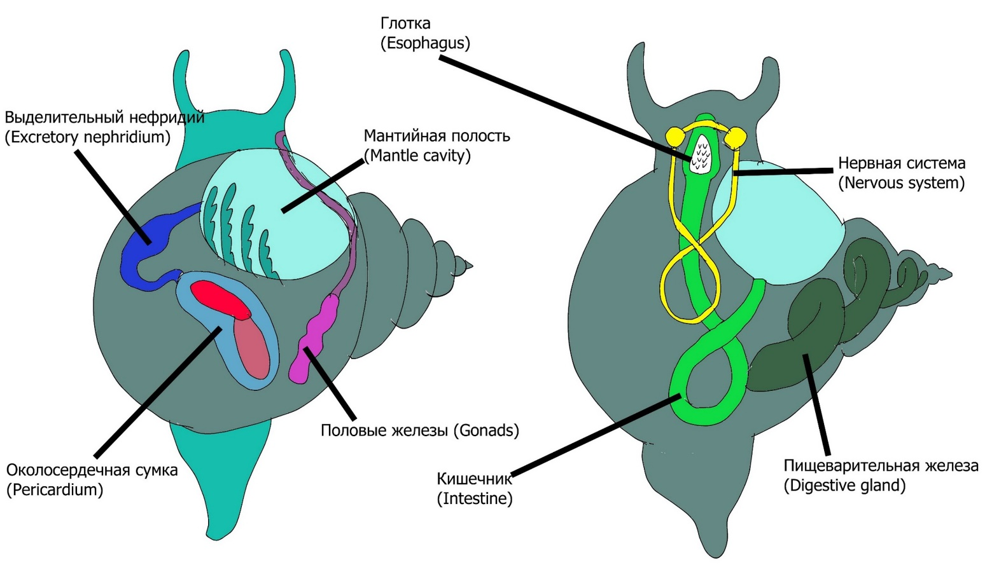
Mark «true» those of the specified organs of the molluscs that are derived from the coelom or have a connection with the coelom. Mark the rest as «false»:

Variant 1:
  - Pericardium;
  - Mantle cavity;
  - The intestine;
  - Esophagus;
  - Excretory system;
  - Reproductive system;

Variant 2:
  - Pericardium;
  - Mantle cavity;
  - The intestine;
  - Esophagus;
  - Digestive gland;
  - Pedal ganglia;

Variant 3:
  - Pericardium;
  - Mantle cavity;
  - The intestine;
  - Esophagus;
  - Esophageal nerve ring;
  - Visceral ganglia;

Task ID 41 – 3 points
Common part of the question for all variants:
Whales can dive deep. A blue whale (Balaenoptera musculus), for example, can dive up to 540 m. But during the diving, decompression sickness inevitably occurs. It occurs due to the fact that with increasing pressure, the solubility of nitrogen in body fluids becomes greater. Because of this, during a rapid ascent, the blood foams due to the fact that previously dissolved nitrogen passes into a gaseous form and forms bubbles that damage the walls of the vessels. However, whales deal with this problem. The same principle is used by other diving animals, including seals and diving ducks.

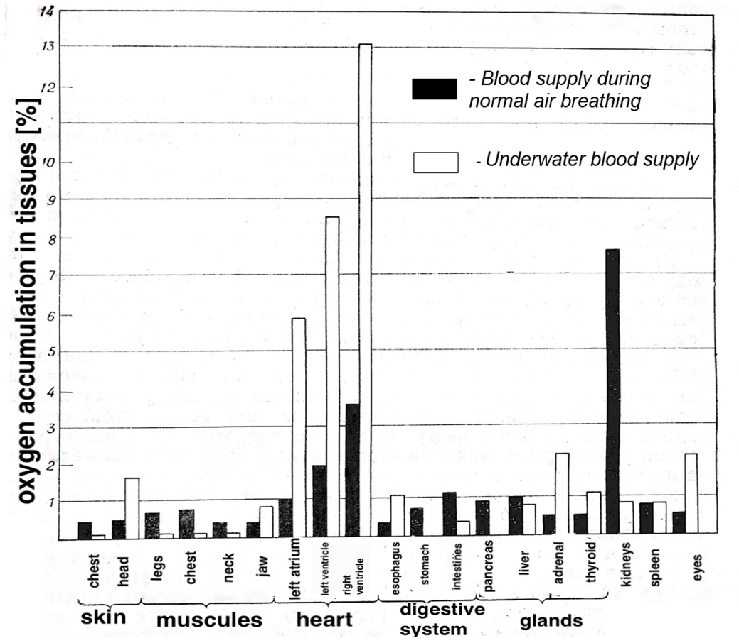
Examine the graph above and mark «true» for the statements below, corresponding to real-life adaptations that help «divers» cope with decompression sickness and oxygen deprivation in the aquatic environment. Mark the rest of the statements as «false»:

Variant 1:
- When diving, whales narrow the lumens of blood vessels in all organs, except for the brain and heart, which constantly need oxygen. At this moment, blood doesn’t flow to the rest of the body, but they organs are protected from nitrogen bubbles;
- Physiologically, nothing changes: whales do not protect their organs from nitrogen in any way and only when they float up, they get rid of bubbles;
- When diving, whales continue to breathe and filter oxygen from the water;
- During diving, the muscles of the animals switch to anaerobic regime and lactic acid accumulates due to the lack of blood flow;
- During diving, the heart rate slows down to 4-8 beats per minute;
- Whale metabolism decreases with diving;

Variant 2:
- When diving, whales narrow the lumens of blood vessels in all organs, except for the brain and heart, which constantly need oxygen. At this moment, blood doesn’t flow to the rest of the body, but they organs are protected from nitrogen bubbles;
- Physiologically, nothing changes: whales do not protect their organs from nitrogen in any way and only when they float up, they get rid of bubbles;
- To prevent hypoxia in the tissues of organs (lack of oxygen in the tissues) during diving, myoglobin molecules retain oxygen through effective binding;
- Heart rate increases during swimming underwater up to 40 beats per minute;
- Whale metabolism decreases with diving;
- Muscles need oxygen when diving and receive more oxygen than all other organs;

Variant 3:
- When diving, whales narrow the lumens of blood vessels in all organs, except for the brain and heart, which constantly need oxygen. At this moment, blood doesn’t flow to the rest of the body, but they organs are protected from nitrogen bubbles;
- Physiologically, nothing changes: whales do not protect their organs from nitrogen in any way and only when they float up, they get rid of bubbles;
- To prevent hypoxia in the tissues of organs (lack of oxygen in the tissues) during diving, myoglobin molecules retain oxygen through effective binding;
- When diving, whales continue to breathe and filter oxygen from the water;
- Whale metabolism decreases with diving;
- Muscles need oxygen when diving and receive more oxygen than all other organs;

Task ID 42 – 3 points
Common part of the question for all variants:
The diagram shows a smooth muscle cell of a blood vessel wall and an adjacent endothelial cell.

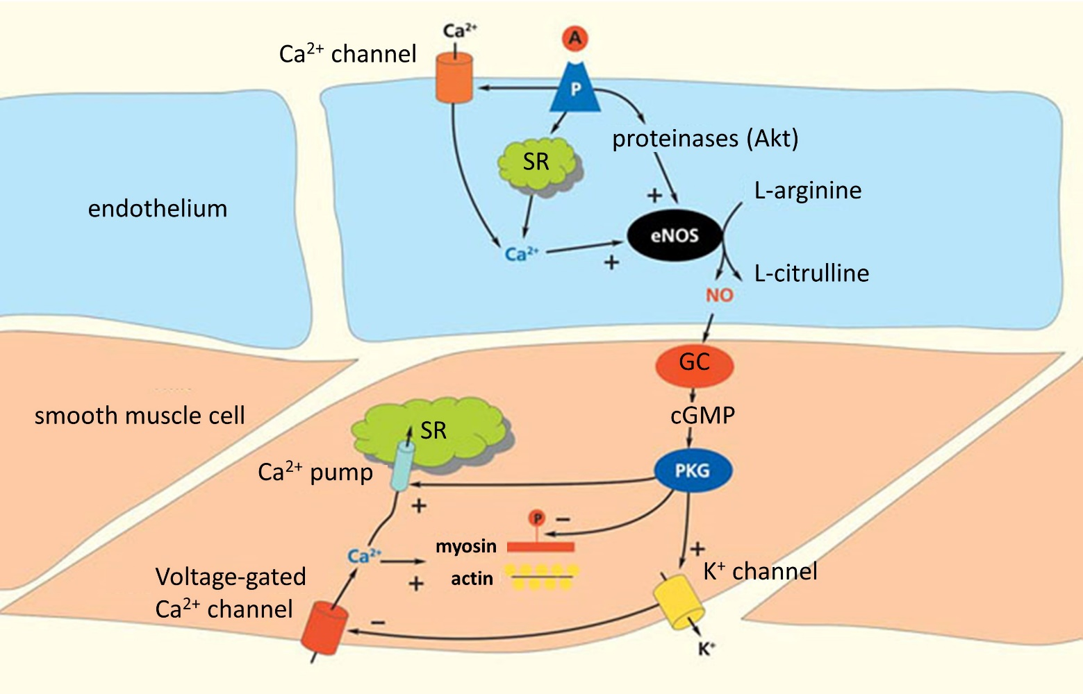

Legend: A - acetylcholine, SR - sarcoplasmic reticulum, eNOS - endothelial NO synthase, NO - nitric oxide (II), GC - guanylate cyclase, cGMP - cyclic guanosine monophosphate, PKG - protein kinase G, P – receptor. A plus at the end of the arrow is an activating effect, a minus at the end of an arrow is an inhibitory effect.
For each of the following statements, indicate whether it is true or false:

Variant 1:
  - When acetylcholine appears in the bloodstream, the vessel lumen narrows;
  - When the endothelium is removed, the effect of acetylcholine will be the same as in an intact vessel;
  - Nitric oxide (II) plays a role in the regulation of filtration and reabsorption processes;
  - Activation of the parasympathetic nervous system leads to the activation of NO synthase;
  - Depolarization of the endothelial cell leads to hyperpolarization of the smooth muscle cell;
  - Activation of endothelial potassium channels leads to the activation of voltage-gated calcium channels in smooth muscle cells;

Variant 2:
  - When acetylcholine appears in the bloodstream, the vessel lumen narrows;
  - Nitric oxide (II) plays a role in the regulation of filtration and reabsorption processes;
  - Activation of smooth muscle contraction occurs when Ca²⁺ ions enter the smooth muscle cell only from the SR;
  - Activation of the sympathetic nervous system leads to the activation of NO synthase;
  - Depolarization of the endothelial cell leads to hyperpolarization of the smooth muscle cell;
  - Activation of endothelial calcium channels leads to activation of potassium channels in smooth muscle cells.

Variant 3:
  - Activation of NO synthase leads to an increase in the level of cyclic forms of nucleotides in a smooth muscle cell;
  - When the endothelium is removed, the effect of acetylcholine will be the same as in an intact vessel;
  - Activation of smooth muscle contraction occurs when Ca²⁺ ions enter the smooth muscle cell only from the SR;
  - Activation of the sympathetic nervous system leads to the activation of NO synthase;
  - Depolarization of the endothelial cell leads to hyperpolarization of the smooth muscle cell;
  - Activation of endothelial potassium channels leads to the activation of voltage-gated calcium channels in smooth muscle cells;

Task ID 43 – 3 points
Common part of the question for all variants:
All living cells are characterized by the presence of a resting potential (membrane potential of a cell in an unexcited state). For neurons, the value of this potential is approximately equal to -70 mV. The figure below shows a diagram of a neuron with the main ions and channels involved in the formation of the cell membrane potential.
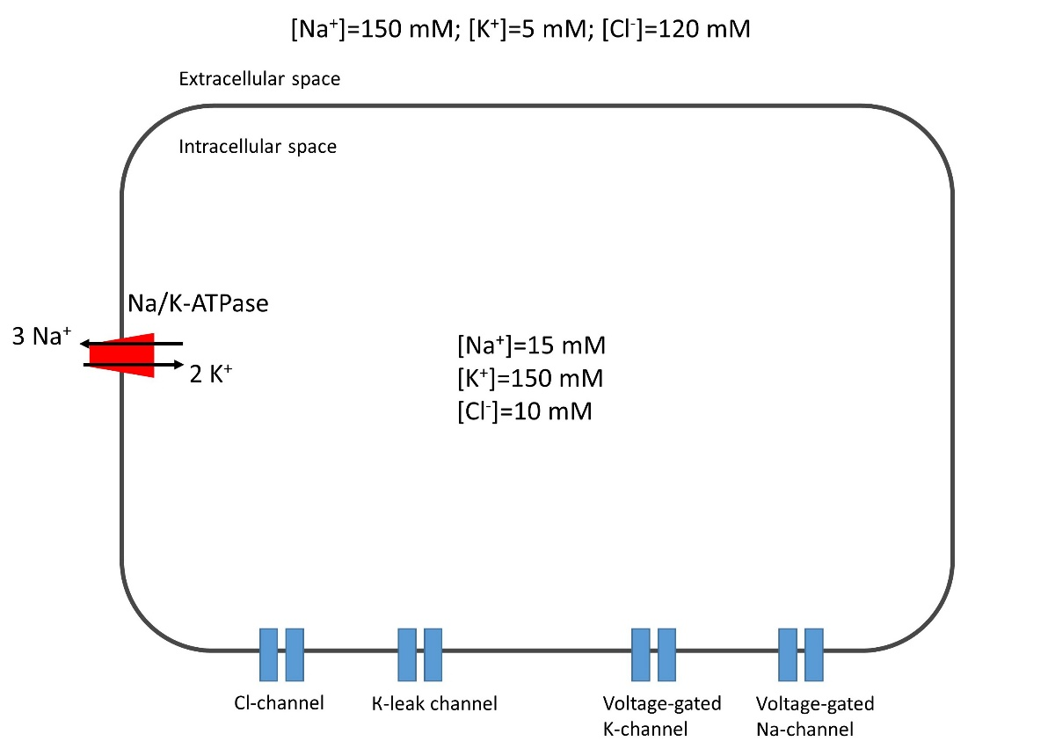
For each of the following statements, indicate whether it is true or false:

Variant 1:
  - When this cell is placed in a solution with a concentration of 50 mM KNO₃, the membrane will depolarize;
  - With an increase in the intracellular concentration of Na⁺, the incoming calcium current will increase;
  - Depolarization of the membrane will lead to the activation of the Na/K-ATPase;
  - Under the influence of tetrodotoxin (sodium channel blocker), the work of Na/K-ATPase is inhibited;
  - With an increase in the expression of genes encoding proteins of voltage-gated sodium channels, there will be a decrease in the resting potential of the cell;
  - Depolarization of the membrane to -30 mV leads to an increase in chlorine current;

Variant 2:
  - Under the influence of tetrodotoxin (sodium channel blocker), the work of Na/K-ATPase is inhibited;
  - With an increase in the expression of genes encoding proteins of voltage-gated sodium channels, there will be a decrease in the resting potential of the cell;
  - Depolarization of the membrane to -30 mV leads to an increase in chlorine current;
  - When this cell is placed in a solution with a concentration of 50 mM KNO₃, the membrane will hyperpolarize;
  - With an increase in the intracellular concentration of Na⁺, the incoming potassium current will increase;
  - The addition of ouabain (an inhibitor of Na/K-ATPase) to the extracellular environment will lead to a decrease in the resting potential of the cell;

Variant 3:
  - When this cell is placed in a solution with a concentration of 50 mM KNO₃, the membrane will depolarize;
  - With an increase in the intracellular concentration of Na⁺, the incoming calcium current will increase;
  - With an increase in the expression of genes encoding proteins of voltage-gated sodium channels, there will be a decrease in the resting potential of the cell;
  - Depolarization of the membrane to -30 mV leads to an increase in chlorine current;
  - The addition of ouabain (an inhibitor of Na/K-ATPase) to the extracellular environment will lead to a decrease in the resting potential of the cell;
  - An increase in the number of voltage-gated sodium channels in the membrane will lead to a more rapid development of the action potential in the neuron;

Task ID 44 – 3 points
The common part of the question for all variants:
Ion distribution across the plasma membrane is unequal. For example, potassium ions are at a much higher concentration in the cytoplasm than in the extracellular fluid, whereas the reverse is true for sodium ions. This is due to the work of Na,K-ATPase which extrudes 3 sodium ions from and imports 2 potassium ions into the cell per cycle.
Suppose that cell membrane is permeable only to potassium ions. These ions will move outward along their concentration gradient. Anions that are incapable of crossing the membrane will accumulate inside the cell membrane, whereas outward potassium ion current will lead to excess of positive charge outside the membrane. Charge separation generates electrical potential gradient across the membrane, which will counterbalance the concentration gradient. At equilibrium, these two forces will be equal to each other and net potassium current will be zero. The membrane potential at this state is called equilibrium potential for potassium ions.

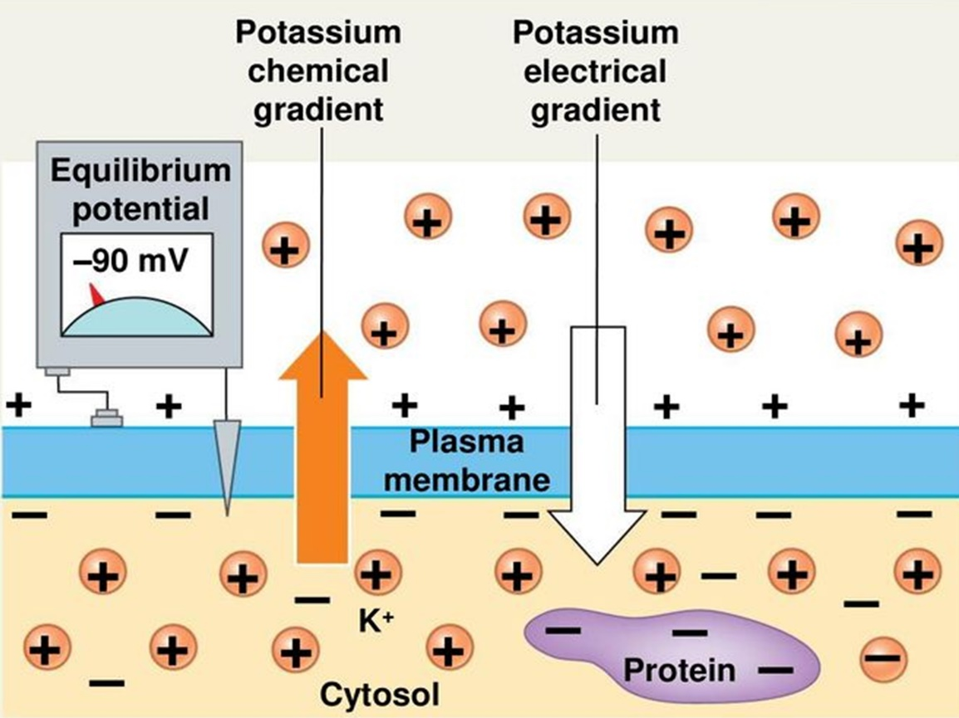

You conduct an electrophysiological study on a single isolated axon. The table below shows extra- and intracellular concentrations of sodium and potassium levels as well as equilibrium potential at T=293K.

Ions | Extracellular concentration, mmol/L | Intracellular concentration, mmol/L | Equilibrium pontential, mV
Potassium | 4 | 150 | –91
Sodium | 140 | 4 | +90

Axonal membrane potential is –70 mV. Movement of a membrane potential to a more negative value is called hyperpolarization. Depolarization is the opposite of hyperpolarization (i.e. membrane potential becomes less negative/more positive). For simplicity one can assume that this membrane is only permeable to sodium and potassium ions.
For each of the following statements, indicate whether it is true or false:

Variant 1:
  - An increase in potassium ion permeability will not change potassium equilibrium potential;
  - At rest axolemma is more permeable to sodium ions than to potassium ions;
  - If one blocks Na/K-ATPase, extra- and intracellular sodium ion concentrations will become equal;
  - A 10-fold increase in sodium ion permeability will result in membrane depolarization;
  - A 10-fold increase in potassium ion permeability will result in membrane hyperpolarization;
  - A 10-fold increase in extracellular potassium ion concentration will result in membrane depolarization;

Variant 2:
  - An increase in potassium ion permeability will not change potassium equilibrium potential;
  - At rest axolemma is more permeable to potassium ions than to sodium ions;
  - If one blocks Na/K-ATPase, extra- and intracellular sodium ion concentrations will become equal;
  - A 10-fold increase in sodium ion permeability will result in membrane hyperpolarization;
  - A 10-fold increase in potassium ion permeability will result in membrane depolarization;
  - A 10-fold increase in intracellular sodium ion concentration will result in membrane depolarization;

Variant 3:
  - An increase in potassium ion permeability will not change potassium equilibrium potential;
  - At rest axolemma is more permeable to potassium ions than to sodium ions;
  - If one blocks Na/K-ATPase, extra- and intracellular sodium ion concentrations will become equal;
  - A 10-fold increase in sodium ion permeability will result in membrane hyperpolarization;
  - A 10-fold increase in potassium ion permeability will result in membrane depolarization;
  - A 10-fold increase in extracellular potassium ion concentration will result in membrane depolarization;

Task ID 45 – 3 points
The common part of the question for all variants:
In autonomic nervous system, nerve impulses from central nervous system (CNS) are transmitted to their target organs via a two-neuron pathway. The first motor neuron resides within CNS with its axon reaching peripheral autonomic ganglion, where it makes a synaptic contact with second neuron’s soma. The axon of this second neuron then reaches a target organ.
Within the eye there are some structures receiving autonomic control. Among them are two antagonistic smooth muscles controlling pupil diameter, namely sphincter pupillae and dilator pupillae. The picture below is a simplified diagram of the autonomic innervation of these muscles (ACh – acetylcholine, NA – noradrenaline).

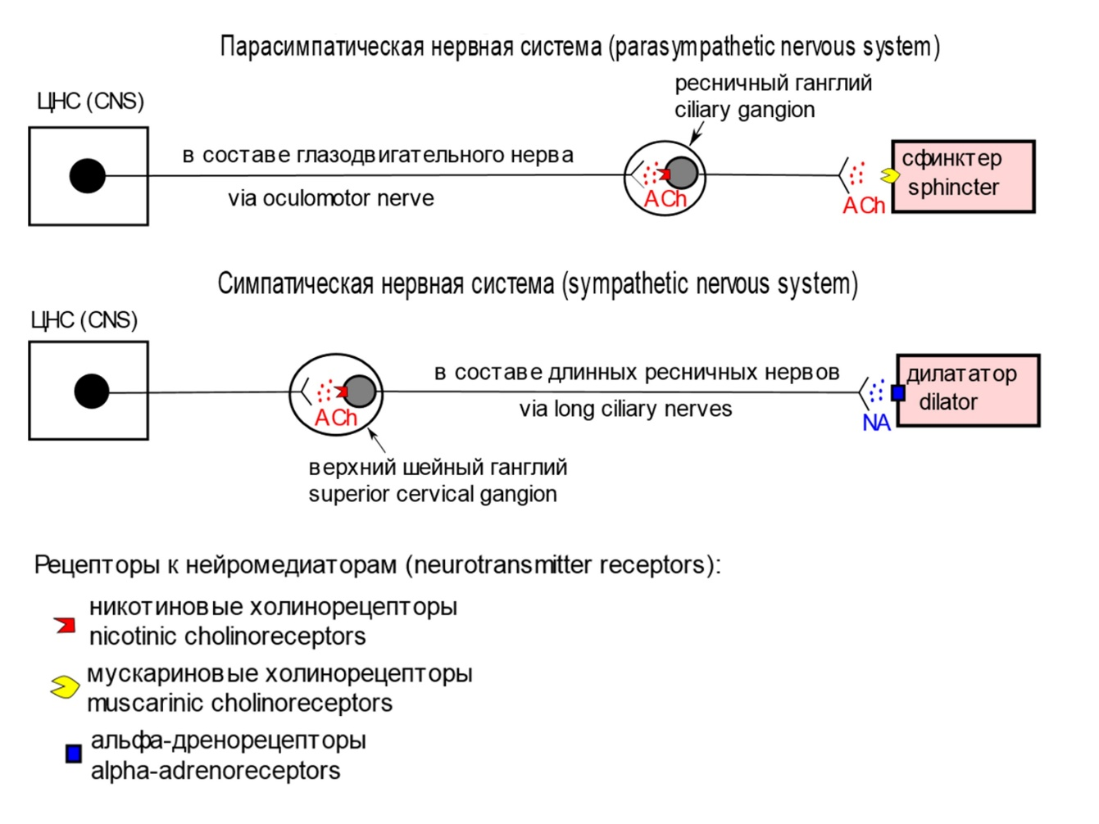

Label «true» those cases in which the pupils will be dilated and their response to light will weaken or completely disappear. Mark the rest of the cases as «false»:

Variant 1:
- Transection of oculomotor nerves;
- Ciliary ganglia ablation;
- Poisoning with muscarinic receptor antagonist;
- Cervical spinal cord trauma;
- Instillation of acetylcholinestetase blocker solution into the conjunctival sacs (this enzyme catalyses acetylcholine hydrolysis in the synaptic cleft);
- Injection of botulinum toxin (blocks acetylcholine release in the synaptic cleft) into the anterior chamber of the eyes.

Variant 2:
- Transection of oculomotor nerves;
- Ablation of superior cervical ganglia;
- Cervical spinal cord trauma;
- Instillation of acetylcholinestetase blocker solution into the conjunctival sacs (this enzyme catalyses acetylcholine hydrolysis in the synaptic cleft);
- Instillation of alpha-adrenoreceptor antagonist solution into the conjunctival sacs;
- Instillation of muscarinic receptor agonist solution into the conjunctival sacs;

Variant 3:
- Transection of long ciliary nerves;
- Ablation of superior cervical ganglia;
- Poisoning with muscarinic receptor antagonist;
- Cervical spinal cord trauma;
- Instillation of acetylcholinestetase blocker solution into the conjunctival sacs (this enzyme catalyses acetylcholine hydrolysis in the synaptic cleft);
- Instillation of alpha-adrenoreceptor antagonist solution into the conjunctival sacs;

Task ID 46 – 3 points
Common part of the question for all variants:
Biochemical pathway of purine synthesis is a great example to study principles of feedback regulation. Concentration of AMP and GMP is tightly regulated to meet the needs of the cell. The scheme below represents some parts of purine synthesis. Black arrows denote chemical reaction where as dash lines with red lines in the end represent negative regulation. Abbreviations: PRPP - 5-Phosphoribosyl-1-pyrophosphate, IMP – Inosinate, AdSuc – Adenylosuccinate, XMP – Xanthylate, GPA, AC and ID – enzymes involved in the pathway.
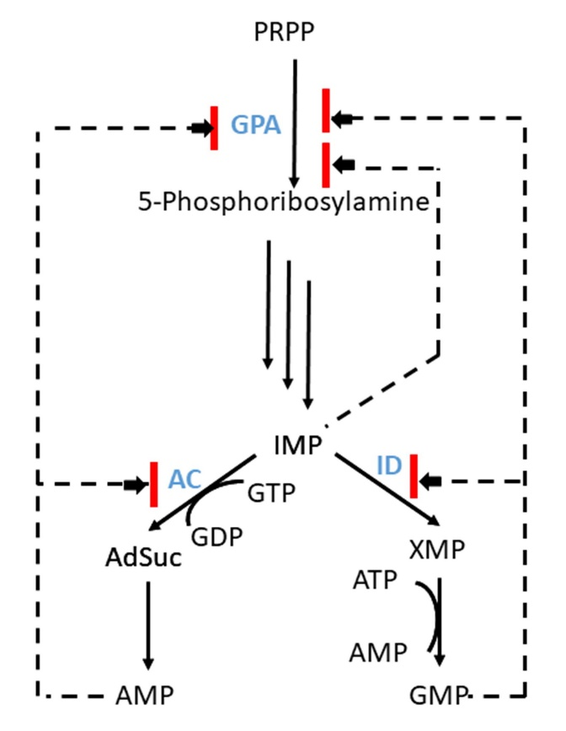
Analyze presented scheme and determine which of the statements are true or false:

Variant 1:
  - Increase in the AMP and ATP concentration activates synthesis of GMP;
  - Change in AMP concentration does not affect the rate of GMP synthesis;
  - Inhibition of purine synthesis is more prominent when both AMP and GMP concentrations increase;
  - GMP inhibits ID activity;
  - High concentration of GMP inhibits АС;
  - A high concentration of AMP blocks the work of ID, and an increase in the concentration of HMP inhibits AS.

Variant 2:
  - Increase in the GMP and GTP concentration activates synthesis of AMP;
  - Change in AMP concentration does not affect the rate of GMP synthesis;
  - AMP inhibits AC activity;
  - The accumulation of AMP and GMP in the cell leads to an increase in the concentration of IMP, which inhibits the synthesis of all purine nucleotides;
  - Purine synthesis is regulated by positive feedback loops;
  - A high concentration of AMP blocks the work of ID, and an increase in the concentration of HMP inhibits AS.

Variant 3:
  - Increase in the AMP and ATP concentration activates synthesis of GMP;
  - Inhibition of purine synthesis is more prominent when both AMP and GMP concentrations increase;
  - GMP inhibits ID activity;
  - AdSuc and XMP branches compete for IMP;
  - High concentration of GMP inhibits АС;
  - Purine synthesis is regulated by positive feedback loops;

Task B ID 47 – 3 points
Common part of the question for all variants:
Carbohydrate metabolism is a key process for an energy flow through the cell. Glucose level in blood is regulated by liver and remains constant. Key nodes of glucose metabolism are regulated by hormonal signals and are marked with a red star on the figure below. The hormone glucagon reorients metabolic processes in the liver cell, causing the release of glucose into the bloodstream. Adrenaline also acts on the enzymes of the metabolic junction points, however, its activate the mobilization of carbohydrates for the internal needs of the cell. Insulin, on the other hand, leads to a decrease in the concentration of glucose in the blood. In the figure below a part of metabolic map of carbohydrate metabolism taking place in the liver cell is depicted. Metabolism of glucose is strictly regulated by hormones. The crucial points of regulation are marked by red stars. Abbreviations: GluT – glucose transporter, PPP – pentose phosphate pathway, Fr-bP – Fructose-1,6-bisphosphatase.
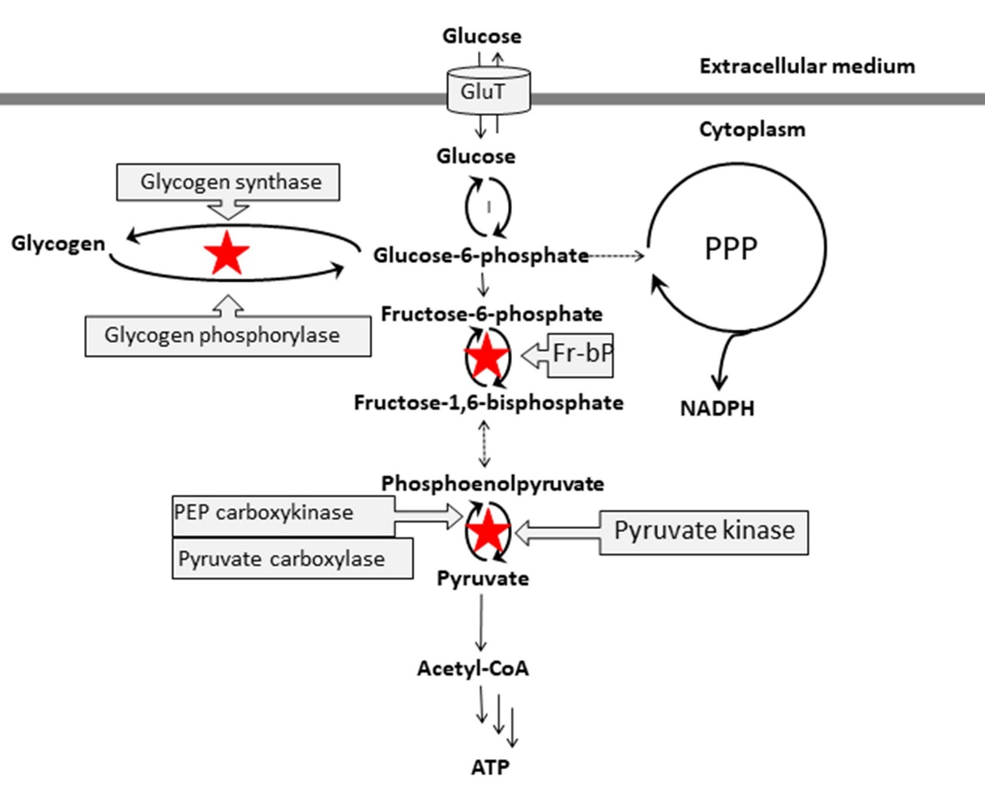
Analyze presented scheme and determine which of the statements are true or false:

Variant 1:
  - Glucagon acts on the liver cell by sequentially activating G-protein coupled receptors, G-proteins and protein kinase A;
  - Glucose mobilization in the liver cell is more prominent after glucagon application than after adrenaline;
  - Insulin activate fructose-1,6-bisphosphatase;
  - Glucagon activates gluconeogenesis whereas insulin activated glycolysis;
  - Phosphoenolpyruvate is synthesized in one step during gluconeogenesis;
  - After a meal, concentration of glucose in blood increases, which leads to activation of fructose-1,6-bisphosphatase;

Variant 2:
  - Glucagon acts on the liver cell by sequentially activating G-protein coupled receptors, G-proteins and protein kinase A;
  - Glucagon activates glycogen phosphorylase and inhibits glycogen synthase;
  - Glucagon activates glucose-6-phosphate breakdown in PPP;
  - Insulin activate fructose-1,6-bisphosphatase;
  - Not only hepatocytes but also myocytes release glucose in the blood;
  - During fasting glycogen synthase is activated and glycogen phosphorylase remains inhibited;

Variant 3:
  - Glucagon acts on the liver cell by sequentially activating G-protein coupled receptors, G-proteins and protein kinase A;
  - Glucose mobilization in the liver cell is more prominent after glucagon application than after adrenaline;
  - Glucagon activates glucose-6-phosphate breakdown in PPP;
  - Glucagon activates gluconeogenesis whereas insulin activated glycolysis;
  - After a meal, concentration of glucose in blood increases, which leads to activation of fructose-1,6-bisphosphatase;
  - During fasting glycogen synthase is activated and glycogen phosphorylase remains inhibited;

Task ID 48 – 3 points
The common part of the question for all variants:
You are studying protein “X” and plan to use CRISPR-Cas technology to edit the gene “X” that encodes it. To edit the genome using the CRISPR-Cas system, it is necessary to select a guide RNA (gRNA or sgRNA) to direct the complex to a specific genome sequence (target DNA) and an endonuclease Сas (CRISPR-associated protein, Cas nuclease).
The guide RNA must be complementary to the region of the genome to which the defined PAM sequence (proto-spacer adjacent motif) is adjacent. Cas9 from Streptococcus pyogenes (Cas9 nuclease) recognizes the PAM sequence 5'-NGG-3', Cas12a from Lachnospiraceae bacterium (Cas12a nuclease) recognizes the PAM sequence 5'-TTTN-3', where N is any nucleotide, and then endonuclease Cas makes a double-strand break in DNA (cleavage). The location of the PAM sequences in relation to the target DNA and guide RNA is shown in the figure below.
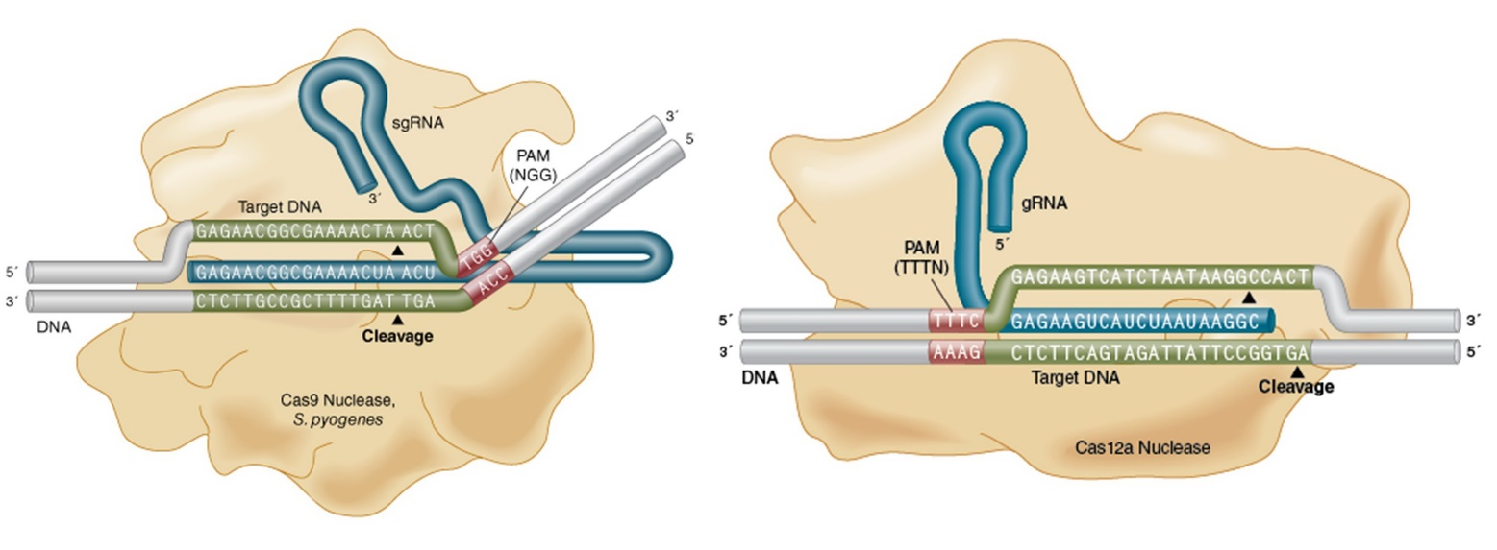
The sequence of genomic DNA at the border of exon 3 and intron 4 (underlined) of gene “X” is shown below. It is a sequence of the genomic DNA strand that is depicted at the top in the figure in complex with gRNAs and Cas nucleases:
5’ CGCGCGTCTTTCCACGAGCTCTCCACGGGGAGGAGGGGAAAACTGCTGAAGAGCTTTCAGGTAAGTGGCTGTTTCGGAGAGACCTCATCTAGTCGCTGGCCTCGTCAAGG 3'
For each of the following statements, indicate whether it is true or false:

Variant 1:
- As a result of the site-directed double-strand break in DNA induced by a Cas nuclease and subsequent repair by the mechanism of non-homologous end joining (NHEJ), a frame shift may occur that leads to the target gene knockout;
- A researcher can use a guide RNA with a nucleotide sequence of 5'-CUUUCCACGAGCUCUCCACG-3' and Cas9 nuclease for the knockout of the target gene “X”;
- A researcher can use a guide RNA with a nucleotide sequence of 5'-GGGGAAAACUGCUGAAGAGC-3' and Cas12a nuclease for the knockout of the target gene “X”;
- A researcher can use a guide RNA with a nucleotide sequence of 5'-GAGAGACCUCAUCUAGUCGC-3' and Cas9 nuclease for the knockout of the target gene “X”;
- A researcher can use a guide RNA with a nucleotide sequence of 5'-CACGAGCUCUCCACGGGGAG-3' and Cas12a nuclease for the knockout of the target gene “X”;
- As a result of the site-directed double-strand break in DNA induced by a Cas nuclease and subsequent repair by the mechanism of homologous recombination (HDR), the target gene “X” can be changed so that it encodes the target protein X fused to the fluorescent protein EGFP.

Variant 2:
- As a result of the site-directed double-strand break in DNA induced by a Cas nuclease and subsequent repair by the mechanism of non-homologous end joining (NHEJ), a frame shift may occur that leads to the target gene knockout;
- A researcher can use a guide RNA with a nucleotide sequence of 5'-GGGGAAAACUGCUGAAGAGC-3' and Cas12a nuclease for the knockout of the target gene “X”;
- A researcher can use a guide RNA with the nucleotide sequence 5'-UCUAGUCGCUGGCCUCGUCA-3 'and Cas9 nuclease for the knockout of the target gene “X”;
- A researcher can use a guide RNA with the nucleotide sequence 5'-AAAACUGCUGAAGAGCUUUС-3 'and Cas9 nuclease for the knockout of the target gene “X”;
- Guide RNA should contain not only regions complementary to the target DNA sequence, but also the transactivator part for the interaction with Cas9 nuclease;
- A researcher can use a guide RNA to the promoter of the target gene “X” and Cas9 modified protein with inactivated nuclease domain fused with a transcription activator domain (dCas9-VP64) to activate expression of the gene “X” using CRISPR-Cas technology;

Variant 3:
- As a result of the site-directed double-strand break in DNA induced by a Cas nuclease and subsequent repair by the mechanism of non-homologous end joining (NHEJ), a frame shift may occur that leads to the target gene knockout;
- A researcher can use a guide RNA with a nucleotide sequence of 5'-CUUUCCACGAGCUCUCCACG-3' and Cas9 nuclease for the knockout of the target gene “X”;
- A researcher can use a guide RNA with the nucleotide sequence 5'-UCUAGUCGCUGGCCUCGUCA-3 'and Cas9 nuclease for the knockout of the target gene “X”;
- Guide RNA should contain not only regions complementary to the target DNA sequence, but also the transactivator part for the interaction with Cas9 nuclease;
- A researcher can use a guide RNA with the nucleotide sequence 5'-UCUUUCCACGAGCUCUCCAC -3 'and Cas9 nuclease for the knockout of the target gene “X”;
- A researcher can use a guide RNA with a nucleotide sequence of 5'-GGAGAGACCUCAUCUAGUCG -3 'and Cas12a nuclease for the knockout of the target gene “X”;

Task ID 49 – 3 points
The common part of the question for all variants:
The picture below shows the process of translation initiation in eukaryotes.

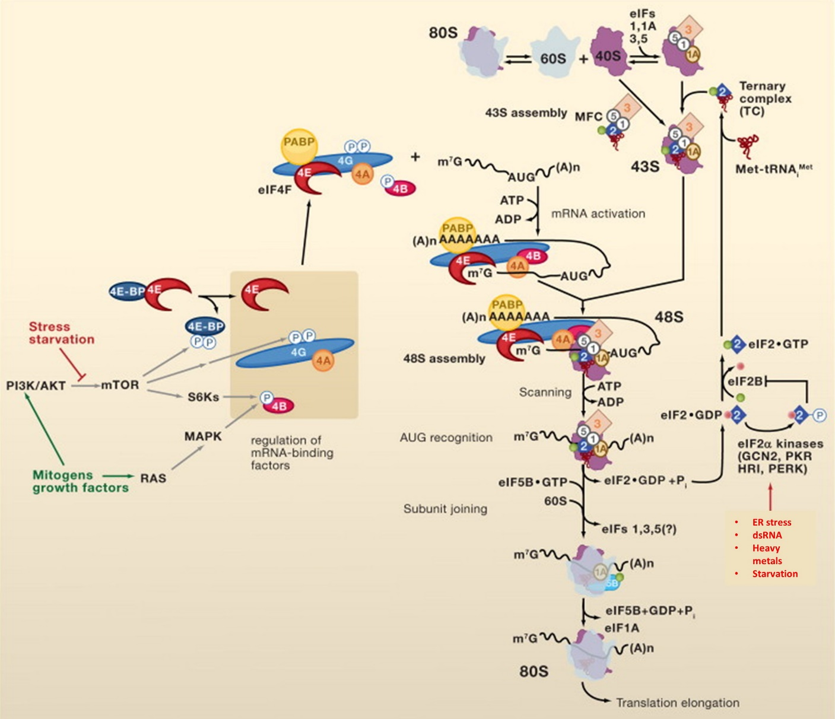

Explanations of some abbreviations in the figure: 4E-BP – eIF4E binding protein; dsRNA – double-stranded RNA; eIF – eukaryotic initiation factor; ternary complex – complex of eIF2, Met-tRNA^{Met} and GTP; Met-tRNA^{Met} – initiator methionyl tRNA; m⁷G – mRNA cap structure; PABP – poly (A) -binding protein.
Review the diagram and for each of the following statements indicate whether it is true or false:

Variant 1:
- Treatment of mammalian cells with a mTOR inhibitor leads to activation of cap-dependent translation;
- eIF4G1 is a scaffold protein: it facilities the fixation of an mRNA in circularized form when its 5'- and 3'-ends are close together;
- The addition of a non-hydrolyzable GTP analogue (GMP-PNP) to a cell-free translation system results in «freezing» of translation initiation at the stage of 48S initiation complex formation;
- The 48S initiation complex assembles directly on the start AUG codon of most cellular mRNAs;
- Infection of eukaryotic cells with a virus which genome is double-stranded RNA leads to inhibition of translation;
- The mRNA sequence in the region of the start codon must contain the Shine-Dalgarno sequence to initiate translation in eukaryotes;

Variant 2:
- eIF4G1 is a scaffold protein: it facilities the fixation of an mRNA in circularized form when its 5'- and 3'-ends are close together;
- Infection of eukaryotic cells with a virus which genome is double-stranded RNA leads to inhibition of translation;
- Only ATP is needed to initiate translation in eukaryotic cells, but not GTP;
- The mRNA sequence in the region of the start codon must contain the Shine-Dalgarno sequence to initiate translation in eukaryotes;
- The knockdown of AKT kinase can be expected to result in a strong decrease in translation level;
- The elongator Met-tRNA^{Met} can be used instead of the initiator Met-tRNA^{Met} to initiate translation in eukaryotic cells;

Variant 3:
- The addition of a non-hydrolyzable GTP analogue (GMP-PNP) to a cell-free translation system results in «freezing» of translation initiation at the stage of 48S initiation complex formation;
- The 48S initiation complex assembles directly on the start AUG codon of most cellular mRNAs;
- It can be expected that overexpression of the mutant isoform of 4E-BP that cannot be phosphorylated leads to inhibition of cap-dependent translation;
- The mRNA sequence in the region of the start codon must contain the Shine-Dalgarno sequence to initiate translation in eukaryotes;
- The knockdown of AKT kinase can be expected to result in a strong decrease in translation level;
- The elongator Met-tRNA^{Met} can be used instead of the initiator Met-tRNA^{Met} to initiate translation in eukaryotic cells;

Task ID 50 – 3 points
The common part of the question for all variants:
Cell death is an important process for organism functioning, disturbances in which lead to various diseases. There are two main morphological types of cell death – apoptosis and necrosis. Apoptosis characteristics are chromatin condensation, nucleus fragmentation and apoptotic bodies production. These bodies are phagocytosed by neighboring cells. Necrosis characteristics are the uncontrolled release of cellular contents into the microenvironment and inflammatory response triggering.
Fluorescent dye Annexin V-FITC stains phosphatidylserine. In normal conditions phosphatidylserine is located on the inner surface of the plasma membrane and is not available for staining. Its appearance on the outer surface of the plasma membrane is an apoptosis marker. This is typical both for still living apoptotic cells and for cells that have died as a result of this type of death.
Another fluorescent dye, propidium iodide (PI), stains DNA. It is also unable to permeate into living cells. The method of flow cytometry allows count cells stained by one of these dyes or both of them. It allows distinguishing apoptotic and necrotic cell death.
You want to study the effect of compounds A and B in cell death using this method. Here you can see the result of such experiment:

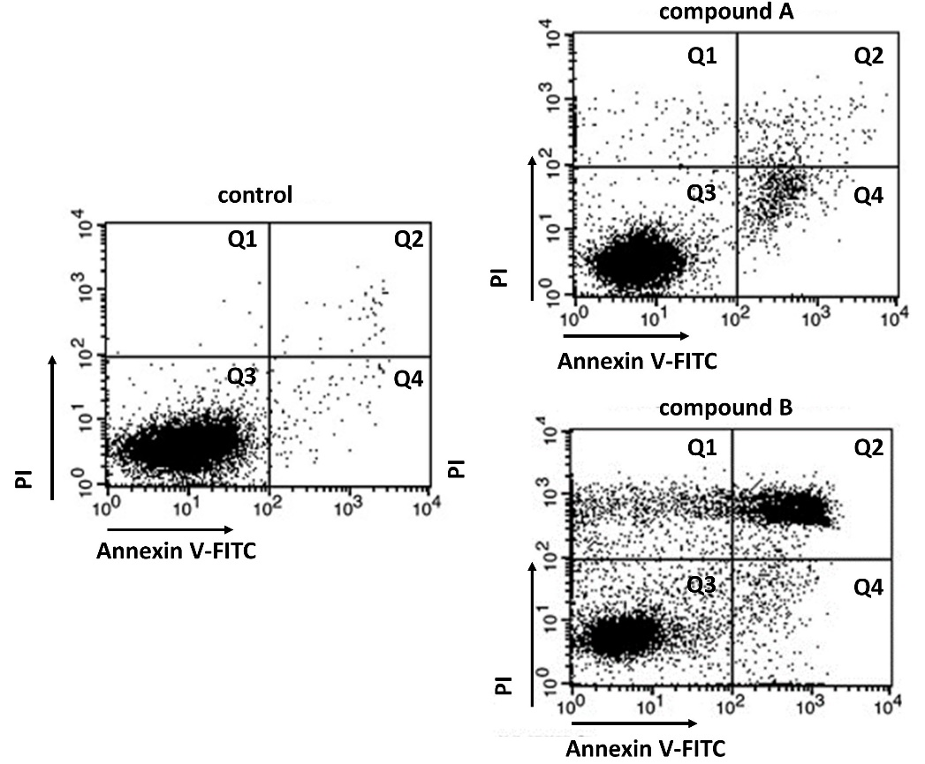

Every point on graphs corresponds to the fluorescence of two dyes from one cell. The abscissa shows the Annexin V-FITC fluorescence intensity, the ordinate shows the PI fluorescence intensity. Cells can be divided into four populations (Q1 - Q4) corresponding to different forms of cell death.
For each of the following statements indicate whether it is true or false:

Variant 1:
  - Q3 population consists of cells weakly stained by both dyes;
  - Q1 population consists of living cells;
  - Apoptotic cells are in Q1 и Q3 populations;
  - This method does not allow distinguish early apoptotic cells (still living) and late apoptotic cells (dead);
  - After compound A treatment cells die mostly from necrosis;
  - Compound B causes more intensive cell death than compound A.

Variant 2:
  - Q3 population consists of cells weakly stained by both dyes;
  - Q2 population consists of living cells;
  - Apoptotic cells are in Q1 и Q3 populations;
  - This method does not allow distinguish early apoptotic cells (still living) and late apoptotic cells (dead);
  - After compound A treatment cells die mostly from apoptosis;
  - Compound B causes more intensive cell death than compound A.

Variant 3:
  - Q2 population consists of cells highly stained by both dyes;
  - Q3 population consists of living cells;
  - Apoptotic cells are in Q2 и Q4 populations;
  - This method does not allow distinguish early apoptotic cells (still living) and late apoptotic cells (dead);
  - After compound A treatment cells die mostly from necrosis;
  - Compound A causes more intensive cell death than compound B;

Task ID 51 – 3 points
The common part of the question for all variants:
You want to study the effect of compound X on the intracellular localization of two proteins – A and B. For this reason, you use two cell cultures – control, which was grown in normal conditions, and experimental, which was grown with compound X addition.
To study protein localization in the cell, you used the method of fractionation, which allowed you to separate free cytoplasm from membrane organelles. You analyzed these fractions with electrophoresis in polyacrylamide gel and western blotting. This procedure consists of few steps:
1) Sodium dodecyl sulfate is added to fractions samples (it denatures the protein, firmly binding with it and gives the resulting complex a negative charge) and beta-mercaptoethanol (destroys disulfide bonds in the protein).
2) This mix is added into polyacrylamide gel, put into an electrophoresis container, filled with special solution and having two electrodes: cathode and anode.
3) Сonstant electric current is turned on. Unfolded proteins coated with a negative charge move in the thickness of the polyacrylamide gel under the influence of an electric field. The mobility of the protein depends on its mass: proteins with a large mass move more slowly than lighter proteins.
4) The electric current is turned off, the proteins are transferred from the gel to a special membrane, keeping their position relative to each other. This also uses an electric current.
5) The membrane is stained with antibodies that specifically bind one or more proteins.
Here you can see a membrane with the result of your experiment, stained with antibodies to proteins A and B.
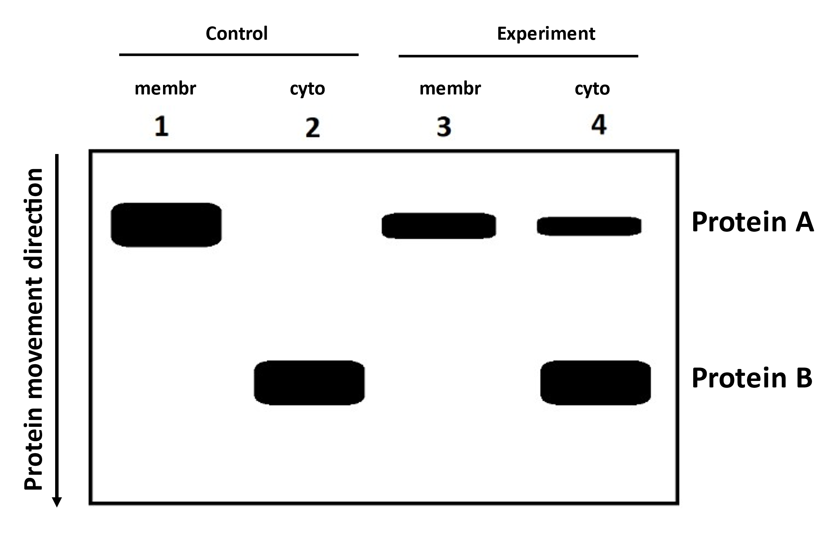
Sample 1 – membrane fraction of the control cell culture, Sample 2 – cytoplasmic fraction of the control cell culture, Sample 3 - membrane fraction of the experimental cell culture, Sample 4 – cytoplasmic fraction of the experimental cell culture.
Analyze experiment results and for each of the following statements indicate whether it is true or false:

Variant 1:
  - Protein B has lower molecular weight than protein A;
  - Protein B is a mitochondrial protein;
  - Protein B is an ER protein;
  - Protein A changes its localization upon treatment with substance X;
  - Protein A dimerizes upon treatment with substance X;
  - This method does not allow distinguishing between nuclear and mitochondrial proteins;

Variant 2:
  - Protein B has lower molecular weight than protein A;
  - Protein B is a mitochondrial protein;
  - Protein B undergoes rapid degradation in the cytoplasm under normal conditions;
  - Protein A changes its localization upon treatment with substance X;
  - Protein A undergoes limited proteolysis upon treatment with substance X;
  - This method allows distinguishing between mitochondrial and cytoplasmic proteins;

Variant 3:
  - Protein B is an ER protein;
  - Protein B undergoes rapid degradation in the cytoplasm under normal conditions;
  - Protein A changes its localization upon treatment with substance X;
  - Protein A dimerizes upon treatment with substance X;
  - Protein B has a higher molecular weight than Protein A;
  - This method allows distinguishing between mitochondrial and cytoplasmic proteins;

Task ID 52 – 3 points
The common part of the question for all variants:
Lac operon on Escherichia coli is a classical model for gene expression regulation in bacteria.
In E. coli gene lacI codes repressor protein. The protein product of lacI binds the operator, when not bound with lactose. But when there is free lactose in the cell, it is binded by the repressor causing complex dissociation from the operator. LacZ gene encodes β-galactosidase enzyme. Let’s assume that lacI and lacZ gene mutations shut down their protein synthesis. Mutations in promoter and operator destroy protein interactions with these sites. The CAP protein is activated when the level of cAMP in the cell increases due to starvation (in the absence of glucose), which leads to its binding to the CAP site. There is no β-galactosidase synthesis without active CAP-protein. P and O in the diagram below represent, respectively, a promoter and an operator.

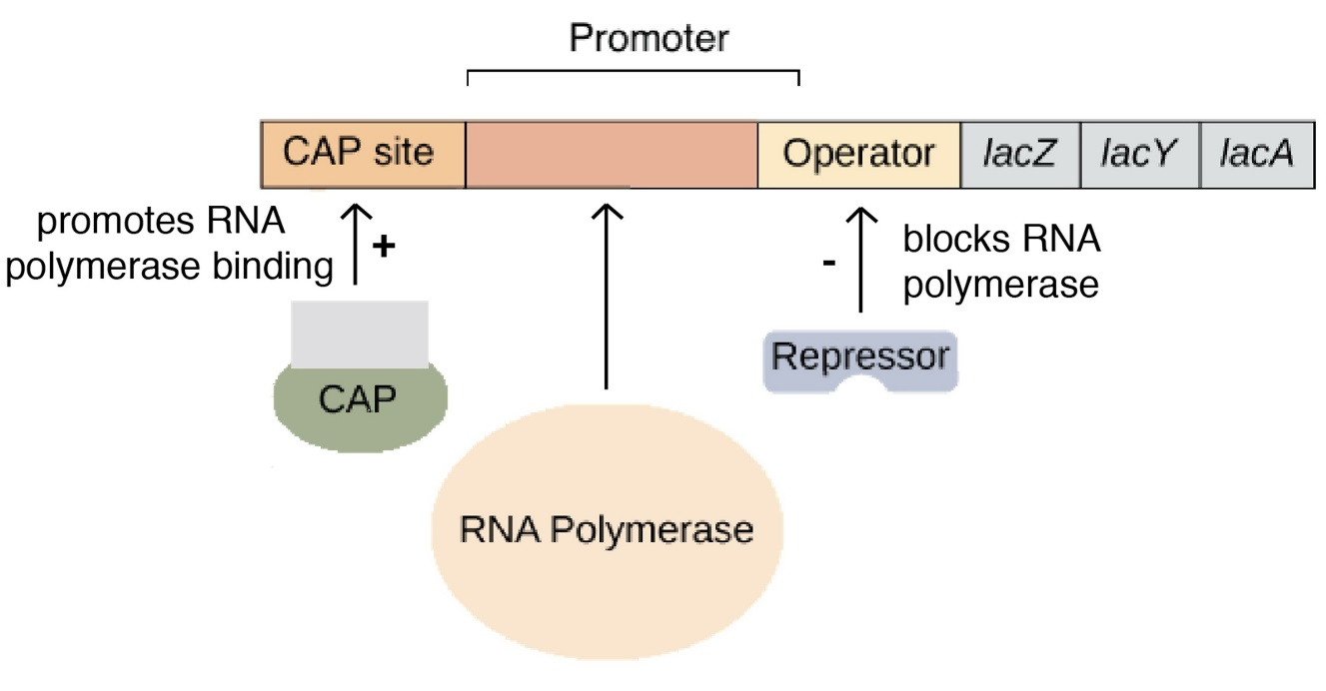

Mark as «true» the conditions under which β-galactosidase enzyme will be synthesized in E. coli cells. Mark the rest of the conditions as «false»:

Variant 1:
  - NO mutations, glucose in environment, lactose in environment;
  - NO mutations, NO glucose in environment, lactose in environment;
  - lacI mutation, glucose in environment, lactose in environment;
  - lacI mutation, NO glucose in environment, NO lactose in environment;
  - lacZ mutation, NO glucose in environment, lactose in environment;
  - O mutation, NO glucose in environment, NO lactose in environment;

Variant 2:
  - NO mutations, glucose in environment, NO lactose in environment;
  - NO mutations, NO glucose in environment, lactose in environment;
  - lacI mutation, NO glucose in environment, lactose in environment;
  - O mutation, glucose in environment, lactose in environment;
  - NO mutations, NO glucose in environment, NO lactose in environment;
  - P mutation, NO glucose in environment, lactose in environment;

Variant 3:
  - NO mutations, NO glucose in environment, lactose in environment;
  - lacI mutation, glucose in environment, lactose in environment;
  - lacI mutation, NO glucose in environment, lactose in environment;
  - O mutation, glucose in environment, lactose in environment;
  - lacI mutation, NO glucose in environment, NO lactose in environment;
  - lacZ mutation, glucose in environment, lactose in environment;

Task ID 53 – 3 points
The common part of the question for all variants:
Nowadays many blood group systems are used in practice, but most popular of them are ABO and MN systems. Your colleagues are investigating two island tribes X and Y. On the picture you can see allele frequencies for this population during the time (T1, T2, T3).

Population X
T1: | T2: | T3:
p(A) = 0,7  p(B) = 0,2  p(0) = 0,1  p(M) = 0,65  p(N) = 0,35 | p(A) = 0,6  p(B) = 0,1  p(0) = 0,3  p(M) = 0,7  p(N) = 0,3 | p(A) = 0,15  p(B) = 0,05  p(0) = 0,8  p(M) = 0,62  p(N) = 0,38

Population Y
T1: | T2: | T3:
p(A) = 0,07  p(B) = 0,9  p(0) = 0,03  p(M) = 0,05  p(N) = 0,95 | p(A) = 0,1  p(B) = 0,9  p(0) = 0  p(M) = 0,2  p(N) = 0,8 | p(A) = 0,15  p(B) = 0,85  p(0) = 0  p(M) = 0,65  p(N) = 0,35

For each of the following statements, indicate whether it is true or false:

Variant 1:
  - Alleles A, B, M, N are in one locus;
  - Population X is in balance for M and N alleles;
  - Data may indicate that there is driving selection to the IV blood group in population Х;
  - Alleles A, B and 0 are not in sexual chromosome;
  - Alleles A, B and 0 – are in the same locus;
  - Population Y is in balance for M and N alleles;

Variant 2:
  - Data may indicate that there is driving selection to the I blood group in population Х;
  - Some Y members may have founded population X;
  - Alleles A, B and 0 – are in the same locus;
  - Allele 0 in population Y might have been lost randomly;
  - Population Y is in balance for M and N alleles;
  - Some X members may have founded population Y;

Variant 3:
  - Data may indicate that there is driving selection to the I blood group in population Х;
  - Population X is in balance for M and N alleles;
  - Alleles M and N are in one locus;
  - Populations X and Y are in balance for M and N alleles;
  - Alleles A, B and 0 – are in the same locus;
  - Population Y is in balance for M and N alleles;
Task ID 54 – 3 points
The common part of the question for all variants:
Mark «true» any statements that indicate that a population has recently been selected for a particular gene. Mark the rest of the statements as «false»:

Variant 1:
  - Reduced nucleotide diversity in this gene;
  - The frequency of synonymous nucleotide substitutions in this gene is higher than non-synonymous nucleotide substitutions;
  - The frequency of non-synonymous nucleotide substitutions in this gene is higher than synonymous nucleotide substitutions;
  - High population size;
  - Low reproduction rate;
  - This gene is highly conserved;

Variant 2:
  - Reduced nucleotide diversity in this gene;
  - The frequency of non-synonymous nucleotide substitutions in this gene is higher than synonymous nucleotide substitutions;
  - Low population size;
  - High reproduction rate;
  - This gene is highly conserved;
  - This gene encodes a protein that is not essential for survival;

Variant 3:
  - Reduced nucleotide diversity in this gene;
  - The frequency of non-synonymous nucleotide substitutions in this gene is higher than synonymous nucleotide substitutions;
  - Synonymous and non-synonymous nucleotide substitutions in this gene occur with the same frequency;
  - High population size;
  - High reproduction rate;
  - This gene encodes a protein that is not essential for survival;

Task ID 55 – 3 points
The common part of the question for all variants:
For each of the following statements about the main trends in the evolution of ontogeny, indicate whether it is true or false:

Variant 1:
  - Reducing the role of environmental factors;
  - Decreased the development sustainability;
  - The emergence of the ability to pass part of the stages under the protection of the maternal organism or egg membranes;
  - Loss of the ability to pass part of the stages under the protection of the maternal organism or egg membranes;
  - Enhancing the integrity of ontogeny;
  - Internal factors of development are replaced by external ones;

Variant 2:
  - Enhancing the role of environmental factors;
  - Enhancing the development sustainability;
  - The emergence of the ability to pass part of the stages under the protection of the maternal organism or egg membranes;
  - Decrease in the integrity of ontogeny;
  - Internal factors of development are replaced by external ones;
  - External environmental factors are replaced by internal mechanisms of development;

Variant 3:
  - Reducing the role of environmental factors;
  - Enhancing the role of environmental factors;
  - Enhancing the development sustainability;
  - Loss of the ability to pass part of the stages under the protection of the maternal organism or egg membranes;
  - Decrease in the integrity of ontogeny;
  - External environmental factors are replaced by internal mechanisms of development;

Part C: Matching Questions

In the tasks of this part, the participants need to analyze various photographs, drawings, diagrams (marked with Arabic numerals) and compare them with elements from the two lists below (marked with Latin letters and Roman numerals). As an answer in each task, the participants must draw arrows between the elements being compared.

Grading system:
For each correctly indicated match between elements of 1 and 2 rows or 1 and 3 rows, the participant receives 0.5 points.
For each incorrect match - 0 points.

Task ID 57 – 5 points
Variant 1
The term «spore» derives from the ancient Greek word and means “seed”. These unicellular structures produced the reproduction and dispersal of most plants and fungi. The origin and structure of spores are very diverse and different in distant taxa. The figures below show the spores of different organisms. Determine the belonging of objects to the Divisions of plants or fungi, and correlate photos with the textual descriptions.

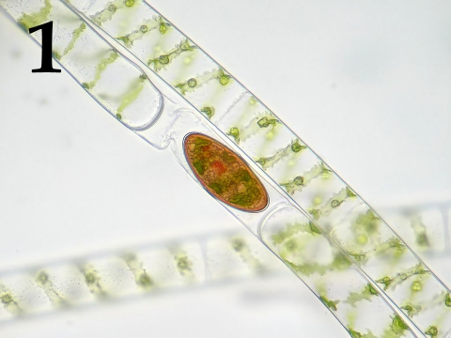 | 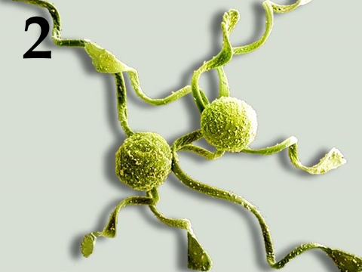 | 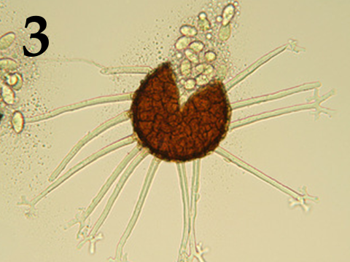
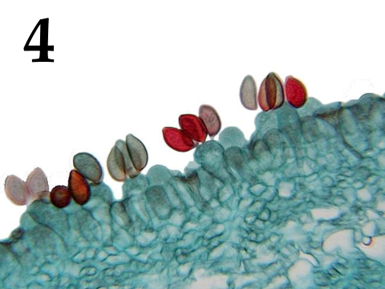 | 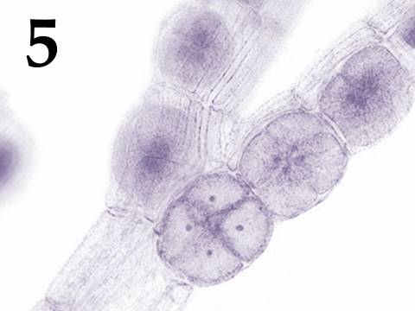

Systematic category (the list is redundant - it contains unnecessary taxa):
- Ascomycota;
- Basidiomycota;
- Chlorophyta (green algae);
- Charophyta;
- Ochrophyta;
- Rhodophyta (red algae);
- Bryophyta (mosses);
- Polypodiophyta (ferns);

List of descriptions:
- Haploid spores with elaters formed in the sporangium because of meiosis;
- Haploid spores formed exogenously because of meiosis of terminal cells of dikaryotic hyphae;
- Haploid spores formed by meiosis within tetrasporangium;
- Diploid zygospores formed because of conjugation;
- Haploid spores formed endogenously within the clestothecium;

Task ID 57 – 5 points
Variant 2
The term «spore» derives from the ancient Greek word and means “seed”. These unicellular structures produced the reproduction and dispersal of most plants and fungi. The origin and structure of spores are very diverse and different in distant taxa. The figures below show the spores of different organisms. Determine the belonging of objects to the Divisions of plants or fungi, and correlate photos with the textual descriptions.

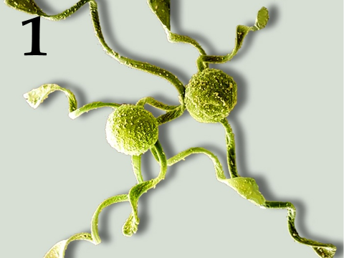 | 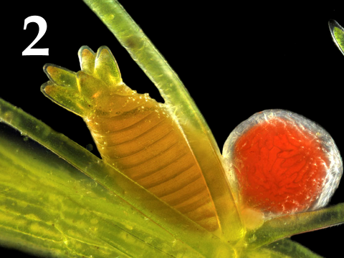 | 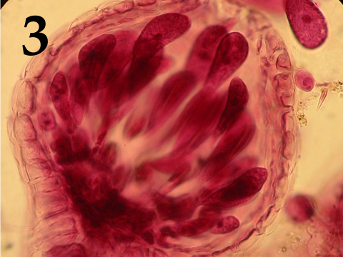
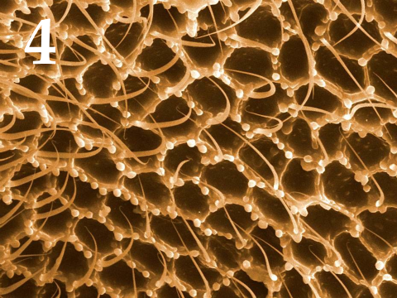 | 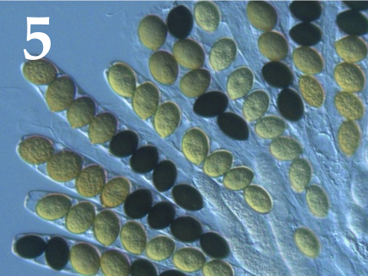

Systematic category (the list is redundant - it contains unnecessary taxa):
- Ascomycota;
- Basidiomycota;
- Chlorophyta (green algae);
- Charophyta;
- Ochrophyta;
- Rhodophyta (red algae);
- Bryophyta (mosses);
- Polypodiophyta (ferns);

List of descriptions:
- The diploid oospore formed because of fertilization within the oogonia;
- Haploid spores with elaters formed in the sporangium because of meiosis;
- Haploid spores formed exogenously because of meiosis of terminal cells of dikaryotic hyphae;
- Large immobile diploid carpospores formed inside the carposporangium because of mitosis;
- Haploid spores formed endogenously inside the sac because of meiosis, followed by a mitotic cell division;

Task ID 57 – 5 points
Variant 3
The term «spore» derives from the ancient Greek word and means “seed”. These unicellular structures produced the reproduction and dispersal of most plants and fungi. The origin and structure of spores are very diverse and different in distant taxa. The figures below show the spores of different organisms. Determine the belonging of objects to the Divisions of plants or fungi, and correlate photos with the textual descriptions.

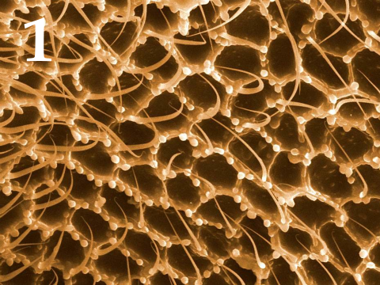 | 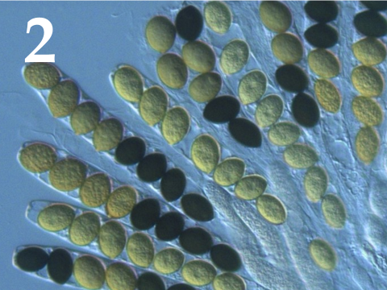 | 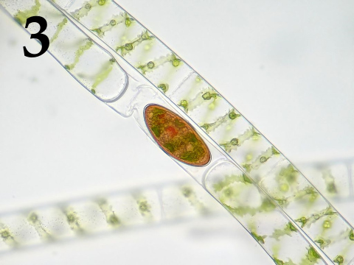
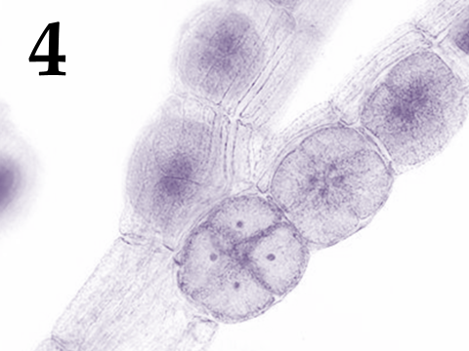 | 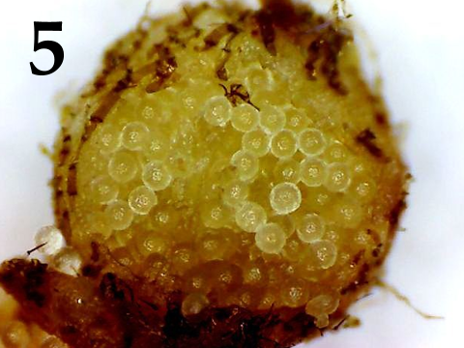

Systematic category (the list is redundant - it contains unnecessary taxa):
- Ascomycota;
- Basidiomycota;
- Chlorophyta (green algae);
- Charophyta;
- Ochrophyta;
- Rhodophyta (red algae);
- Bryophyta (mosses);
- Polypodiophyta (ferns);

List of descriptions:
- Large haploid megaspores formed within the sporocarp because of meiosis;
- Diploid zygospores formed because of conjugation;
- Haploid spores formed endogenously inside the sac because of meiosis, followed by a mitotic cell division;
- Haploid spores formed by meiosis within tetrasporangium;
- Haploid spores formed exogenously because of meiosis of terminal cells of dikaryotic hyphae;

Task ID 59 – 5 points
Variant 1
Mammals have an important feature in addition to feeding their youngsters with milk - the differentiation of teeth by functions. The molars grind food, the premolars help to grab food, tear and grind, the canines tear off pieces of food and hold the prey, the incisors bite.
Environment and type of food that mammal eats determine characteristic of structure of teeth and jaw. Please look at the jaws of different mammals on photos and write to whom they belong, what the animal eats and what kind of life it leads.

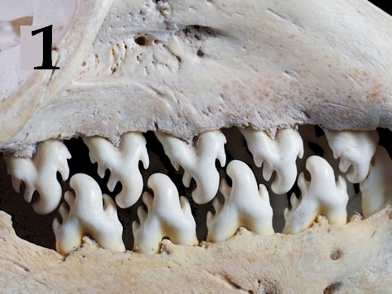 | 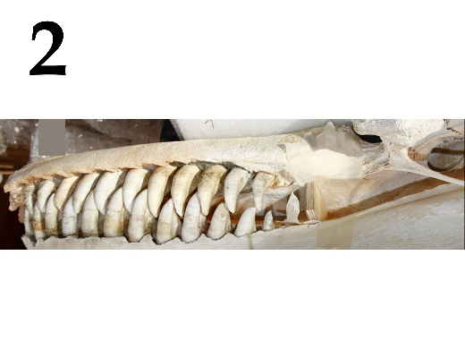 | 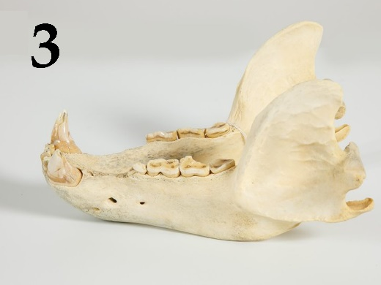
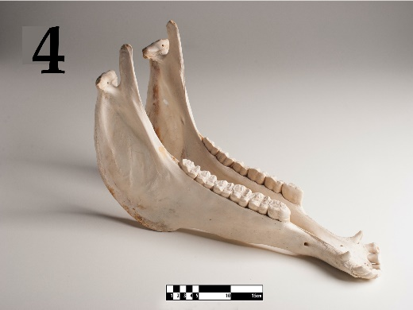 | 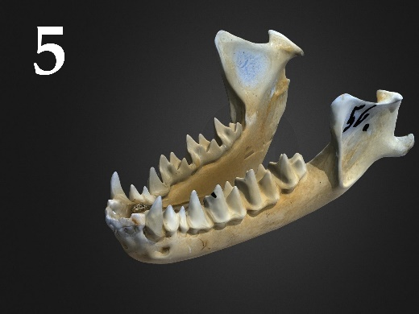

List of animal names (the list is redundant - it contains unnecessary names):
- Wolf (Canis lupus), family Canidae;
- Killer whale (Orcinus orca), family Delphinidae;
- European hedgehog (Erinaceus europaeus), family Erinaceidae;
- Greater mouse-eared bat (Myotis myotis), family Vespertilionidae;
- Cheetah (Acinonyx jubatus), family Felidae;
- Racoon dog (Nyctereutes procyonoides), family Canidae;
- Horse (Equus ferus caballus), family Equidae;
- Cow (Bos taurus), family Bovidae;
- Crabeater seal (Lobodon carcinophaga), family Phocidae;
- Brown bear (Ursus arctos), family Ursidae;

List of characteristics of various animals (the list is redundant - it contains unnecessary characteristics):
- Predator, eats exclusively meat. Hunts from an ambush. The fastest land animal.
- There are 3 ecotypes which have differences in a food ratio, morphology, habitat and behavior: fish-eating (resident and off-shore) and specializing in eating pinnipeds and whales (transit). They are living in a matriarchal family groups.
- Due to its omnivorous nature, this mammal has settled throughout Eurasia. Different populations specialize in eating different types of food - the more northern subspecies are mainly carnivorous, the subspecies of the middle latitudes are mainly eating plant matter, the Far Eastern-North American subspecies feed on fish during the spawning season.
- It has specialization in eating invertebrates – krill.
- Eating exclusively vegetation. They graze in pastures, feed on grains and sedges. The upper jaw has incisors.
- Predator that hunts in groups for ungulates. Lives in packs. It focuses mainly on the sense of smell.
- It specializes in feeding on flying insects. Catches prey using echolocation.

Task ID 59 – 5 points
Variant 2
Mammals have an important feature in addition to feeding their youngsters with milk - the differentiation of teeth by functions. The molars grind food, the premolars help to grab food, tear and grind, the canines tear off pieces of food and hold the prey, the incisors bite.
Environment and type of food that mammal eats determine characteristic of structure of teeth and jaw. Please look at the jaws of different mammals on photos and write to whom they belong, what the animal eats and what kind of life it leads.

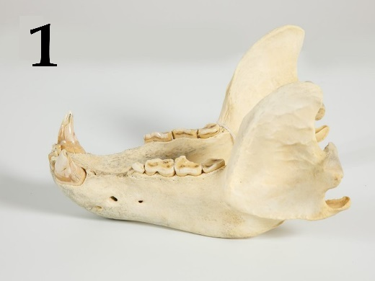 | 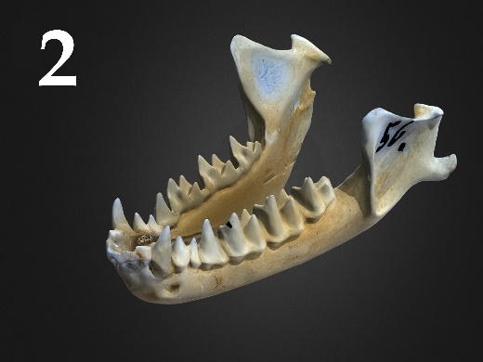 | 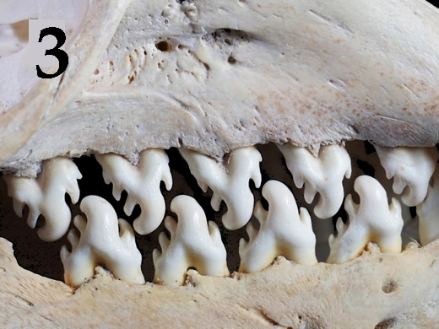
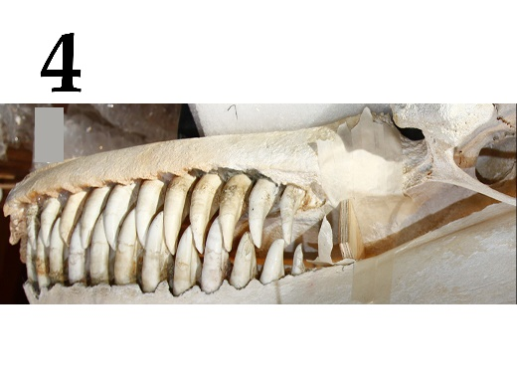 | 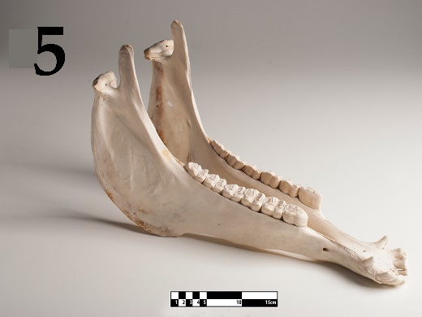

List of animal names (the list is redundant - it contains unnecessary names):
- Wolf (Canis lupus), family Canidae;
- Killer whale (Orcinus orca), family Delphinidae;
- European hedgehog (Erinaceus europaeus), family Erinaceidae;
- Greater mouse-eared bat (Myotis myotis), family Vespertilionidae;
- Cheetah (Acinonyx jubatus), family Felidae;
- Racoon dog (Nyctereutes procyonoides), family Canidae;
- Horse (Equus ferus caballus), family Equidae;
- Cow (Bos taurus), family Bovidae;
- Crabeater seal (Lobodon carcinophaga), family Phocidae;
- Brown bear (Ursus arctos), family Ursidae;

List of characteristics of various animals (the list is redundant - it contains unnecessary characteristics):
- Due to its omnivorous nature, this mammal has settled throughout Eurasia. Different populations specialize in eating different types of food - the more northern subspecies are mainly carnivorous, the subspecies of the middle latitudes are mainly eating plant matter, the Far Eastern-North American subspecies feed on fish during the spawning season.
- There are 3 ecotypes which have differences in a food ratio, morphology, habitat and behavior: fish-eating (resident and off-shore) and specializing in eating pinnipeds and whales (transit). They are living in a matriarchal family groups.
- It has specialization in eating invertebrates – krill.
- Eating exclusively vegetation. They graze in pastures, feed on grains and sedges. The upper jaw has incisors.
- It specializes in feeding on flying insects. Catches prey using echolocation.
- Predator that hunts in groups for ungulates. Lives in packs. It focuses mainly on the sense of smell.
- Predator, eats exclusively meat. Hunts from an ambush. The fastest land animal.

Task ID 59 – 5 points
Variant 3
Mammals have an important feature in addition to feeding their youngsters with milk - the differentiation of teeth by functions. The molars grind food, the premolars help to grab food, tear and grind, the canines tear off pieces of food and hold the prey, the incisors bite.
Environment and type of food that mammal eats determine characteristic of structure of teeth and jaw. Please look at the jaws of different mammals on photos and write to whom they belong, what the animal eats and what kind of life it leads.

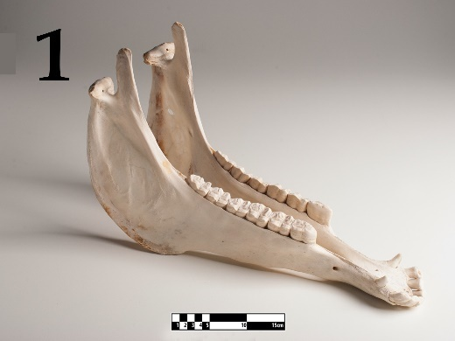 | 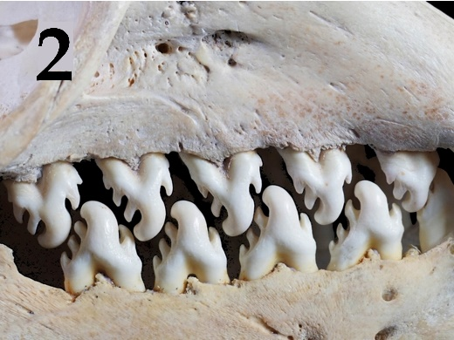 | 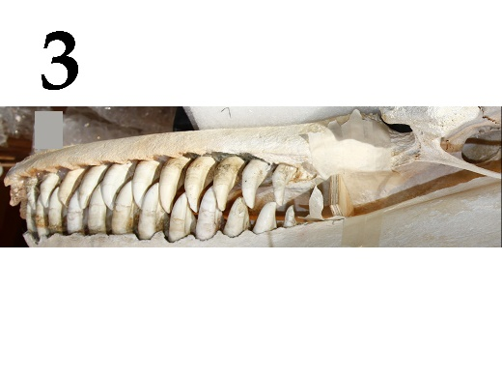
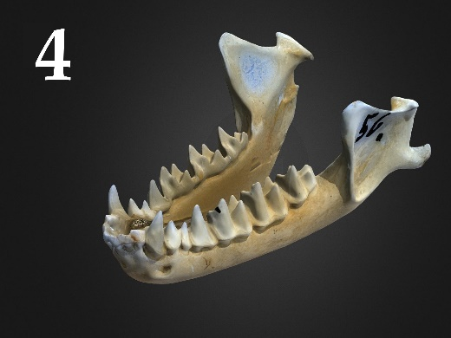 | 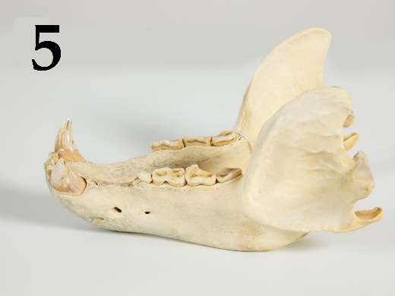

List of animal names (the list is redundant - it contains unnecessary names):
- Wolf (Canis lupus), family Canidae;
- Killer whale (Orcinus orca), family Delphinidae;
- European hedgehog (Erinaceus europaeus), family Erinaceidae;
- Greater mouse-eared bat (Myotis myotis), family Vespertilionidae;
- Cheetah (Acinonyx jubatus), family Felidae;
- Racoon dog (Nyctereutes procyonoides), family Canidae;
- Horse (Equus ferus caballus), family Equidae;
- Cow (Bos taurus), family Bovidae;
- Crabeater seal (Lobodon carcinophaga), family Phocidae;
- Brown bear (Ursus arctos), family Ursidae;

List of characteristics of various animals (the list is redundant - it contains unnecessary characteristics):
- Predator, eats exclusively meat. Hunts from an ambush. The fastest land animal.
- Predator that hunts in groups for ungulates. Lives in packs. It focuses mainly on the sense of smell.
- It specializes in feeding on flying insects. Catches prey using echolocation.
- Eating exclusively vegetation. They graze in pastures, feed on grains and sedges. The upper jaw has incisors.
- It has specialization in eating invertebrates – krill.
- There are 3 ecotypes which have differences in a food ratio, morphology, habitat and behavior: fish-eating (resident and off-shore) and specializing in eating pinnipeds and whales (transit). They are living in a matriarchal family groups.
- Due to its omnivorous nature, this mammal has settled throughout Eurasia. Different populations specialize in eating different types of food - the more northern subspecies are mainly carnivorous, the subspecies of the middle latitudes are mainly eating plant matter, the Far Eastern-North American subspecies feed on fish during the spawning season.

Task ID 60 – 5 points
Variant 1
A human receives information about the external world and internal state of the body through receptors, which leads to activation of reflexes through reflex arcs. Relate elements of reflex arcs to each other.

List of receptor names (sensory cells):
- Inner hair cells of cochlea;
- Baroreceptors of aorta;
- Meissner's corpuscles;
- Сones;
- Olfactory receptors;

List of conducting paths (the list is redundant, it contains unnecessary elements):
- Optic tract;
- Vestibulocochlear nerve;
- Olfactory tract;
- Spinal nerves;
- Trigeminal nerve;
- Glossopharyngeal nerve;
- Vagus nerve;

List of signal processing structure in central nervous system:
- Sensomotor area of cerebral cortex;
- Occipital lobe of cerebral cortex;
- Solitary nucleus (medulla oblongata);
- Septum pellucidum;
- Temporal lobe of cerebral cortex;

Task ID 60 – 5 points
Variant 2
A human receives information about the external world and internal state of the body through receptors, which leads to activation of reflexes through reflex arcs. Relate elements of reflex arcs to each other.

List of receptor names (sensory cells):
- Ruffini corpuscle;
- Outer hair cells of cochlea;
- Olfactory receptors;
- Taste papillae of posterior third of tongue;
- Rod cell;

List of conducting paths (the list is redundant, it contains unnecessary elements):
- Optic tract;
- Vestibulocochlear nerve;
- Olfactory tract;
- Spinal nerves;
- Trigeminal nerve;
- Glossopharyngeal nerve;
- Vagus nerve;

List of signal processing structure in central nervous system:
- Insular lobe of cerebral cortex;
- Sensomotor area of cerebral cortex;
- Temporal lobe of cerebral cortex;
- Septum pellucidum;
- Occipital lobe of cerebral cortex;

Task ID 60 – 5 points
Variant 3
A human receives information about the external world and internal state of the body through receptors, which leads to activation of reflexes through reflex arcs. Relate elements of reflex arcs to each other.

List of receptor names (sensory cells):
- Pain receptors of forehead skin;
- Hair cells of semicircular canals;
- Cones;
- Olfactory receptors;
- Meissner's corpuscles;

List of conducting paths (the list is redundant, it contains unnecessary elements):
- Optic tract;
- Vestibulocochlear nerve;
- Olfactory tract;
- Spinal nerves;
- Trigeminal nerve;
- Glossopharyngeal nerve;
- Vagus nerve;

List of signal processing structure in central nervous system:
- The nucleus of superficial sensitivity of nerve V;
- Cerebellum;
- Sensomotor area of cerebral cortex;
- Occipital lobe of cerebral cortex;
- Septum pellucidum;

Task ID 61 – 5 points
Variant 1
The photographs below show histological sections of five different organs.
Match the histological sections shown in the photographs with the name of the main cell type that can be identified on them and with the appropriate functional characteristic for that cell type.

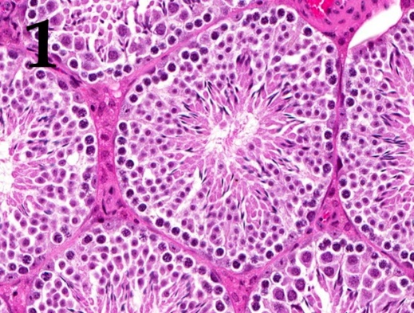 | 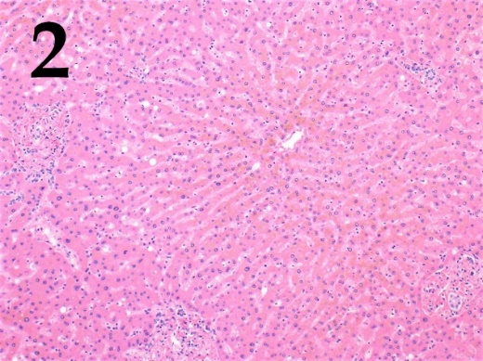 | 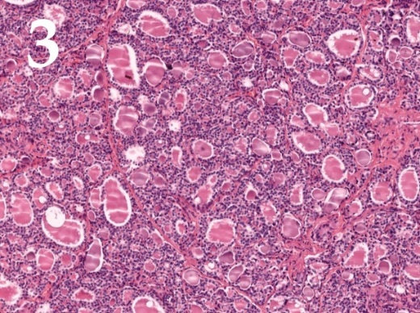
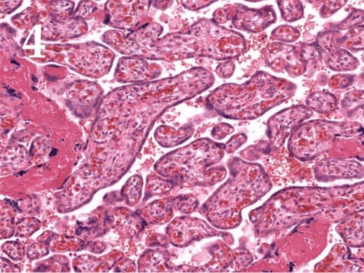 | 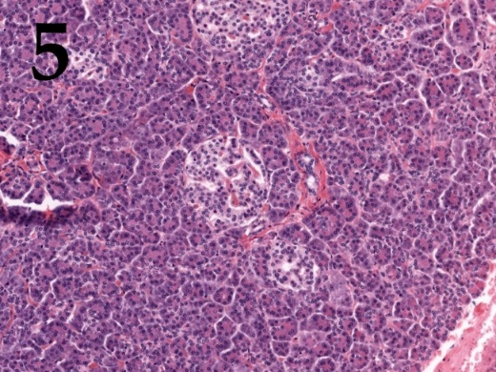

List of cell types (this list is redundant - it contains unnecessary names):
- Kupffer cells (specialized macrophages whose primary role is to remove foreign agents entering hepatic portal system);
- Sertoli cells (cells that provide nourishment to developing germ cells and play important role in endocrine regulation of spermatogenesis);
- Purkinje cells (large inhibitory neurons whose axons constitute the sole output from cerebellar cortex);
- Juxtaglomerular cells (specialized cells within afferent arteriole wall in kidneys that are engaged in arterial pressure regulation);
- Beta-cells (insulin secreting cells);
- Decidual cells (cells that are thought crucial for immune tolerance towards the fetus during pregnancy);
- Follicular cells (cells lining thyroid follicles);
- Parietal cells (hydrochloric acid producing cells).

List of functional characteristics of cells:
- These cells are located in the capillary lumen;
- These cells can be found adjacent to cells that secrete glucagon, somatostatin or ghrelin;
- These cells express follicle-stimulating hormone receptors;
- During embryogenesis these cells develop from endodermal cells near the root of the tongue;
- These cells differentiate from endometrial stromal fibroblasts.

Task ID 61 – 5 points
Variant 2
The photographs below show histological sections of five different organs.
Match the histological sections shown in the photographs with the name of the main cell type that can be identified on them and with the appropriate functional characteristic for that cell type.

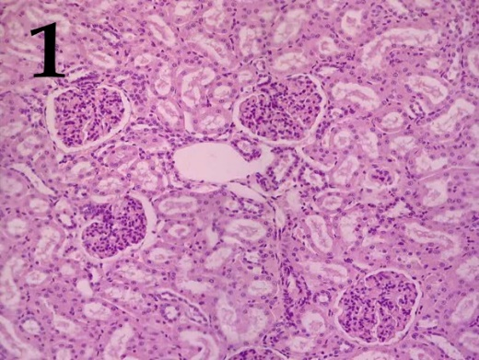 | 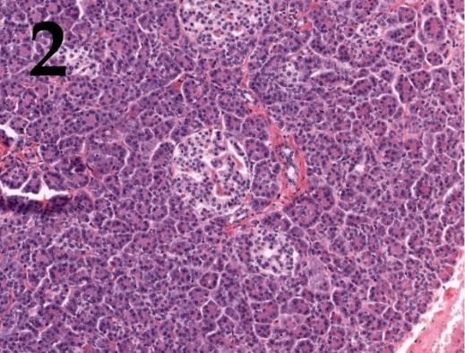 | 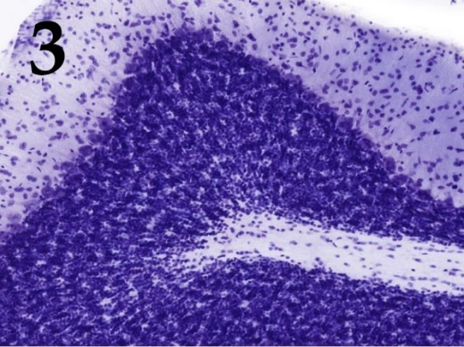
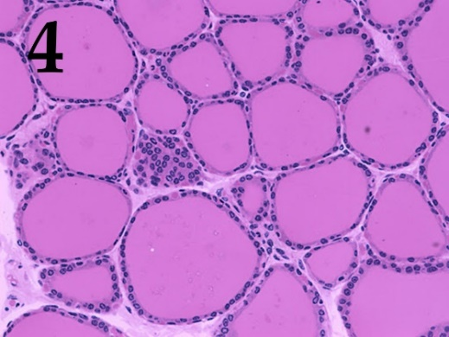 | 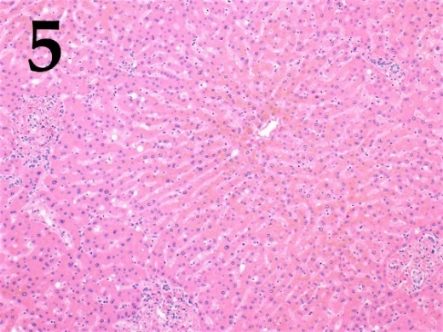

List of cell types (this list is redundant - it contains unnecessary names):
- Kupffer cells (specialized macrophages whose primary role is to remove foreign agents entering hepatic portal system);
- Sertoli cells (cells that provide nourishment to developing germ cells and play important role in endocrine regulation of spermatogenesis);
- Purkinje cells (large inhibitory neurons whose axons constitute the sole output from cerebellar cortex);
- Juxtaglomerular cells (specialized cells within afferent arteriole wall in kidneys that are engaged in arterial pressure regulation);
- Beta-cells (insulin secreting cells);
- Decidual cells (cells that are thought crucial for immune tolerance towards the fetus during pregnancy);
- Follicular cells (cells lining thyroid follicles);
- Parietal cells (hydrochloric acid producing cells).

List of functional characteristics of cells:
- These cells are specialized smooth muscle cells;
- These cells express major histocompatibility complex class II molecules;
- These cells can be found adjacent to cells that secrete glucagon, somatostatin or ghrelin;
- These cells have ectodermal origin.
- The secretory activity of these cells is regulated by hypophysis.

Task ID 61 – 5 points
Variant 3
The photographs below show histological sections of five different organs.
Match the histological sections shown in the photographs with the name of the main cell type that can be identified on them and with the appropriate functional characteristic for that cell type.

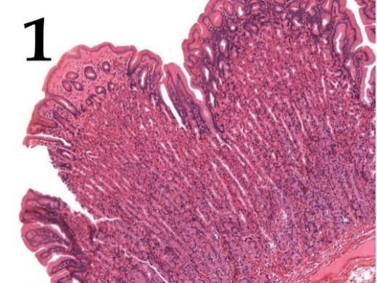 | 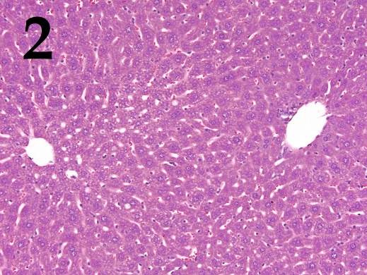 | 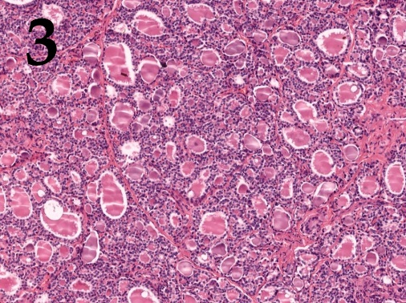
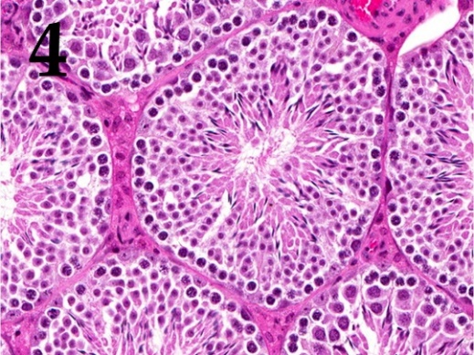 | 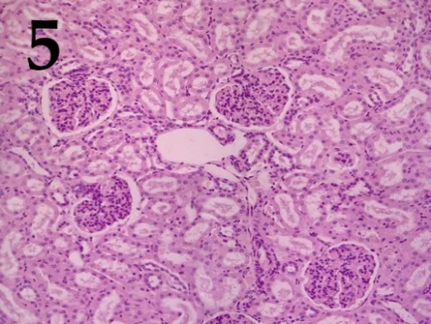

List of cell types (this list is redundant - it contains unnecessary names):
- Kupffer cells (specialized macrophages whose primary role is to remove foreign agents entering hepatic portal system);
- Sertoli cells (cells that provide nourishment to developing germ cells and play important role in endocrine regulation of spermatogenesis);
- Purkinje cells (large inhibitory neurons whose axons constitute the sole output from cerebellar cortex);
- Juxtaglomerular cells (specialized cells within afferent arteriole wall in kidneys that are engaged in arterial pressure regulation);
- Beta-cells (insulin secreting cells);
- Decidual cells (cells that are thought crucial for immune tolerance towards the fetus during pregnancy);
- Follicular cells (cells lining thyroid follicles);
- Parietal cells (hydrochloric acid producing cells).

List of functional characteristics of cells:
- During peak secretory activity the apical membrane surface of these cells is dramatically expanded by fusion of preformed vesicles with plasma membrane;
- These cells play a vital role in maintaining blood-tissue barrier in the organ they reside in;
- These cells are specialized smooth muscle cells;
- During embryogenesis these cells originate between first and second pharyngeal pouches;
- These cells express major histocompatibility complex class II molecules;

Task ID 62 – 5 points
Variant 1
Functional activity and structure of protein is usually regulated by posttranslational modifications. In the pictures below some of the modified aminoacids are presented. Compare the formulas of modified amino acids with their names and with their role in functional activity of proteins in cell.

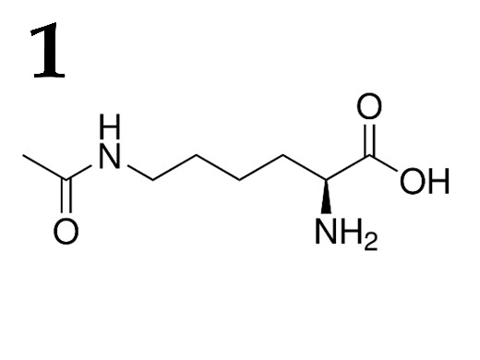 | 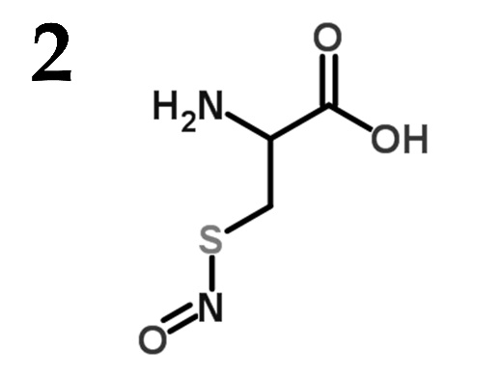 | 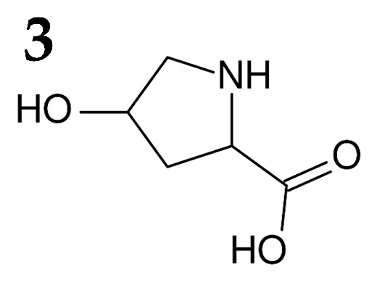
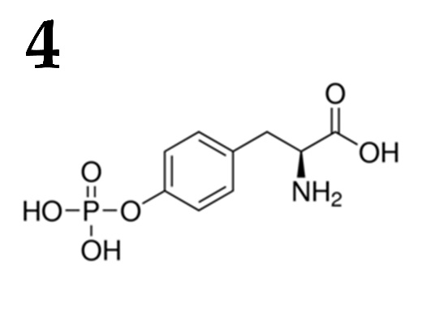 | 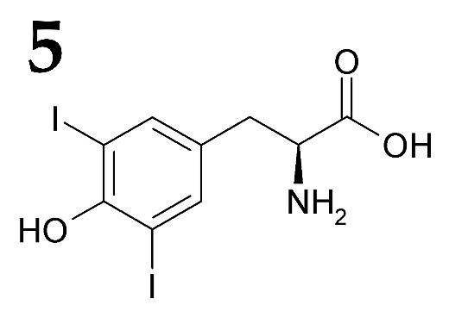

List of modified amino acids (the list is redundant - it contains unnecessary names):
- Diiodotyrosine;
- 4-Hydroxyproline;
- N-acetylglucosamine threonine;
- Acetyl lysine;
- Gamma-carboxyglutamic acid;
- S-Nitrosocysteine;
- O-Phosphotyrosine;
- Phosphoserine;

List of functions for amino acids with various post-translational modifications (the list is redundant - it contains unnecessary descriptions):
- Acts as a part of signal transducing pathway during insulin receptor activation;
- Blocks some of phosphorylation sites in protein;
- Decreases positive charge of a protein, participates in chromatin remodeling;
- Binds calcium ion with great affinity, participates in the blood coagulation process;
- During ischemia acts as a potent vasodilatation factor;
- Participates in correct collagen structure assembly;
- Regulated phosphorylase b kinase;
- Acts as a precursor in the synthesis of potent metabolic hormone;

Task ID 62 – 5 points
Variant 2
Functional activity and structure of protein is usually regulated by posttranslational modifications. In the pictures below some of the modified aminoacids are presented. Compare the formulas of modified amino acids with their names and with their role in functional activity of proteins in cell.

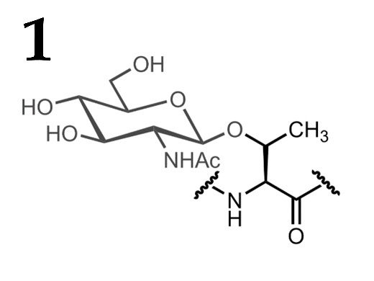 | 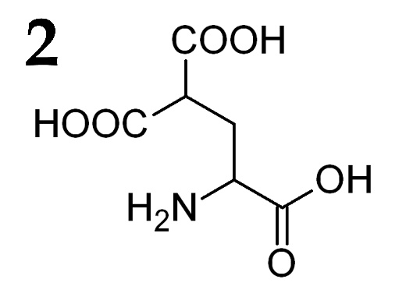 | 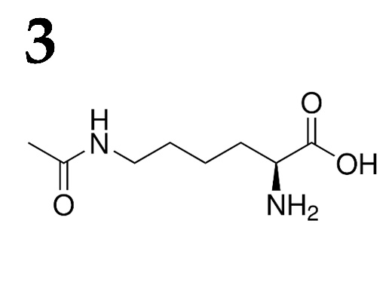
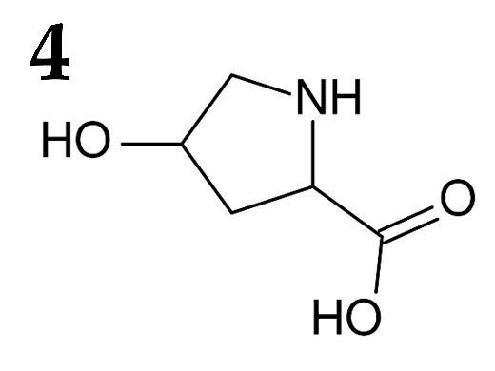 | 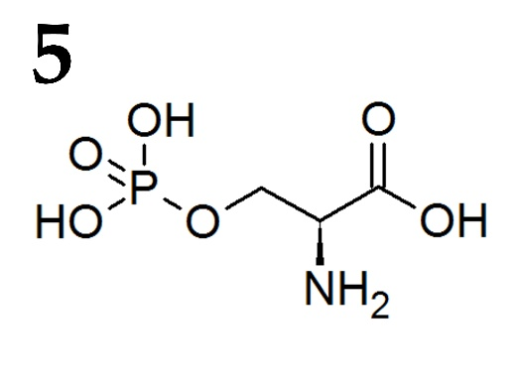

List of modified amino acids (the list is redundant - it contains unnecessary names):
- Diiodotyrosine;
- 4-Hydroxyproline;
- N-acetylglucosamine threonine;
- Acetyl lysine;
- Gamma-carboxyglutamic acid;
- S-Nitrosocysteine;
- O-Phosphotyrosine;
- Phosphoserine;

List of functions for amino acids with various post-translational modifications (the list is redundant - it contains unnecessary descriptions):
- Acts as a part of signal transducing pathway during insulin receptor activation;
- Blocks some of phosphorylation sites in protein;
- Decreases positive charge of a protein, participates in chromatin remodeling;
- Binds calcium ion with great affinity, participates in the blood coagulation process;
- During ischemia acts as a potent vasodilatation factor;
- Participates in correct collagen structure assembly;
- Regulated phosphorylase b kinase;
- Acts as a precursor in the synthesis of potent metabolic hormone;

Task ID 62 – 5 points
Variant 3
Functional activity and structure of protein is usually regulated by posttranslational modifications. In the pictures below some of the modified aminoacids are presented. Compare the formulas of modified amino acids with their names and with their role in functional activity of proteins in cell.

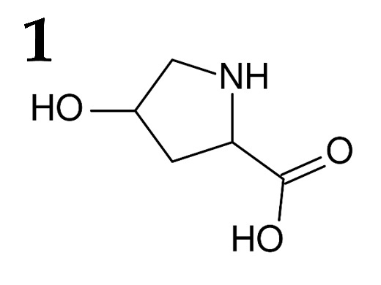 | 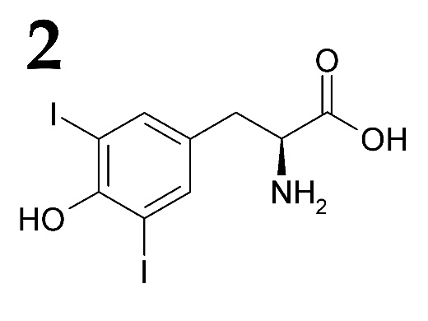 | 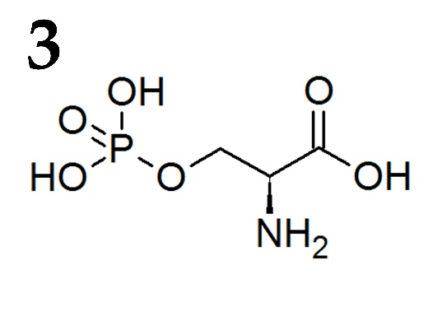
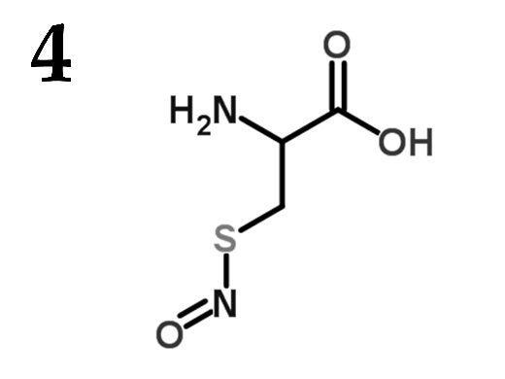 | 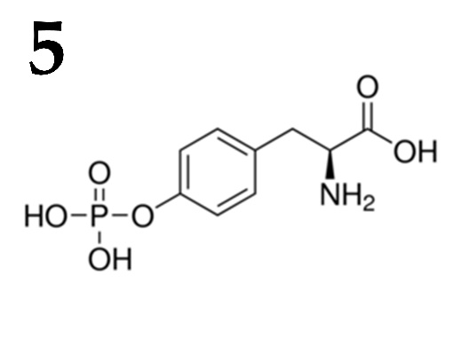

List of modified amino acids (the list is redundant - it contains unnecessary names):
- Diiodotyrosine;
- 4-Hydroxyproline;
- N-acetylglucosamine threonine;
- Acetyl lysine;
- Gamma-carboxyglutamic acid;
- S-Nitrosocysteine;
- O-Phosphotyrosine;
- Phosphoserine;

List of functions for amino acids with various post-translational modifications (the list is redundant - it contains unnecessary descriptions):
- Acts as a part of signal transducing pathway during insulin receptor activation;
- Blocks some of phosphorylation sites in protein;
- Decreases positive charge of a protein, participates in chromatin remodeling;
- Binds calcium ion with great affinity, participates in the blood coagulation process;
- During ischemia acts as a potent vasodilatation factor;
- Participates in correct collagen structure assembly;
- Regulated phosphorylase b kinase;
- Acts as a precursor in the synthesis of potent metabolic hormone;

Task ID 63 – 5 points
Variant 1
The molecular biologist uses a variety of methods. Match pictures illustrating different methods with their names and possible tasks for which researcher can use these methods.

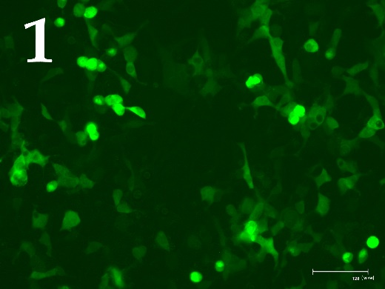 | 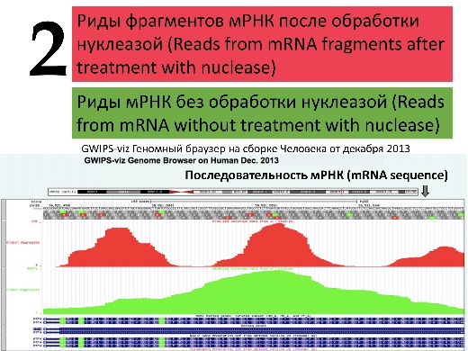 | 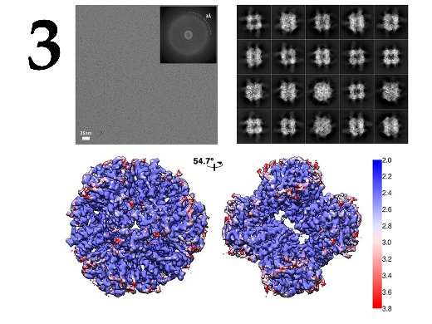
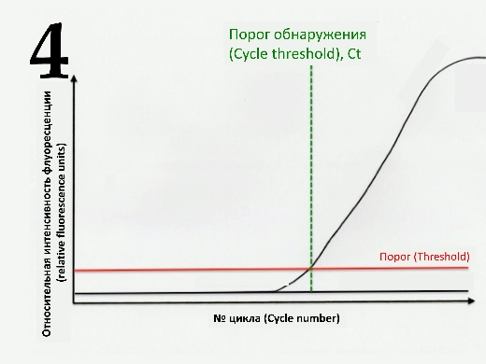 | 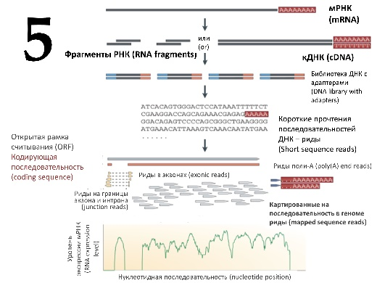

List of methods (this list is redundant - it contains unnecessary names):
- Fluorescence microscopy;
- Sanger DNA sequencing;
- Enzyme-linked immunosorbent assay (ELISA);
- Real-time PCR;
- Ribosome profiling;
- Western blotting;
- RNA-seq with next-generation sequencing (NGS);
- Mass spectrometry;
- PCR with endpoint detection using DNA electrophoresis;
- Cryoelectron microscopy;

List of researcher’s tasks (this list is redundant - it contains unnecessary tasks):
- High-precision quantification of the C-reactive protein level in the murine serum;
- Genome-wide analysis of the transcriptome of the cells treated with an mTOR inhibitor in comparison with control cells;
- Verification of the nucleotide sequence in the target molecular genetic construct obtained by the researcher;
- Evaluation of the transfection efficiency of HEK293T cells with a plasmid carrying the EGFP gene;
- Qualitative analysis of E. coli colonies for the presence of a target insert in the desired molecular genetic construct;
- Quantification of the decrease in the expression of the IGBP1 (insulin-like growth factor binding protein 1) gene at the level of transcription in cells treated with 10 μM dexamethasone;
- Obtaining the structure of the protein of interest;
- Identification of specific partner proteins of the protein under study, obtained as a result of target protein immunoprecipitation from cells under native conditions;
- Genome-wide search for translated open reading frames in mRNA;
- Qualitative assessment of the decrease in the expression of the target protein upon siRNA-mediated knockdown;

Task ID 63 – 5 points
Variant 2
The molecular biologist uses a variety of methods. Match pictures illustrating different methods with their names and possible tasks for which researcher can use these methods.

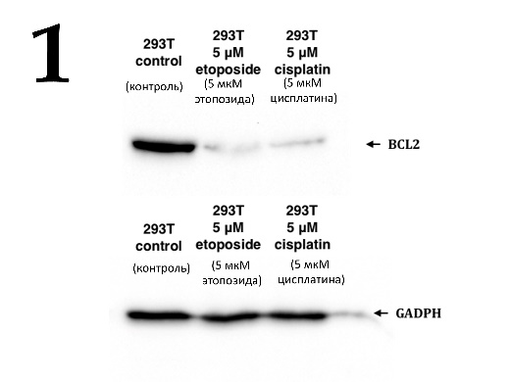 | 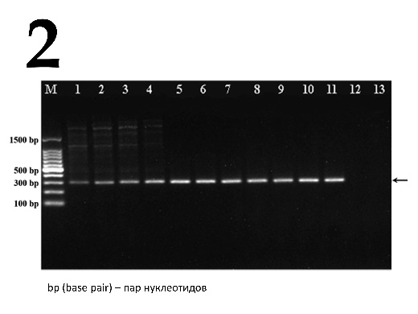 | 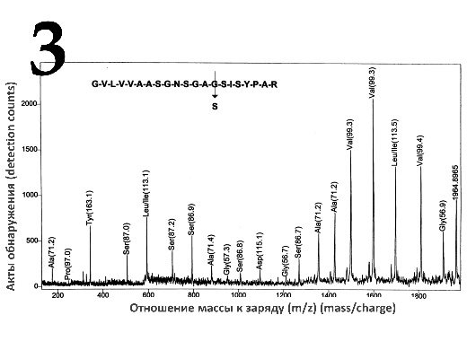
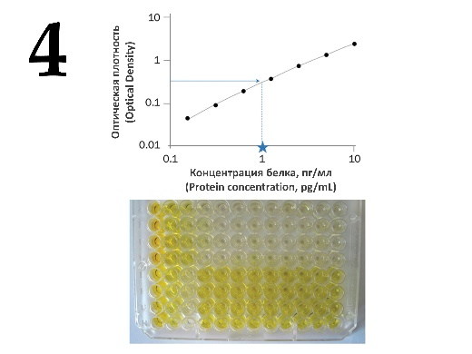 | 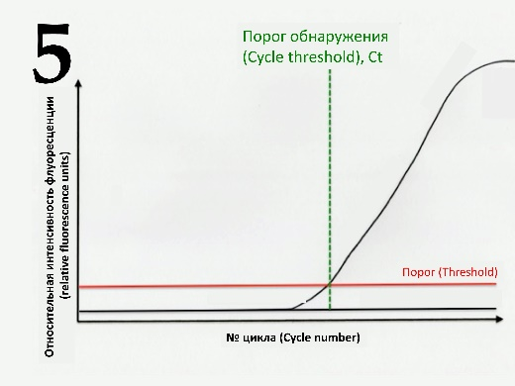

List of methods (this list is redundant - it contains unnecessary names):
- Fluorescence microscopy;
- Sanger DNA sequencing;
- Enzyme-linked immunosorbent assay (ELISA);
- Real-time PCR;
- Ribosome profiling;
- Western blotting;
- RNA-seq with next-generation sequencing (NGS);
- Mass spectrometry;
- PCR with endpoint detection using DNA electrophoresis;
- Cryoelectron microscopy;

List of researcher’s tasks (this list is redundant - it contains unnecessary tasks):
- High-precision quantification of the C-reactive protein level in the murine serum;
- Genome-wide analysis of the transcriptome of the cells treated with an mTOR inhibitor in comparison with control cells;
- Verification of the nucleotide sequence in the target molecular genetic construct obtained by the researcher;
- Evaluation of the transfection efficiency of HEK293T cells with a plasmid carrying the EGFP gene;
- Qualitative analysis of E. coli colonies for the presence of a target insert in the desired molecular genetic construct;
- Quantification of the decrease in the expression of the IGBP1 (insulin-like growth factor binding protein 1) gene at the level of transcription in cells treated with 10 μM dexamethasone;
- Obtaining the structure of the protein of interest;
- Identification of specific partner proteins of the protein under study, obtained as a result of target protein immunoprecipitation from cells under native conditions;
- Genome-wide search for translated open reading frames in mRNA;
- Qualitative assessment of the decrease in the expression of the target protein upon siRNA-mediated knockdown;

Task ID 63 – 5 points
Variant 3
The molecular biologist uses a variety of methods. Match pictures illustrating different methods with their names and possible tasks for which researcher can use these methods.

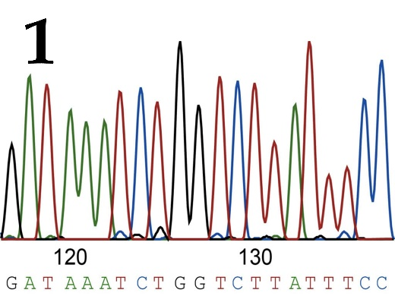 | 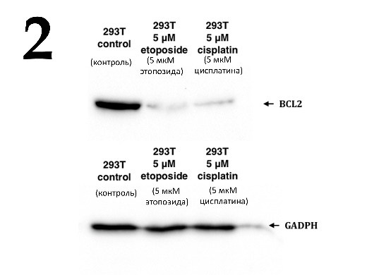 | 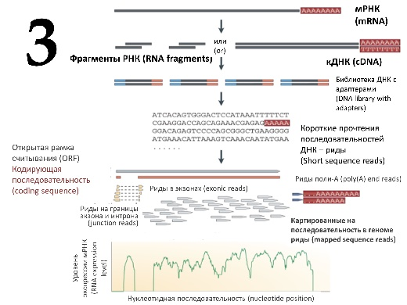
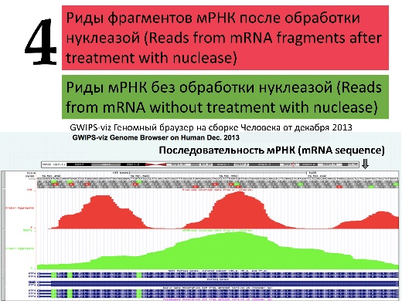 | 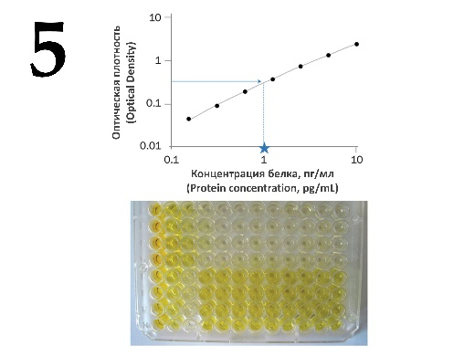

List of methods (this list is redundant - it contains unnecessary names):
- Fluorescence microscopy;
- Sanger DNA sequencing;
- Enzyme-linked immunosorbent assay (ELISA);
- Real-time PCR;
- Ribosome profiling;
- Western blotting;
- RNA-seq with next-generation sequencing (NGS);
- Mass spectrometry;
- PCR with endpoint detection using DNA electrophoresis;
- Cryoelectron microscopy;

List of researcher’s tasks (this list is redundant - it contains unnecessary tasks):
- High-precision quantification of the C-reactive protein level in the murine serum;
- Genome-wide analysis of the transcriptome of the cells treated with an mTOR inhibitor in comparison with control cells;
- Verification of the nucleotide sequence in the target molecular genetic construct obtained by the researcher;
- Evaluation of the transfection efficiency of HEK293T cells with a plasmid carrying the EGFP gene;
- Qualitative analysis of E. coli colonies for the presence of a target insert in the desired molecular genetic construct;
- Quantification of the decrease in the expression of the IGBP1 (insulin-like growth factor binding protein 1) gene at the level of transcription in cells treated with 10 μM dexamethasone;
- Obtaining the structure of the protein of interest;
- Identification of specific partner proteins of the protein under study, obtained as a result of target protein immunoprecipitation from cells under native conditions;
- Genome-wide search for translated open reading frames in mRNA;
- Qualitative assessment of the decrease in the expression of the target protein upon siRNA-mediated knockdown;

Task ID 64 – 5 points
Variant 1
These images were obtained from scanning electron microscope. Define cells on them and correlate each type of cells with disease linked with their dysregulation:

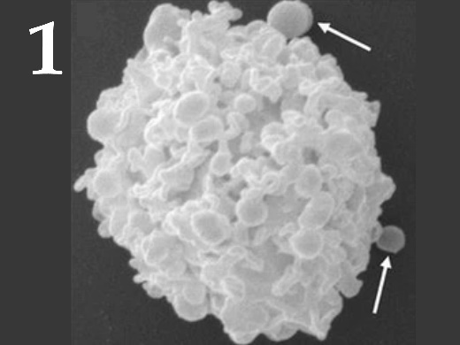 | 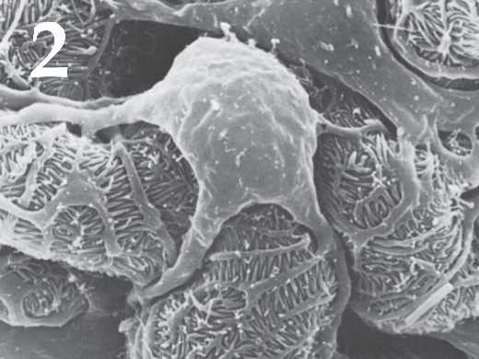 | 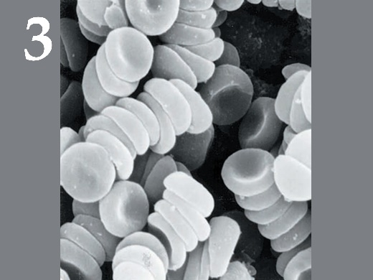
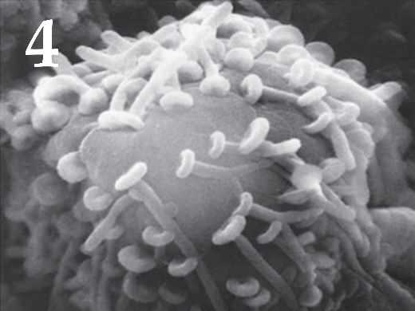 | 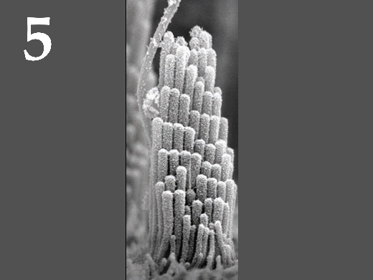

List of cell types (the list is redundant - it contains unnecessary names):
- Podocyte;
- Neuron;
- Erythrocyte;
- Hair cell;
- Mast cell;
- Ciliary epitheliocyte of the trachea;

List of diseases associated with a malfunction of this type of cells (the list is redundant - it contains unnecessary names):
- Haemophilia;
- Hearing loss;
- Kidney failure;
- Allergy;
- Parkinson disease;
- Bronchopulmonary diseases;

Task ID 64 – 5 points
Variant 2
These images were obtained from scanning electron microscope. Define cells on them and correlate each type of cells with disease linked with their dysregulation:

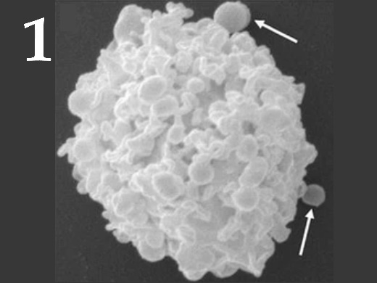 | 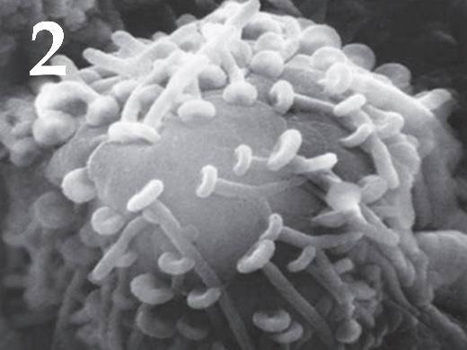 | 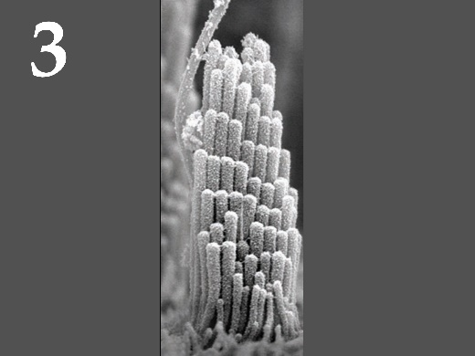
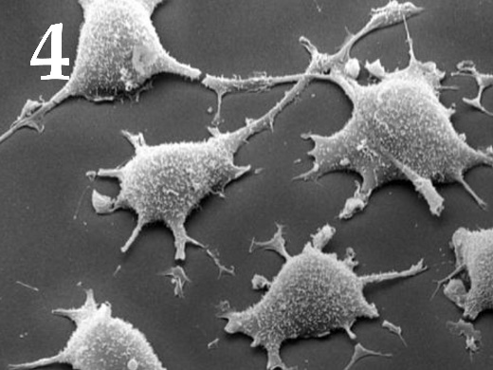 | 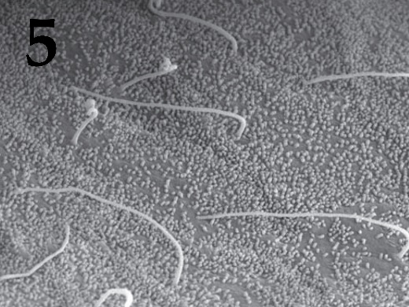

List of cell types (the list is redundant - it contains unnecessary names):
- Podocyte;
- Neuron;
- Hair cell;
- Fibroblast;
- Mast cell;
- Cholangiocyte (bile duct lining cell);

List of diseases associated with a malfunction of this type of cells (the list is redundant - it contains unnecessary names):
- Hearing loss;
- Fibrosis;
- Primary biliary cirrhosis;
- Allergy;
- Parkinson disease;
- Kidney failure;

Task ID 64 – 5 points
Variant 3
These images were obtained from scanning electron microscope. Define cells on them and correlate each type of cells with disease linked with their dysregulation:

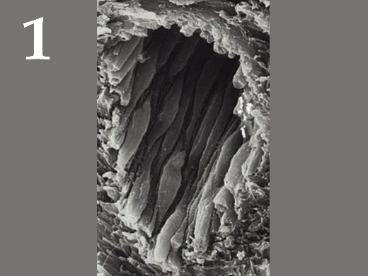 | 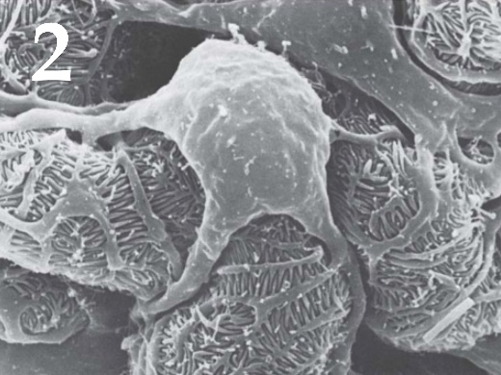 | 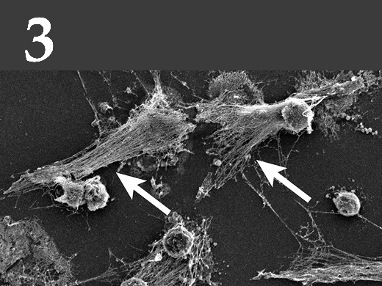
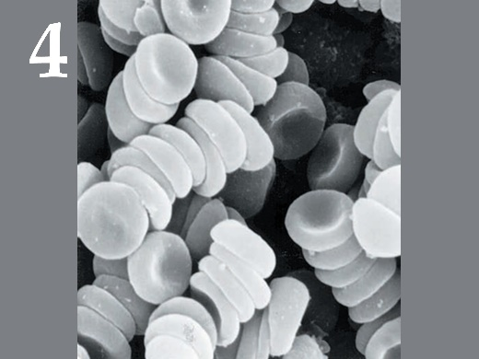 | 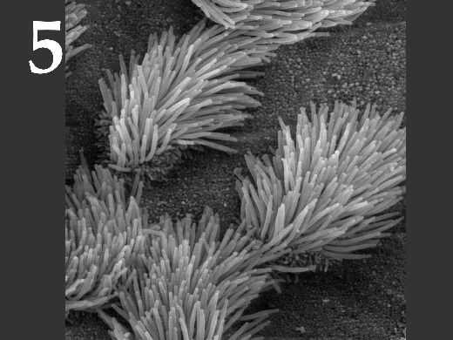

List of cell types (the list is redundant - it contains unnecessary names):
- Podocyte;
- Neuron;
- Endotheliocyte;
- Erythrocyte;
- Neutrophil;
- Ciliary epitheliocyte of the trachea;

List of diseases associated with a malfunction of this type of cells (the list is redundant - it contains unnecessary names):
- Haemophilia;
- Kidney failure;
- Bronchopulmonary diseases;
- Systemic lupus erythematosus;
- Atherosclerosis;
- Parkinson disease;

Task ID 65 – 5 points
Variant 1
Drosophila melanogaster is a model object in modern genetics. Fly sex is determined not like in humans, but it depends on the sex chromosomes to autosome ratio.

Sex chromosomes | Number of autosome sets | Sexual phenotype
XX | 2 | Female
XY | 2 | Male
X0 | 2 | Male
XXY | 2 | Female
XXX | 2 | SuperFemale
XXXY | 2 | SuperFemale
XX | 3 | Intersex
X0 | 3 | SuperMale
XXXX | 3 | SuperFemale

You have received the metaphase chromosomes samples from your collaborators. In the corresponding letter is written that this samples are treated with fluorescent DNA oligonucleotide probes (FISH technology).

Oligonucleotide probe name | Oligonucleotide probe sequence | Conjugated fluorescent dye
Olig1 | 5’TCTAGCTCCTGGACTTTGCT 3’ | Alexa488
Olig2 | 5’TTCTATTTTAATTTGTTGTT 3’ | AMCA
Olig3 | 5’AGACAAGGGGAAGCGCTTGG 3’ | Cy5
Olig4 | 5’ATGAAATGCCGTTGGTTTTG 3’ | TRITC

Blasting the oligos you found the drosophila genome parts where this oligos may be complement.

X chromosome (beginning): | 5’CCTTCTAGCTCCTGGACTTTGCTCAACAGCTTTTGCAACTGCAATC 3’  3’GGAAGATCGAGGACCTGAAACGACTTGTCGAAAACGTTGACGTTAG 5’
X chromosome (end): | 5’CGCCAAGCGCTTCCCCTTGTCTCAGTCCATCGAGCAACGCCCCAA 3’  3’GCGGTTCGCGAAGGGGAACAGAGTCAGGTAGCTCGTTGCGGGGTT 5’
Y chromosome (beginning): | 5’TTCCATCTAGCTGTTGCATACTTCTATTTTAATTTGTTGTTTACTA 3’  3’AAGGTAGATCGACAACGTATGAAGATAAAATTAAACAACAAATGAT 5’
Y chromosome (end): | 5’GATCCGTTATCCTGTTGAAATGTCCAAAACCAACGGCATTTCATC 3’  3’CTAGGCAATAGGACAACTTTACAGGTTTTGGTTGCCGTAAAGTAG 5’

This morning you saw some posters on the lab freezers, there may be some valuable information about excitation and emission spectra for different fluorescent dyes.

Dye Name | Maximum exitation, nm | Maximum emission, nm
Alexa488 | 493 | 517
AMCA | 399 | 446
Cy5 | 649 | 670
TRITC | 550 | 580

Wavelength, nm | Color
620-700 | Red
590-620 | Orange
540-690 | Yellow
500-540 | Green
470-500 | Ligh Blue
430-470 | Dark Blue

Using fluorescent microscope, you have obtained images of the cells in the red, yellow, green and blue fluorescent channels. Every time you used the maximum excitation wavelength for each dye. For each cell, you joined all channels in one multichannel picture. On the pictures below you can see such multicolor metaphase nuclei pictures form different drosophilas from your collaborators. The number of autosome sets for the fly is also written on each picture (for example N=2 means 2 autosome sets).
For each photo define karyotype and the sexual phenotype of the fly.

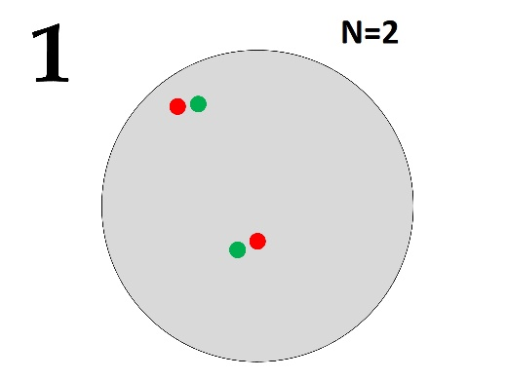 | 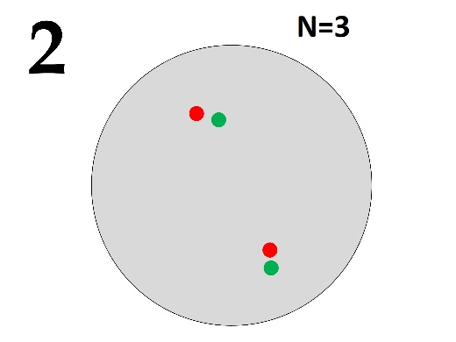 | 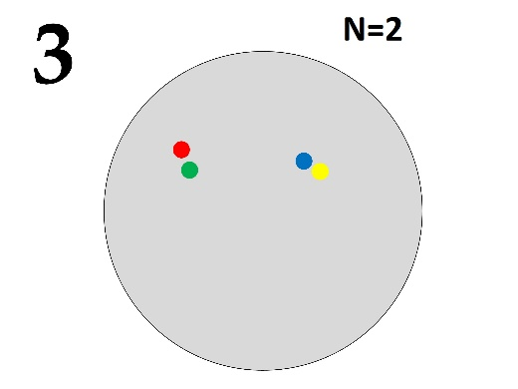
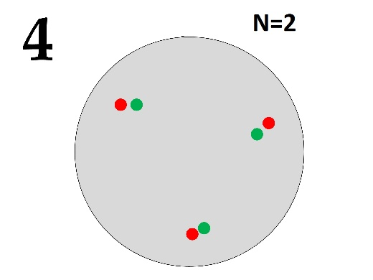 | 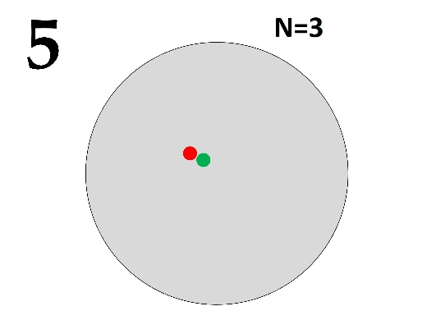

A set of sex chromosomes (the list is redundant - it contains extra options, some options may correspond to several different flies at the same time):
- XX;
- XXX;
- X0;
- XY;
- XXXX;
- XXY;

List of drosophila phenotype by sex:
- SuperMale;
- Male;
- Female;
- Intersex;
- SuperFemale;

Task ID 65 – 5 points
Variant 2
Drosophila melanogaster is a model object in modern genetics. Fly sex is determined not like in humans, but it depends on the sex chromosomes to autosome ratio.

Sex chromosomes | Number of autosome sets | Sexual phenotype
XX | 2 | Female
XY | 2 | Male
X0 | 2 | Male
XXY | 2 | Female
XXX | 2 | SuperFemale
XXXY | 2 | SuperFemale
XX | 3 | Intersex
X0 | 3 | SuperMale
XXXX | 3 | SuperFemale

You have received the metaphase chromosomes samples from your collaborators. In the corresponding letter is written that this samples are treated with fluorescent DNA oligonucleotide probes (FISH technology).

Oligonucleotide probe name | Oligonucleotide probe sequence | Conjugated fluorescent dye
Olig1 | 5’TCTAGCTCCTGGACTTTGCT 3’ | Alexa488
Olig2 | 5’TTCTATTTTAATTTGTTGTT 3’ | AMCA
Olig3 | 5’AGACAAGGGGAAGCGCTTGG 3’ | Cy5
Olig4 | 5’ATGAAATGCCGTTGGTTTTG 3’ | TRITC

Blasting the oligos you found the drosophila genome parts where this oligos may be complement.

X chromosome (beginning): | 5’CCTTCTAGCTCCTGGACTTTGCTCAACAGCTTTTGCAACTGCAATC 3’  3’GGAAGATCGAGGACCTGAAACGACTTGTCGAAAACGTTGACGTTAG 5’
X chromosome (end): | 5’CGCCAAGCGCTTCCCCTTGTCTCAGTCCATCGAGCAACGCCCCAA 3’  3’GCGGTTCGCGAAGGGGAACAGAGTCAGGTAGCTCGTTGCGGGGTT 5’
Y chromosome (beginning): | 5’TTCCATCTAGCTGTTGCATACTTCTATTTTAATTTGTTGTTTACTA 3’  3’AAGGTAGATCGACAACGTATGAAGATAAAATTAAACAACAAATGAT 5’
Y chromosome (end): | 5’GATCCGTTATCCTGTTGAAATGTCCAAAACCAACGGCATTTCATC 3’  3’CTAGGCAATAGGACAACTTTACAGGTTTTGGTTGCCGTAAAGTAG 5’

This morning you saw some posters on the lab freezers, there may be some valuable information about excitation and emission spectra for different fluorescent dyes.

Dye Name | Maximum exitation, nm | Maximum emission, nm
Alexa488 | 493 | 517
AMCA | 399 | 446
Cy5 | 649 | 670
TRITC | 550 | 580

Wavelength, nm | Color
620-700 | Red
590-620 | Orange
540-690 | Yellow
500-540 | Green
470-500 | Ligh Blue
430-470 | Dark Blue

Using fluorescent microscope, you have obtained images of the cells in the red, yellow, green and blue fluorescent channels. Every time you used the maximum excitation wavelength for each dye. For each cell, you joined all channels in one multichannel picture. On the pictures below you can see such multicolor metaphase nuclei pictures form different drosophilas from your collaborators. The number of autosome sets for the fly is also written on each picture (for example N=2 means 2 autosome sets).
For each photo define karyotype and the sexual phenotype of the fly.

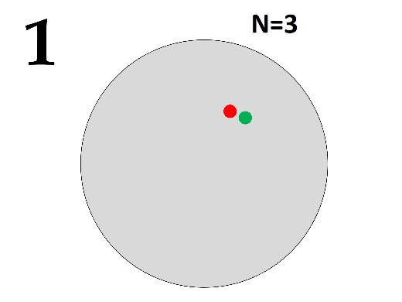 | 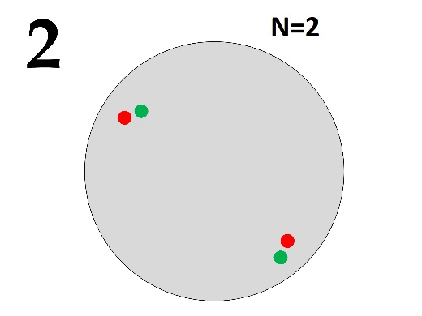 | 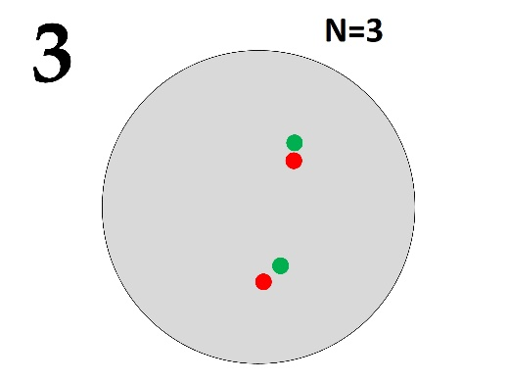
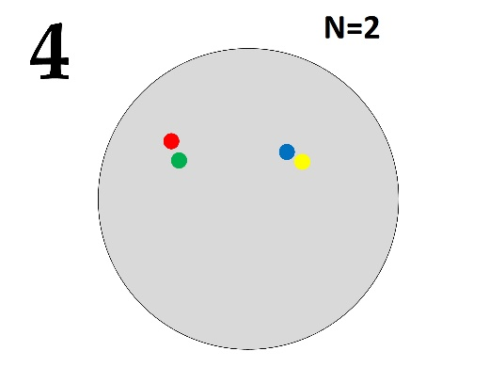 | 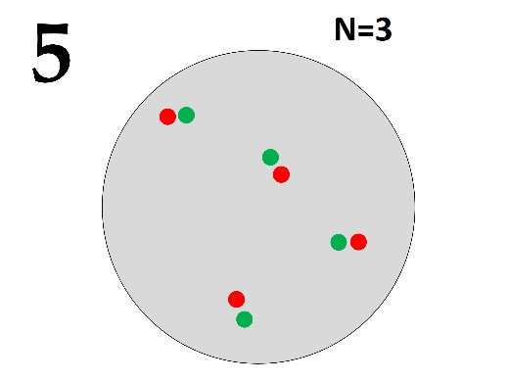

A set of sex chromosomes (the list is redundant - it contains extra options, some options may correspond to several different flies at the same time):
- XX;
- XXX;
- X0;
- XY;
- XXXX;
- XXY;

List of drosophila phenotype by sex:
- SuperMale;
- Male;
- Female;
- Intersex;
- SuperFemale;

Task ID 65 – 5 points
Variant 3
Drosophila melanogaster is a model object in modern genetics. Fly sex is determined not like in humans, but it depends on the sex chromosomes to autosome ratio.

Sex chromosomes | Number of autosome sets | Sexual phenotype
XX | 2 | Female
XY | 2 | Male
X0 | 2 | Male
XXY | 2 | Female
XXX | 2 | SuperFemale
XXXY | 2 | SuperFemale
XX | 3 | Intersex
X0 | 3 | SuperMale
XXXX | 3 | SuperFemale

You have received the metaphase chromosomes samples from your collaborators. In the corresponding letter is written that this samples are treated with fluorescent DNA oligonucleotide probes (FISH technology).

Oligonucleotide probe name | Oligonucleotide probe sequence | Conjugated fluorescent dye
Olig1 | 5’TCTAGCTCCTGGACTTTGCT 3’ | Alexa488
Olig2 | 5’TTCTATTTTAATTTGTTGTT 3’ | AMCA
Olig3 | 5’AGACAAGGGGAAGCGCTTGG 3’ | Cy5
Olig4 | 5’ATGAAATGCCGTTGGTTTTG 3’ | TRITC

Blasting the oligos you found the drosophila genome parts where this oligos may be complement.

X chromosome (beginning): | 5’CCTTCTAGCTCCTGGACTTTGCTCAACAGCTTTTGCAACTGCAATC 3’  3’GGAAGATCGAGGACCTGAAACGACTTGTCGAAAACGTTGACGTTAG 5’
X chromosome (end): | 5’CGCCAAGCGCTTCCCCTTGTCTCAGTCCATCGAGCAACGCCCCAA 3’  3’GCGGTTCGCGAAGGGGAACAGAGTCAGGTAGCTCGTTGCGGGGTT 5’
Y chromosome (beginning): | 5’TTCCATCTAGCTGTTGCATACTTCTATTTTAATTTGTTGTTTACTA 3’  3’AAGGTAGATCGACAACGTATGAAGATAAAATTAAACAACAAATGAT 5’
Y chromosome (end): | 5’GATCCGTTATCCTGTTGAAATGTCCAAAACCAACGGCATTTCATC 3’  3’CTAGGCAATAGGACAACTTTACAGGTTTTGGTTGCCGTAAAGTAG 5’

This morning you saw some posters on the lab freezers, there may be some valuable information about excitation and emission spectra for different fluorescent dyes.

Dye Name | Maximum exitation, nm | Maximum emission, nm
Alexa488 | 493 | 517
AMCA | 399 | 446
Cy5 | 649 | 670
TRITC | 550 | 580

Wavelength, nm | Color
620-700 | Red
590-620 | Orange
540-690 | Yellow
500-540 | Green
470-500 | Ligh Blue
430-470 | Dark Blue

Using fluorescent microscope, you have obtained images of the cells in the red, yellow, green and blue fluorescent channels. Every time you used the maximum excitation wavelength for each dye. For each cell, you joined all channels in one multichannel picture. On the pictures below you can see such multicolor metaphase nuclei pictures form different drosophilas from your collaborators. The number of autosome sets for the fly is also written on each picture (for example N=2 means 2 autosome sets).
For each photo define karyotype and the sexual phenotype of the fly.

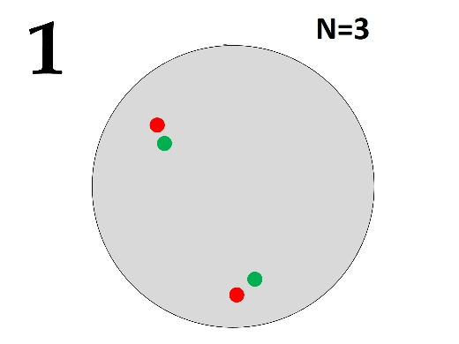 | 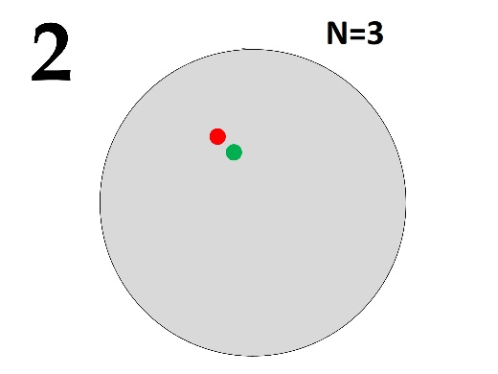 | 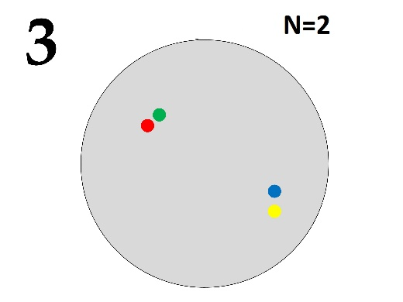
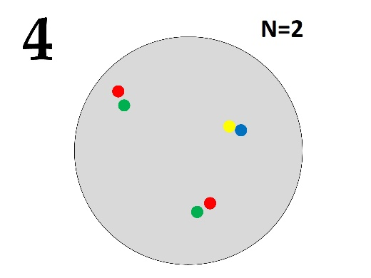 | 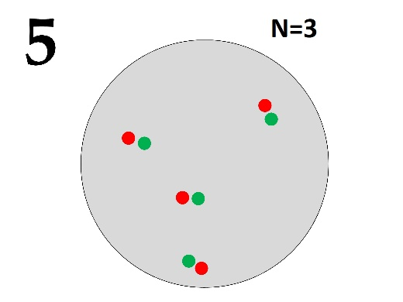

A set of sex chromosomes (the list is redundant - it contains extra options, some options may correspond to several different flies at the same time):
- XX;
- XXX;
- X0;
- XY;
- XXXX;
- XXY;

List of drosophila phenotype by sex:
- SuperMale;
- Male;
- Female;
- Intersex;
- SuperFemale;

Task ID 66 – 5 points
Variant 1
Here are various phylogenetic trees. The same symbols indicate the same state of the feature. Which concept corresponds to the presence of features marked with an asterisk? Choose an example to illustrate this concept:

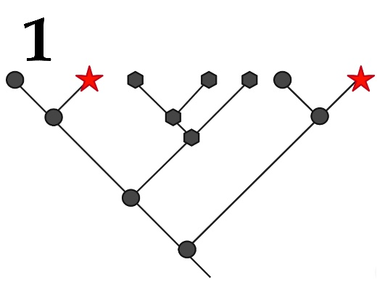 | 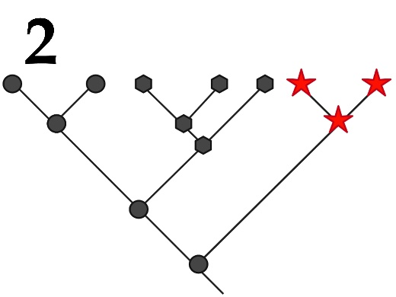 | 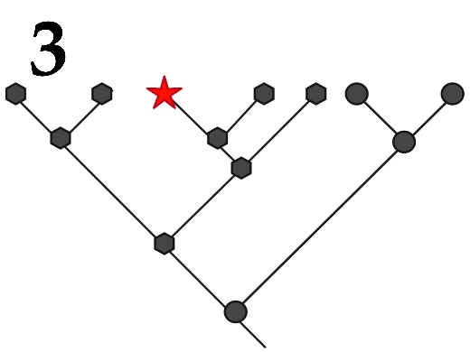
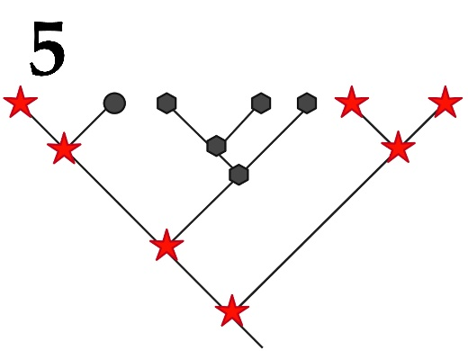 | 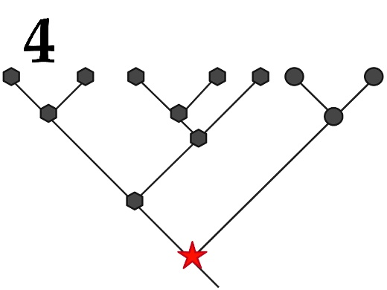

Concept in biological taxonomy:
- Autapomorphy – a distinctive derived trait that is unique to a given taxon or group;
- Synapomorphy – the similarity of several compared groups according to the derived trait;
- Symplesiomorphy – the similarity of several groups in the ancestral trait;
- Homoplasy – the independent gain of derived trait states, between which there is a superficial similarity;
- Plesiomorphy – the ancestral state of the trait;

An example illustrating this concept (but not a specific picture):
- The presence of a gnawing mouth apparatus in Orthoptera (grasshoppers, locusts and crickets etc.) and beetles (Coleoptera) in relation to all insects;
- The presence of legs in the ancestors of snakes;
- Development of shark and dolphin fins;
- The presence of a specialized generative organ - a flower for different families of angiosperms in relation to all plants;
- The presence of the placenta for the allocation of Placentals into a separate group among all vertebrates;

Task ID 66 – 5 points
Variant 2
Here are various phylogenetic trees. The same symbols indicate the same state of the feature. Which concept corresponds to the presence of features marked with an asterisk? Choose an example to illustrate this concept:

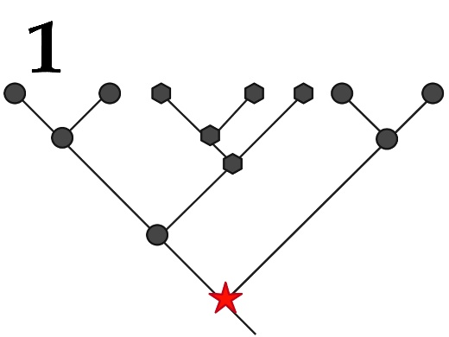 | 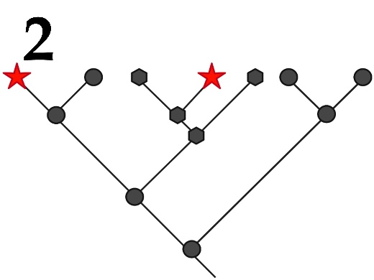 | 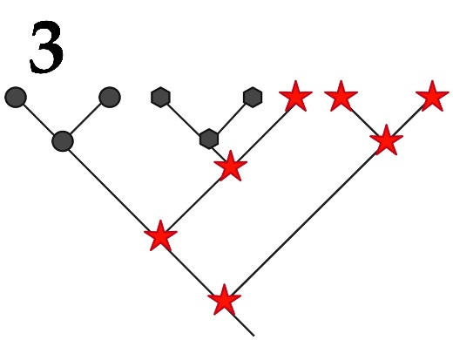
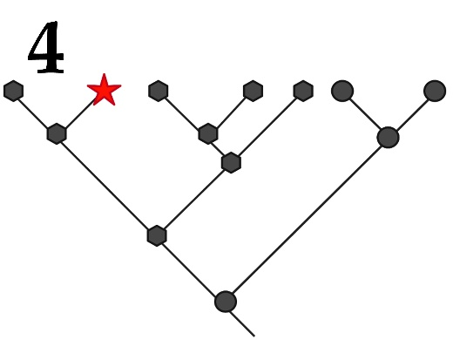 | 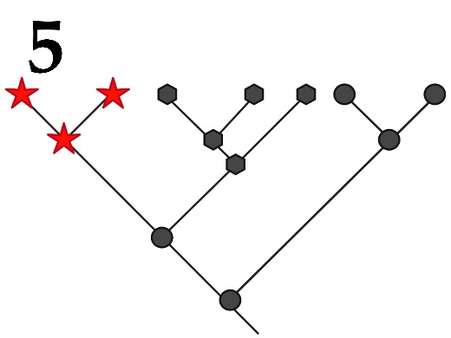

Concept in biological taxonomy:
- Autapomorphy – a distinctive derived trait that is unique to a given taxon or group;
- Synapomorphy – the similarity of several compared groups according to the derived trait;
- Symplesiomorphy – the similarity of several groups in the ancestral trait;
- Homoplasy – the independent gain of derived trait states, between which there is a superficial similarity;
- Plesiomorphy – the ancestral state of the trait;

An example illustrating this concept (but not a specific picture):
- The presence of a gnawing mouth apparatus in Orthoptera (grasshoppers, locusts and crickets etc.) and beetles (Coleoptera) in relation to all insects;
- The presence of legs in the ancestors of snakes;
- Development of shark and dolphin fins;
- The presence of a specialized generative organ - a flower for different families of angiosperms in relation to all plants;
- The presence of the placenta for the allocation of Placentals into a separate group among all vertebrates;

Task ID 66 – 5 points
Variant 3
Here are various phylogenetic trees. The same symbols indicate the same state of the feature. Which concept corresponds to the presence of features marked with an asterisk? Choose an example to illustrate this concept:

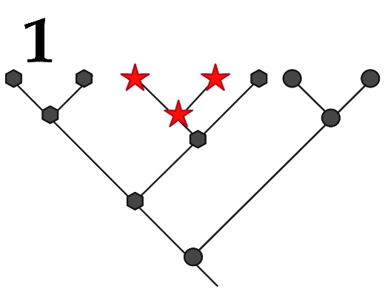 | 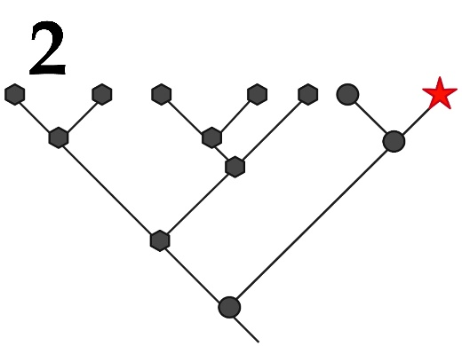 | 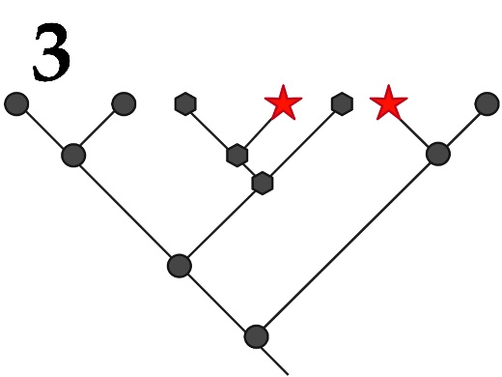
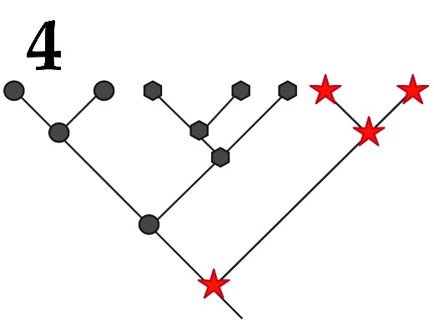 | 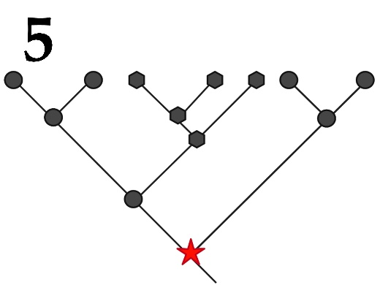

Concept in biological taxonomy:
- Autapomorphy – a distinctive derived trait that is unique to a given taxon or group;
- Synapomorphy – the similarity of several compared groups according to the derived trait;
- Symplesiomorphy – the similarity of several groups in the ancestral trait;
- Homoplasy – the independent gain of derived trait states, between which there is a superficial similarity;
- Plesiomorphy – the ancestral state of the trait;

An example illustrating this concept (but not a specific picture):
- The presence of a gnawing mouth apparatus in Orthoptera (grasshoppers, locusts and crickets etc.) and beetles (Coleoptera) in relation to all insects;
- The presence of legs in the ancestors of snakes;
- Development of shark and dolphin fins;
- The presence of a specialized generative organ - a flower for different families of angiosperms in relation to all plants;
- The presence of the placenta for the allocation of Placentals into a separate group among all vertebrates;

