Phystech.International Olympiad in Biology
2020/21 academic year
Final stage (online with proctoring)

ANSWERS TO Tasks for graduating level

The Olympiad tasks are divided into three parts:
Part A: Tasks with one correct answer (total: 23 tasks, 32 points)
Part B: Multiple Choice Questions (total: 9 tasks, 27 points)
Part C: Matching Questions (total: 8 tasks, 39 points)
Total: 98 points

Part A: Tasks with one correct answer

In all the tasks of this part, there is a condition at the beginning, and then four answer options (under the letters from A to D). Participants need to determine which one of the answer options is correct (fits the wording of the task). Each task can have only one correct answer. For each question, the number of points for the correct answer is indicated: there are two costs - 1 point each and 2 points each.

Grading system:
For each correct answer - 1 or 2 points
For each wrong answer - 0 points

Correct answers are underlined

Task 1 (ID 2) – 1 point
Common part of the question for all variants:
The photo shows the vascular bungle of a flowering plant (Angiospermae).

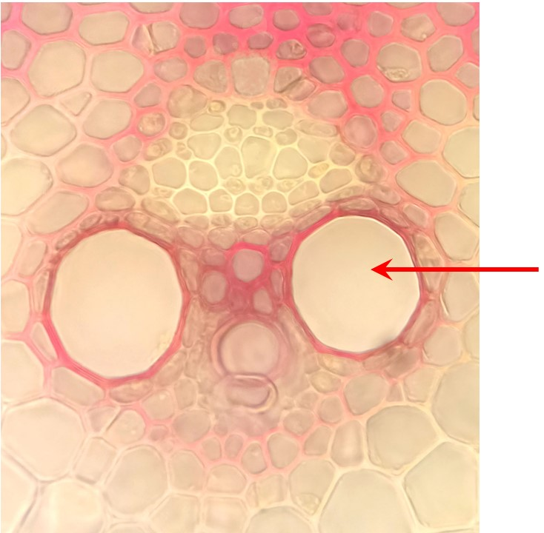

Choose the answer that correctly indicates: (1) the type of the vascular bungle, (2) a group of plants for which this vascular bungle is characteristic, (3) tissue indicated by an arrow.

Variant 1:
  - (1) collateral open, (2) Monocotyledoneae, (3) phloem;
  - (1) collateral closed, (2) Monocotyledoneae, (3) xylem;
  - (1) bicollateral, (2) Monocotyledoneae, (3) sclerenchyma;
  - (1) collateral closed, (2) Dicotyledoneae, (3) phloem;

Variant 2:
  - (1) collateral closed, (2) Monocotyledoneae, (3) parenchyma;
  - (1) collateral open, (2) Dicotyledoneae, (3) xylem;
  - (1) collateral closed, (2) Monocotyledoneae, (3) xylem;
  - (1) collateral open, (2) Monocotyledoneae, (3) xylem;

Task 2 (ID 3) – 2 points
Common part of the question for all variants:
In the root and shoot apical meristems of the most spore plants (Thracheophyta), there is only one initial cell (initial). Initial is very different from other cells in size and shape. The photos below show longitudinal sections of the apexes of flowering (Angiospermae) and spore plants.
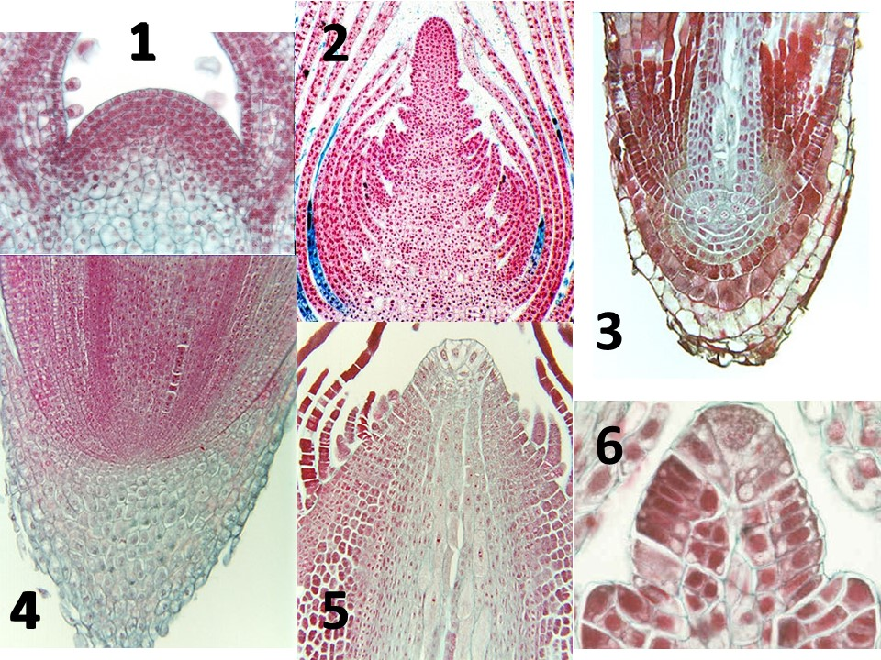

The apexes of spore plants are shown in the photographs:

Variant 1:
  - 1, 2, 4;
  - 3, 5, 6;
  - 1, 6;
  - 3, 4, 5;

Variant 2:
  - 3, 5, 6;
  - 3, 4, 5, 6;
  - 2, 5;
  - 1, 3, 4;

Task 3 (ID 5) – 1 point
Common part of the question for all variants:
Root systems can be allorhizal and homorrhizal in origin.

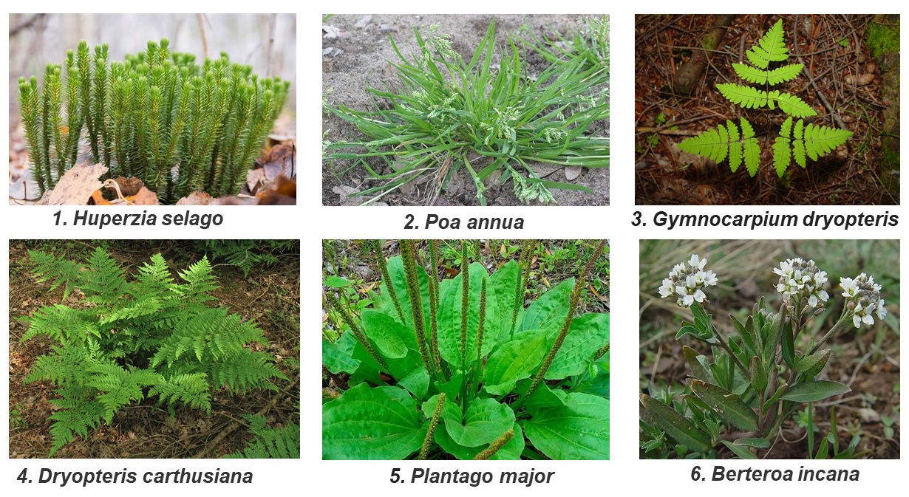

The primary homorrhizal root system develops in the plants shown in the figure:

Variant 1:
- 2, 4, 5;
- 1, 3, 4;
- 1, 3, 5;
- 4, 5, 6;

Variant 2:
- 1, 3, 4;
- 1, 2, 4;
- 2, 4, 6;
- 3, 5, 6;

Task 4 (ID 6) – 2 points
Common part of the question for all variants:
The figure below depicts the various structures used for the propagation of fungi.

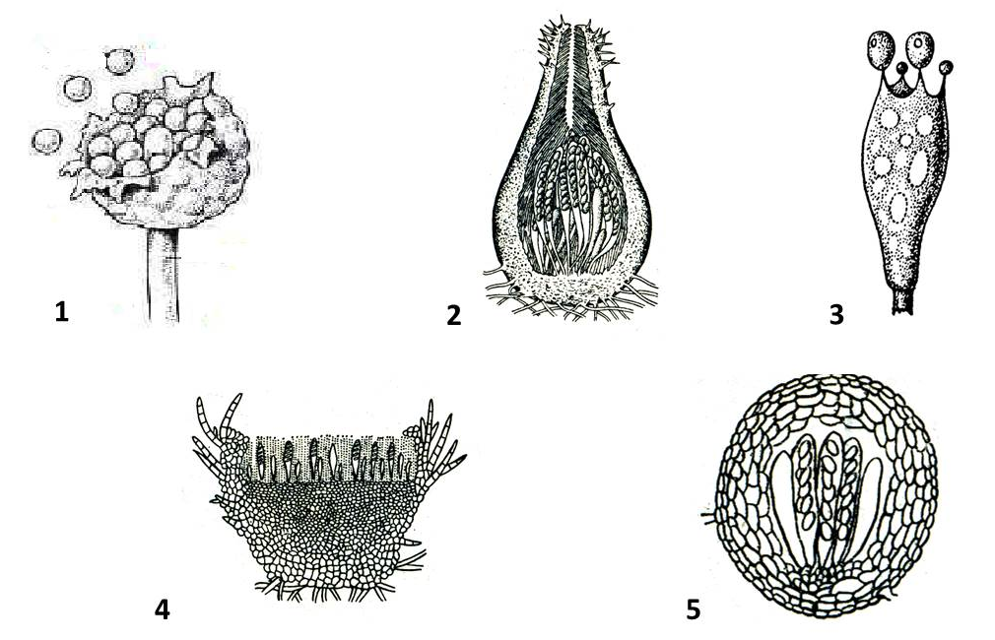

Choose the correct combination of numbers and names of reproductive organs corresponding to the representatives of Ascomycetes:

Variant 1:
- 1 – sporangium, 2 – perithecium, 3 – holobasidia;
- 2 – perithecium, 3 – holobasidia, 4 – apothecia;
- 2 – perithecium, 4 – apothecia, 5 – cleistocarp;
- 3 – holobasidia, 4 – apothecia, 5 – cleistocarp;

Variant 2:
- 1 – clestothecium 2 – holobasidia, 3 – perithecium;
- 2 – perithecium, 4 – apothecia, 5 – cleistocarp;
- 1 – clestothecium, 3 – holobasidia, 4 – apothecia;
- 2 – perithecium, 3 – holobasidia, 5 – sporangium;

Task 5 (ID 8) – 1 point
Common part of the question for all variants:
The figure below shows the skulls of some mammals (Mammalia).

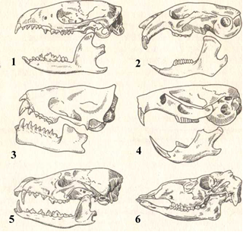

Using the figure and your theoretical knowledge, choose the correct answer:

Variant 1:
- Skulls 2 and 4 belong to mainly herbivorous mammals;
- Skull 5 lacks canines;
- Skull 6 belongs to a brown bear (Ursus arctos);
- An animal with skull 1 has a well-defined diastema;

Variant 2:
- Skulls 1 and 6 belong to animals that eat animal food;
- Skull 4 has well-defined canines;
- An animal with a skull 4 belongs to the order Rodentia;
- In an animal with skull 5, the incisors are much larger than the canines;

Task 6 (ID 9) – 2 points
Common part of the question for all variants:
The figure below shows the chewing surfaces of the teeth of some mammals (Mammalia).

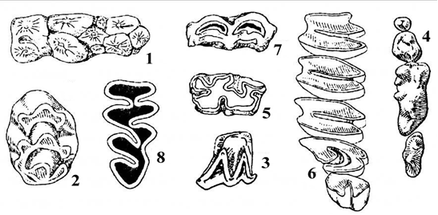

Using the figure and your theoretical knowledge, choose the correct answer:

Variant 1:
- Figures 1, 4, 6 show the tooth surfaces of carnivorous mammals (Carnivora);
- Tooth surface 1 is typical for representatives of the order Lagomorpha (rabbits);
- Teeth with surfaces 1, 4, 8 are typical for herbivores;
- Surface 4 may belong to a wolf (Canis lupus);

Variant 2:
- Figures 1, 4, 6 show the tooth surface of even-toed ungulates (Artiodactyla);
- Tooth surface 1 is typical for representatives of pigs (Artiodactyla, Suidae);
- Teeth with surfaces 1, 4, 8 are typical for omnivores;
- Surface 6 may belong to the red fox (Vulpes vulpes);

Task 7 (ID 11) – 1 point
Common part of the question for all variants:
The figure below shows a section of a CT scan of the chest in the frontal plane.

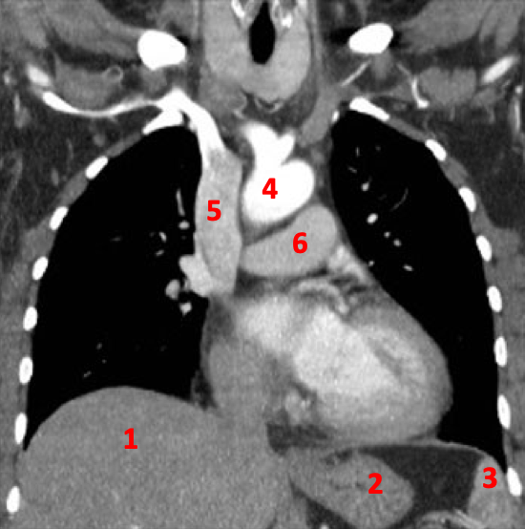

What structures of the human chest are indicated by numbers? Choose the right combination of numbers and structure names:

Variant 1:
- 1 - spleen, 2 - stomach, 3 - liver, 4 - aorta, 5 - pulmonary trunk, 6 - superior vena cava;
- 1 - liver, 2 - spleen, 3 - stomach, 4 - superior vena cava, 5 - aorta, 6 - pulmonary trunk;
- 1 - liver, 2 - spleen, 3 - stomach, 4 - superior vena cava, 5 - aorta, 6 - pulmonary trunk;
- 1 - liver, 2 - stomach, 3 - spleen, 4 - aorta, 5 - superior vena cava, 6 - pulmonary trunk;

Variant 2:
- 1 - spleen, 2 - liver, 3 - stomach, 4 - pulmonary trunk, 5 - superior vena cava, 6 - aorta;
- 1 - liver, 2 - stomach, 3 - spleen, 4 - pulmonary trunk, 5 - aorta; 6 - superior vena cava;
- 1 - liver, 2 - stomach, 3 - spleen, 4 - aorta, 5 - superior vena cava, 6 - pulmonary trunk;
- 1 - stomach, 2 - spleen, 3 - liver, 4 - superior vena cava, 5 - aorta, 6 - pulmonary trunk;

Task 8 (ID 12) – 2 points
Common part of the question for all variants:
On auscultation of the heart, two tones can normally be heard normally: the first is generated by the closing of the atrioventricular valves during ventricular contraction (AV valves close or S1), and the second is the sound of closing the semilunar valves during relaxation of the ventricles (semilunar valves close or S2). This is how you can represent both tones on the phonocardiogram (bottom figure):

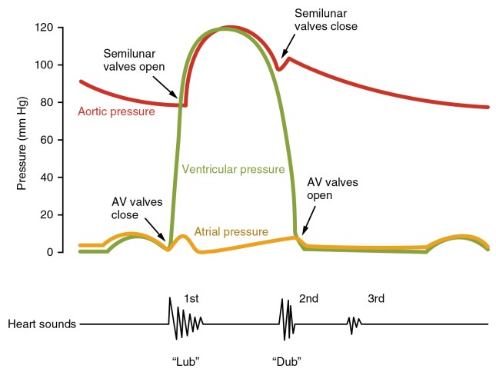

In the classification of heart defects, stenosis (narrowing of the lumen of the valve opening), insufficiency (incomplete closure of the valve leaflets), or their combination are distinguished. Depending on this or that defect, characteristic murmurs are formed, which can be distinguished by auscultation of the heart. Correlate the graphs of pathological phonocardiograms with various heart defects (Note: MC - midsystolic click; OS - opening snap):
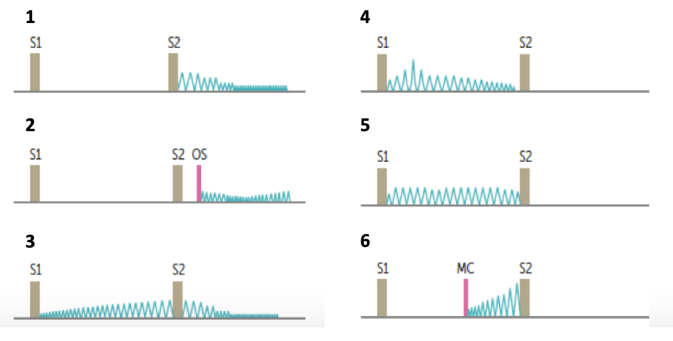

Variant 1:
- 1 - mitral valve prolapse, 2 - aortic stenosis, 3 - mitral valve insufficiency, 4 - mitral stenosis, 5 - patent ductus arteriosus, 6 - aortic valve insufficiency;
- 1 - aortic valve insufficiency, 2 - mitral stenosis, 3 - patent ductus arteriosus, 4 - aortic stenosis, 5 - mitral valve insufficiency, 6 - mitral valve prolapse;
- 1 - mitral stenosis, 2 - patent ductus arteriosus, 3 - aortic stenosis, 4 - mitral valve insufficiency, 5 - mitral valve prolapse, 6 - aortic valve insufficiency;
- 1 - patent ductus arteriosus, 2 - mitral valve prolapse, 3 - aortic valve insufficiency, 4 - mitral stenosis, 5 - aortic stenosis, 6 - mitral valve insufficiency;

Variant 2:
- 1 - mitral stenosis, 2 - aortic stenosis, 3 - mitral valve insufficiency, 4 - mitral valve prolapse, 5 - patent ductus arteriosus, 6 - aortic valve insufficiency;
- 1 - aortic valve insufficiency, 2 - aortic stenosis, 3 - patent ductus arteriosus, 4 - mitral stenosis, 5 - mitral valve prolapse, 6 - mitral valve insufficiency;
- 1 - aortic valve insufficiency, 2 - patent ductus arteriosus, 3 - aortic stenosis, 4 - mitral valve insufficiency, 5 - mitral valve prolapse, 6 - mitral stenosis;
- 1 - aortic valve insufficiency, 2 - mitral stenosis, 3 - patent ductus arteriosus, 4 - aortic stenosis, 5 - mitral valve insufficiency, 6 - mitral valve prolapse;

Task 9 (ID 13) – 1 point
Common part of the question for all variants:
Immune system works almost like the police. Look at the picture below and answer what type of immune cells interaction is demonstrated:

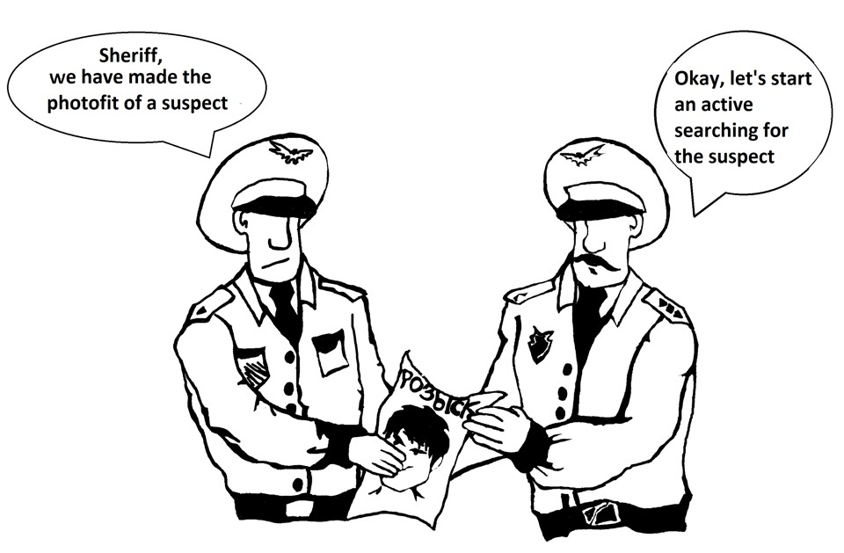

Variant 1:
  - Activation of B-lymphocytes by T-helpers;
  - Antigen presentation to T-lymphocytes;
  - Interaction between T-killers and infected cells;
  - T-cell anergy.

Variant 2:
  - Activation of immune memory cells;
  - Antigen presentation to T-lymphocytes;
  - Activation of the complement system by the infectious agent;
  - Attraction of neutrophils to the focus of inflammation by proinflammatory macrophages;

Task 10 (ID 14) – 1 point
Common part of the question for all variants:
The group of brachiocephalic arteries is shown on the picture below. Find the locus of arterial stenosis which causes Subclavian steal syndrome (syncope and vertigo attacks associated with hand pain, rare pulse and low arterial pressure comparing to the other hand):
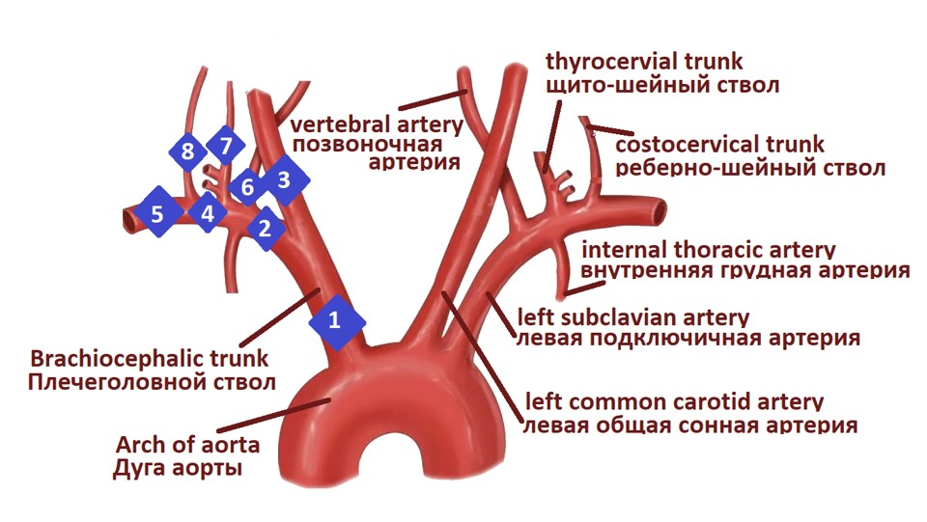

Variant 1:
  - 1;
  - 2;
  - 3;
  - 6;

Variant 2:
  - 1;
  - 2;
  - 4;
  - 5;

Task 11 (ID 15) – 2 points
Common part of the question for all variants:
The picture below demonstrates the scheme of thyroid hormones secretion. Pituitary TSH (Thyroid stimulating hormone) activates secretion of T3 (Triiodothyronine) and T4 (Thyroxine) by thyroid gland. T3 and T4 decrease the secretion of TSH due to negative feedback.
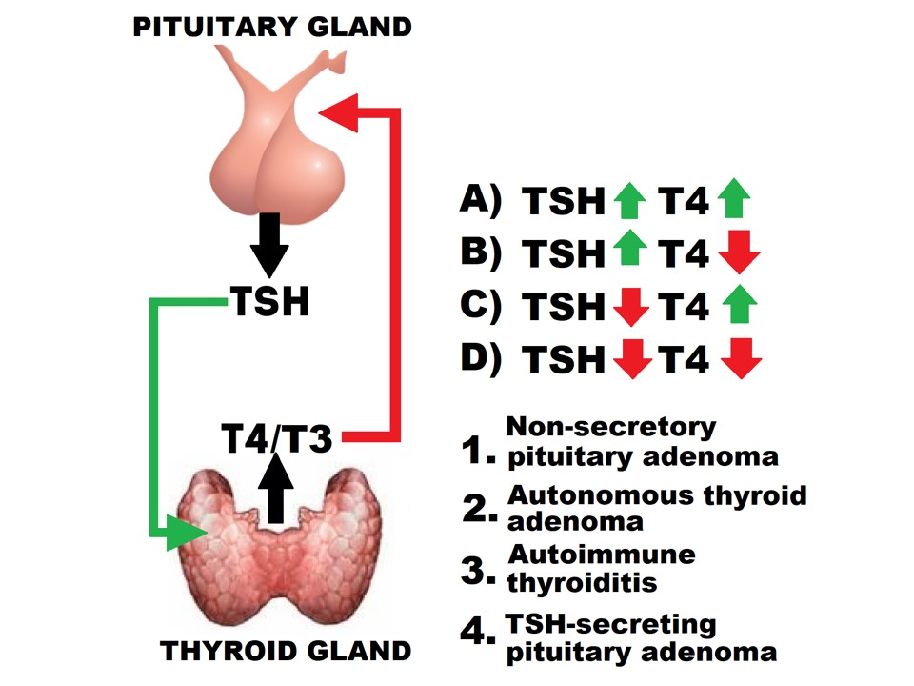

Find a connection between deviations of hormonal blood profile (TSH and T4) and their causes:

Variant 1:
  - A-2, B-4, C-3, D-1;
  - A-4, B-3, C-1, D-2;
  - A-3, B-4, C-2, D-1;
  - A-4, B-3, C-2, D-1;

Variant 2:
  - A-4, B-2, C-1, D-3;
  - A-3, B-4, C-1, D-2;
  - A-4, B-3, C-2, D-1;
  - A-2, B-3, C-4, D-1;

Task 12 (ID 16) – 1 point
Common part of the question for all variants:
You need to isolate the poly (A) binding protein (PABP). To do this, you transformed Escherichia coli with a plasmid encoding PABP with the x6His-SUMO tag, separated from the target protein by a sequence recognized by the Ulp protease. Then you induced protein production and isolated the fairly pure PABP-x6His-SUMO (molar mass - 84 kg/mol) using affinity chromatography on Ni-agarose resin that binds imidazole groups, of which there are many in the x6His-SUMO tag. Now you plan to add an Ulp protease to the solution to cut the protein into the PABP itself (71 kg / mol) and the x6His-SUMO peptide. Ulp protease also contains the indicated tag. Choose the correct statement.

Variant 1:
- As a result of proteolysis of PABP-x6His-SUMO with Ulp protease, an equimolar (equal by mol) amount of PABP and x6His-SUMO tag will be obtained;
- Adding excess imidazole to the reaction buffer will increase the amount of resin bound protein;
- Incubation of the reaction mixture after proteolysis with an excess of fresh Ni-agarose resin followed by removal of the resin will not result in simultaneous purification of the mixture from x6His-SUMO peptide, Ulp protease and unreacted PABP-x6His-SUMO;
- According to the results of the experiment, it can be concluded that bacteria encode the Ulp protease.

Variant 2:
- As a result of proteolysis of PABP-x6His-SUMO with Ulp prostheses, the same mass (in kg) of PABP and x6His-SUMO tag will be obtained;
- Adding excess imidazole to the reaction buffer will increase the amount of resin bound protein;
- Incubation of the reaction mixture after proteolysis with an excess of fresh Ni-agarose resin followed by removal of the resin will result in simultaneous purification of the mixture from x6His-SUMO peptide, Ulp protease and unreacted PABP-x6His-SUMO;
- According to the results of the experiment, it can be concluded that bacteria translate a large number of their own proteins containing the indicated tag.

Task 13 (ID 17) – 1 point
Common part of the question for all variants:
You want to reveal the details of eukaryotic translation release factor 3 (eRF3) function. You know that eRF3 hydrolyzes GTP to GDF and inorganic phosphate (P_{i}) during translation termination. You have performed the GTPase test with various combinations of translation components (eRF3, release factor eRF1 and ribosome (RS)) at their optimal concentrations. During the test, you incubated the components in a reaction buffer containing GTP and then added molybdate and Malachite Green reagent. Molybdate and Malachite Green reagent formed a colored molecular complex with the released P_{i}. The figure below shows you the results of the test. The top row shows calibration experiments with P_{i} solutions at various concentrations. The middle row shows experiments with translation components in the reaction buffer containing 0.5 mM GTP, the bottom row shows the same, but with 10 mM GTP. "Mix" means reaction buffer without translation components. “µM” means µmol/L.

From the data presented in the figure and in the text, it is possible to draw the following conclusion:

Variant 1:
- For eRF3 to function in translation termination, the presence of ribosomes is required, but not eRF1;
- When the concentration of GTP increases from 0.5 to 10 mM, eRF3 becomes capable of hydrolyzing GTP by itself;
- This test is able to distinguish between 0.05 mmol/L and 100 μmol/L inorganic phosphate solutions;
- Molybdate and Malachite Green reagent can be used to detect ATP hydrolysis.

Variant 2:
- For eRF3 to function in translation termination, the simultaneous presence of both eRF1 and ribosomes is required;
- When the concentration of GTP increases from 0.5 to 10 mM, eRF3 becomes capable of hydrolyzing GTP by itself;
- This test is capable of detecting inorganic phosphate at a concentration of 10 pmol/L;
- Molybdate and Malachite Green reagent cannot be used to detect ATP hydrolysis.

Task 14 (ID 18) – 2 points
Common part of the question for all variants:
Phytochelatins are plant peptides consisting of a sequence of γ-glutamylcysteine repeating about ten times, followed by a glycine residue. Phytochelanins protect plants from heavy metal ions. These peptides are synthesized by the enzyme phytochelatine synthase from the molecules of the glutathione tripeptide. The scheme of their synthesis is presented below:
Choose the correct statement:

Variant 1:
- Heavy metal ions form complexes with glycine radical;
- The addition of heavy metal ions increases the resistance of plants to oxidative stress due to the conversion of the glutathione pool to the phytochelatin pool;
- The phytochelatin sequence cannot be synthesized on the ribosome, even recombinantly;
- The phytochelatin molecule has zero net charge at neutral pH.

Variant 2:
- Heavy metal ions form complexes with the terminal amino group of phytochelatin;
- A mutant of arabidobsis with a defective gene encoding glutathione synthetase, has increased resistance to heavy metal ions;
- The phytochelatin sequence cannot be synthesized on the ribosome, even recombinantly;
- The phytochelatin molecule has positive net charge at neutral pH.

Task 15 (ID 19) – 1 point
Common part of the question for all variants:
In 1961, F. Crick and S. Brenner published a work that shed light on the fundamental properties of the genetic code. The researchers studied mutations occurring in the gene B (region rII) of the genome of bacteriophage T4 under the action of proflavine. Loss-of-function mutations in this gene block the T4 bacteriophage growth on E. coli K12 cells. Proflavine is a mutagenic compound that causes mutations such as insertion or deletion of one nucleotide. By the time of the experiments of Crick and Brenner, it was known that the genetic code is non-overlapping (that is, the codons in mRNA do not overlap). Besides, a technique was developed that made it possible to map (that is, find out the location) mutations at the rII locus. The researchers began work with the so-called FC 0 mutant, which was obtained from wild-type bacteriophages by the action of proflavine. As a result of spontaneous mutations, phages with a wild-type phenotype were obtained from the FC 0 mutant. In addition to the FC 0 mutation, each of these phages contained one more so-called suppressive mutation (that is, "suppressing" the FC 0 mutation). The map of these suppressive mutations is shown in the figure (18 such mutations are marked with numbers; the position of the FC 0 mutation is also marked). Moreover, each of these suppressive mutations alone produced a mutant phenotype. Scientists showed that bacteriophages having simultaneously mutations FC 1, 21 and 23 in their genome had a wild-type phenotype.
Analyze the experiment and pick the right statement:

Variant 1:
  - The described experiment proved that genetic code is degenerate;
  - Bacteriophages having simultaneously mutations FC 0, 9 and 23 in their genome will have a wild type phenotype;
  - The described experiment proved that genetic code has triplet nature;
  - If FC 9 mutation is a single-nucleotide deletion than FC 23 mutation should be a single-nucleotide insertion;

Variant 2:
  - The described experiment proved that genetic code has triplet nature;
  - The described experiment proved the universality of genetic code among different organisms;
  - Bacteriophages having simultaneously mutations FC 1 and 21 in their genome will have a wild type phenotype;
  - If FC 0 mutation is a single-nucleotide deletion than FC 1 mutation should also be a single-nucleotide deletion;

Task 16 (ID 20) – 1 point
Common part of the question for all variants:
The researchers introduced into E. coli cells various "gene circuits" - groups of genes linked to each other by regulatory links (see figure) - and monitored the synthesis of green fluorescent protein (GFP) by measuring the fluorescence of the cells. The diagram shows four variants of gene circuits. Green arrows with a sharp end indicate activation, and red arrows with a blunt end indicate inhibition. Promoters are indicated with black arrows. A sequence that accelerates the degradation of proteins in cells (indicated by a black circle) was added to each protein in the gene loop. In the presence of arabinose, the AraC protein binds to the ara sequence and activates transcription, while the LacI protein binds to the LacO sequence and suppresses transcription.
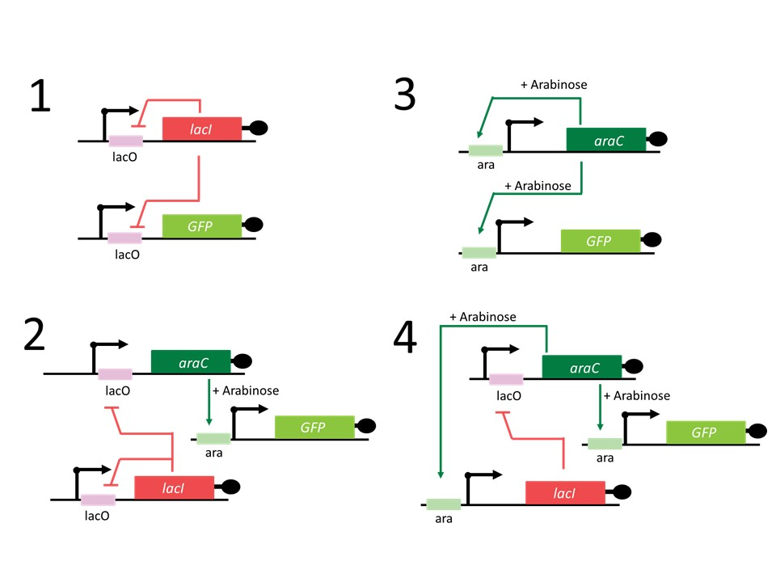
Analyze gene circuit diagrams and pick the right statement:

Variant 1:
  - When gene circuit 3 is introduced into cells and arabinose is added, oscillation (intensity fluctuations) of GFP fluorescence will be observed;
  - If, in genetic circuit 1, the LacO sequence in the GFP gene promoter is removed, the time dependence of the fluorescence intensity will be the same as in the case of the initial variant of system 1;
  - When gene circuit 1 is introduced into cells, there will be an oscillation (fluctuations in intensity) of GFP fluorescence;
  - Genetic circuit 1 is an example of a positive feedback system;

Variant 2:
  - When gene circuit 3 is introduced into cells and arabinose is added, oscillation (intensity fluctuations) of GFP fluorescence will be observed;
  - When gene circuit 2 is introduced into cells and arabinose is added, oscillation (intensity fluctuations) of GFP fluorescence will be observed;
  - If, in genetic circuit 4, the ara sequence in the GFP gene promoter is removed, the time dependence of the fluorescence intensity will be the same as in the case of the initial variant of system 4;
  - Genetic circuit 2 is an example of a positive feedback system;

Task 17 (ID 21) – 2 points
Common part of the question for all variants:
Genomic imprinting is a phenomenon that consists in the expression of only one of the parental alleles. One example of genomic imprinting is the inheritance of the H19 and Igf2 genes in the mouse (Mus musculus). The Igf2 gene encodes an insulin-like growth factor that stimulates cell growth and division. H19 is a long non-coding RNA that inhibits cell growth and division. The expression of these genes is activated by an enhancer. The H19 gene is transcribed only from the maternal allele while the Igf2 gene - only from the paternal allele. This is achieved due to the different state of the ICR sequence: it is methylated on the paternal allele and not methylated on the maternal one. DNA methylation is carried out by the enzyme DNA methyltransferase. ICR methylation suppresses the transcription of the H19 gene and blocks the ability of the CTCF protein to bind to this sequence. Binding of CTCF restricts the effect of the enhancer, preventing it from activating transcription of the Igf2 gene. Mutations in the Igf2 and H19 genes in mice are not lethal but have a phenotypic manifestation.
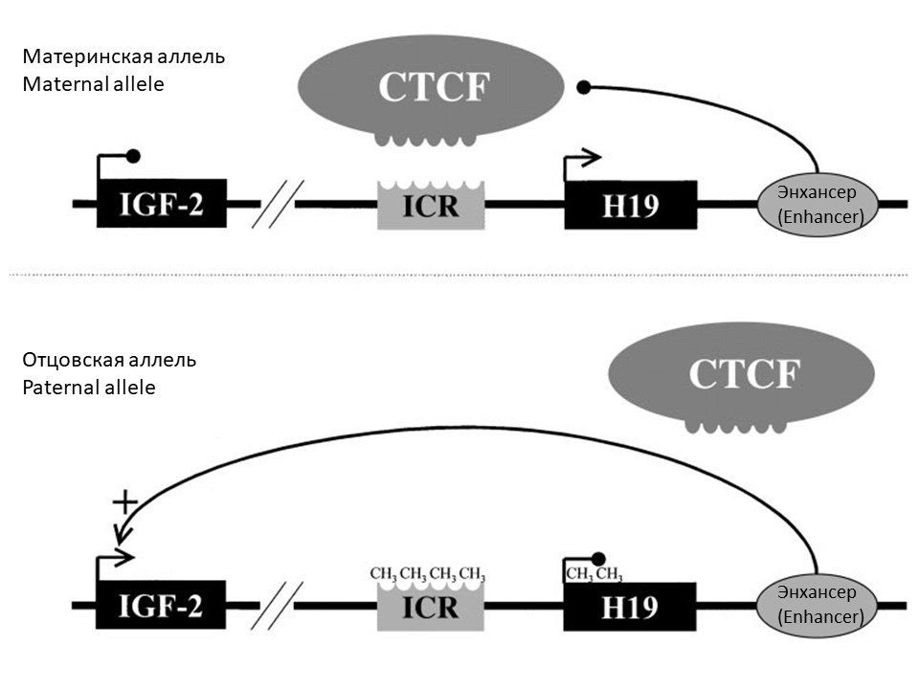
Analyze the diagram and select the correct statement:

Variant 1:
  - An inactivating mutation in the DNA methyltransferase gene will cause the H19 gene to be active on both chromosomes;
  - Methylation of the paternal allele occurs in the zygote;
  - Deletion of the enhancer will lead to the activation of the maternal allele of the Igf2 gene;
  - Mice that inherit the Igf2 gene deletion from their mother will have less body weight than wild-type mice;

Variant 2:
  - Mice that inherit the Igf2 gene deletion from their father will have less body weight than wild-type mice;
  - Mice inheriting the H19 gene deletion from their father will have more body weight than wild-type mice;
  - An inactivating mutation in the DNA methyltransferase gene will cause the Igf2 gene to be active on both chromosomes;
  - Deletion of the enhancer will activate the paternal allele of the H19 gene;

Task 18 (ID 22) – 1 point
Common part of the question for all variants:
Dragons are black and red. When crossing red males with red females, only red offspring always appear. The red male was crossed with three different black females.
Female 1 is black, brought four offspring, 2 are red and 2 are black.
Female 2 is black, gave birth to three offspring, 1 red and 2 black.
Female 3 black gave birth to five black offspring.
What conclusion can be most reliably drawn from the above data?

Variant 1:
- Females 1 and 2 have a different genotype;
- Red descendants inherited color only from the father;
- Females 1 and 2 are homozygotes;
- There are no dominant alleles in the male genotype;

Variant 2:
- The red allele dominates over the black allele;
- Females 1 and 2 have a different genotype;
- Female 3 is most likely a dominant homozygote;
- Females 1 and 2 are homozygotes;

Task 19 (ID 23) – 1 point
Common part of the question for all variants:
Dragons, like humans, have a heterogametic male sex. In population 1, all males have a crest. Females have no crest. In population 2, both males and females have no crest.
When males from population 1 are crossed with females from population 2, all male offspring in the three studied generations (F1, F2, and F3) have a crest. Female descendants never have a crest.
When males from population 2 were crossed with females from population 1, none of the offspring in the three studied generations (F1, F2, and F3) had a ridge.
What conclusion can be most reliably drawn from the above data?

Variant 1:
- Females do not have a gene for the presence of a ridge;
- The gene that determines the presence of a crest is present in both males and females, but manifests itself only in males;
- The gene determining the presence of the crest is located in the autosome;
- The sex of baby dragons depends only on the female.

Variant 2:
- The gene that determines the presence of a crest is present in both males and females, but manifests itself only in males;
- The gene determining the presence of the crest is located in the autosome;
- X and Y chromosomes are composed of different genes, at least in part;
- X and Y chromosomes always consist entirely of the same genes;

Task 20 (ID 24) – 2 points
Common part of the question for all variants:
One white male was found in a population of yellow and green dragons. To find out the nature of the inheritance of the white color, a number of crosses were carried out.
Crossing 1. White male was crossed with green females. In F1, some of the females gave birth to green offspring, and some - yellow and green in a total ratio of 1: 1.
Crossing 2. White male was crossed with yellow females. In F1, all descendants were yellow. In F2, white descendants were obtained from this cross.
What conclusion can be most reliably drawn from the above data?

Variant 1:
- For the gene for the coloring of dragons, 3 alleles are described - alleles of green, yellow and white colors;
- The white gene is not an allele in relation to the yellow and green genes;
- White dragons can be heterozygous;
- The appearance of a white color is the result of a genomic mutation.

Variant 2:
- The white gene is not an allele in relation to the yellow and green genes;
- The white allele dominates the yellow allele, but is recessive to the green allele;
- When crossing green descendants from F1, obtained in crossing 1, in F2 you can get white dragons;
- The appearance of a white color is the result of a genomic mutation.

Task 21 (ID 25) – 1 point
Common part of the question for all variants:
What determines the width of the hybrid zone (the zone where two interbreeding species meet and cross-fertilize with the formation of hybrids)?

Variant 1:
- The evolutionary history of these species;
- The size of the ranges of each species and climatic conditions;
- The fitness of hybrids and the radius of dispersal (activity) of these species;
- The reproduction rate and fertility of the species;

Variant 2:
- The fitness of hybrids and the radius of dispersal (activity) of these species;
- The relative fitness of the species;
- The biotope in which these species live;
- The genetic diversity in the population of each of the species;

Task 22 (ID 26) – 1 point
Common part of the question for all variants:
In the artificial population of fruit flies, obtained by combining the mutant lines "eboni" and "dumpy", as a result of crossing, 50% of the wild-type offspring are obtained. If the experimenter kills all wild-type offspring, then after several generations:

Variant 1:
- All flies will die;
- As a result of crossing, more wild-type offspring will be formed;
- The frequency of wild-type offspring will decrease;
- All crosses will result in wild-type offspring;

Variant 2:
- A new mutation will appear in the population;
- The frequency of wild-type offspring will increase;
- The frequency of wild-type offspring will reach 100%;
- The frequency of wild-type offspring will decrease;

Task 23 (ID 27) – 1 point
Common part of the question for all variants:
How does population size affect the roles of selection and genetic drift in evolution?

Variant 1:
- In populations with low abundance, the role of gene drift is very large;
- Population size does not affect the roles of selection and genetic drift;
- In small populations, the role of selection is more significant;
- Both genetic drift and selection occur only in populations with high abundance;

Variant 2:
- Both genetic drift and selection occur only in populations of low abundance;
- In populations with low abundance, the role of gene drift is very large;
- Genetic drift does not affect the evolution of the species;
- In populations with high abundance, the role of genetic drift is very large;

Part B: Multiple Choice Questions (True / False)

In all the tasks of this part, there is a condition at the beginning, and then six answer options (under the letters from A to F). Participants need to determine whether each of the answer options is correct (fits the problem statement) or incorrect (does not fit the job statement). Each task can have from 0 to 6 correct answers.

Grading system:
For each correctly marked statement, you can get 0.5 points
For each incorrectly marked statement - 0 points

«True» answers are underlined

Task 24 (ID 28) – 3 points
Common part of the question for all variants:
One of the important features of plants is the implementation of the process of photosynthesis. Indicate for each of the following statements whether it is true or false:

Variant 1:
  - Photosynthesis is carried out only by the chlorenchyma of the leaf;
  - In some plants, photosynthetic tissues can be located in the roots;
  - Chloroplasts in chlorenchyma cells can move and occupy a certain position depending on the light intensity;
  - Cells of mechanical tissue collenchyma have a living protoplast, chloroplasts and can carry out photosynthesis;
  - Photosynthetic tissues can combine the functions of photosynthesis and ventilation;
  - In some species of conifers, mesophill cells have folded walls;

Variant 2:
  - Leaf chlorenchyma is subdivided into palisade mesophill and spongy mesophill;
  - In the leaves of some submerged plants, the photosynthetic tissue is the epidermis;
  - In the cells of chlorenchyma, along with chloroplasts, chromoplasts can also be contained;
  - Photosynthetic tissues can combine the functions of photosynthesis and support;
  - In some species of conifers, mesophill cells have folded walls;
  - Palisade mesophill has the greatest photosynthetic activity.

Task 25 (ID 29) – 3 points
Common part of the question for all variants:
The figure shows plants of different taxonomic categories.

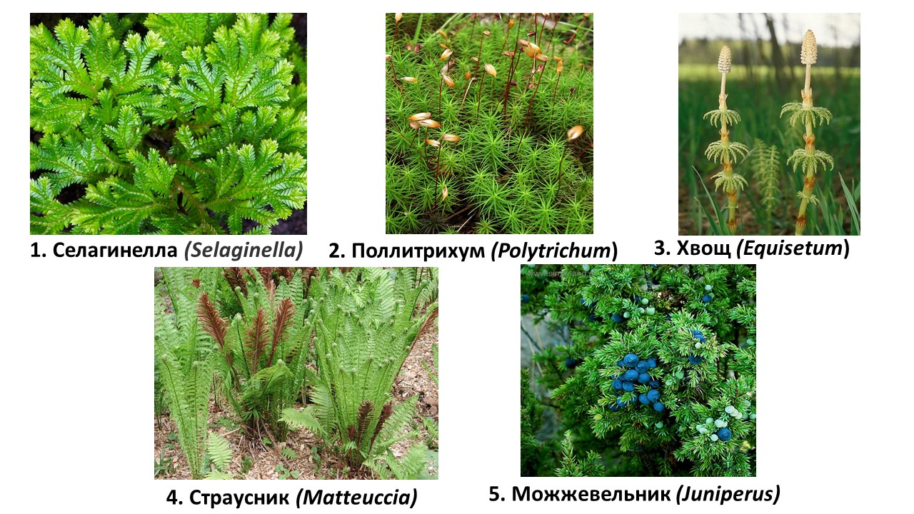

Analyze their morphological features and for each of the following statements indicate whether it is true or false:

Variant 1:
  - Archegonium is developed in the female gametophyte of all these plants;
  - All plants are homosporic;
  - In the development cycle of plants 1, 3, 4 and 5, sporophyte prevails;
  - Plant 1 is characterized by dichotomous branching of aboveground and underground organs;
  - All plants shown in the photographs need water for fertilization;
  - Plants 1, 2 and 3 have enational origin of leaves;

Variant 2:
  - Asexual reproduction is accompanied by the formation of spores only in plants 1 and 2;
  - All plants are homosporic;
  - Plant 3 develops spores with elaters;
  - Plants 1, 2 and 3 have enational origin of leaves;
  - Large aromorphosis - the formation of seeds and fruits- is a characteristic for plant 5;
  - The sporophyte parasitizes the gametophyte of the plant 2;

Task 26 (ID 30) – 3 points
Common part of the question for all variants:
This is a photo of the opened animal.

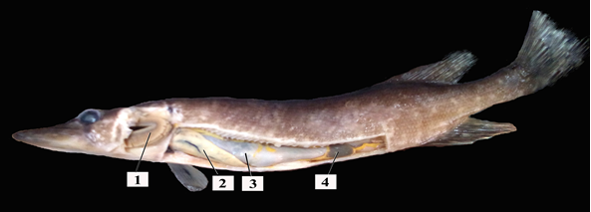

Analyze it and for each subsequent statements indicate whether it is true or not:

Variant 1:
  - The photo shows a representative of vertebrates belonging to fish (Vertebrata, Pisces);
  - It is a cartilaginous fish (Chondrichthyes);
  - In this fish, the dorsal fin is located above the anal;
  - The main respiratory organ are gills, which are indicated in the photo under 1;
  - Organ 2 is the kidneys;
  - It is a predatory fish;

Variant 2:
  - The photo shows a representative of vertebrates belonging to jawless (Vertebrata, Agnatha);
  - It is a bony fish (Osteichthyes);
  - In this fish, the dorsal and anal fins are composed of bony rays;
  - The main respiratory organ are gills, which are indicated in the photo under 3;
  - Organ 2 is the liver;
  - It is a peaceful fish;

Task 27 (ID 30) – 3 points
Common part of the question for all variants:
Hepatitis B virus (HBV) is an infectious disease that can cause severe liver damage. Hepatitis B can become chronic, leading to cirrhosis and liver cancer. Hepatitis B is caused by a DNA virus of the Hepadnaviridae family. Testing to confirm human infection with this virus includes a blood test for anti-HBc antibodies, anti-HBs antibodies, and HBsAg particles. An approximate diagram describing the concentration of these markers in the blood over time after infection with hepatitis B is shown below.

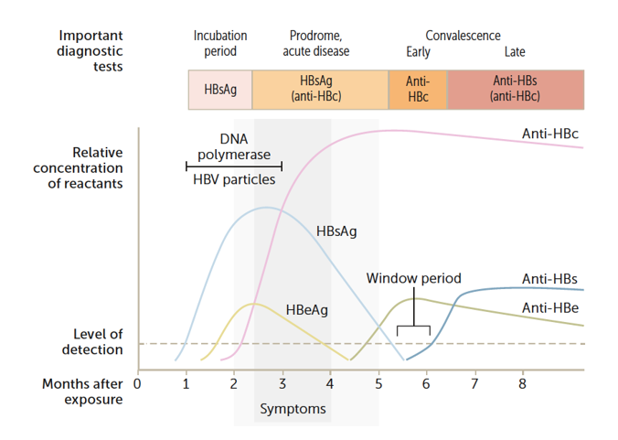
Analyze the diagram and for each of the following statements indicate whether it is true or false:

Variant 1:
- HBsAg is a surface protein, due to which it is possible to detect the presence of the virus in the blood already during the incubation period of the disease;
- If HBsAg is detected for more than 2-3 weeks after the onset of the disease, it is possible to judge the transition of the disease to a chronic form;
- The level of antibodies to HB-core (anti-HBc) antigen decreases simultaneously with the disappearance of HBsAg;
- The presence of anti-HBc in the blood cannot serve as a marker of previous hepatitis B;
- At the end of the incubation period, against the background of the onset of symptoms, HBsAg is detected in the blood in parallel with the determination of virus DNA by PCR, then HBeAg appears in the blood;
- Anti-HBc and anti-HBs are detected during the "serological window period";

Variant 2:
- HBsAg is localized within the viral capsid, and therefore cannot serve as a reliable viral marker during the incubation period of the disease;
- If HBsAg is detected for more than six months after the onset of the disease, it is possible to judge the transition of the disease to a chronic form;
- A rapid increase in the level of antibodies to HB-core (anti-HBc) antigen is observed in the interval after the disappearance of the HBs antigen (HBsAg) and before the appearance of anti-HBs antibodies;
- The presence of anti-HBc in the blood can mean both active infection of the patient and the presence of formed immunity to previous hepatitis B;
- DNA of the hepatitis B virus is recorded by PCR during all periods of the disease;
- Markers of hepatitis B virus replication are viral DNA and HBeAg;

Task 28 (ID 32) – 3 points
The common part of the question for all variants:
Boris B. Egorov was included in the crew of the Voskhod spacecraft and came into space as a first physician-cosmonaut on 12 October 1964.

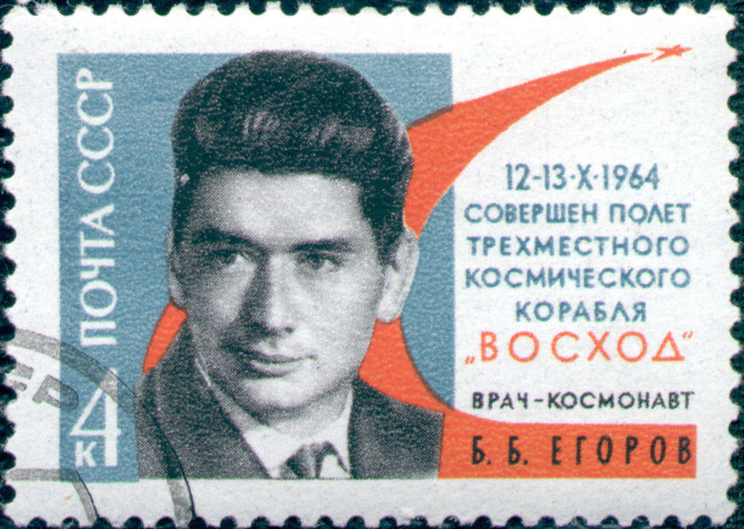

Since the influence of microgravity on human physiology has been actively investigated. Choose the correct statements about physiological reactions on microgravity:

Variant 1:
  - Bone density decreases with prolonged stay in space;
  - The volume of circulating blood decreases with prolonged stay in space;
  - Astronauts have to take melatonin in order to fall asleep due to one hour and half cycle of light changing;
  - The urine of a person in space contains more protein than on Earth;
  - The synthesis of erythropoietin is increased by the kidneys in space;
  - The level of calcitonin increases and the level of parathyroid hormone decreases with prolonged stay in space.

Variant 2:
  - Bone density decreases with prolonged stay in space;
  - Measuring blood pressure, the ankle-brachial index of a person in space will be greater than on Earth;
  - Astronauts need to take more iron from food, because the number of red blood cells in space increases;
  - Astronauts have to drink more water in space than they wants to prevent the development of kidney stones;
  - The venous depot of a person in space contains less blood volume than a person on Earth;
  - The synthesis of erythropoietin is increased by the kidneys in space;

Task 29 (ID 33) – 3 points
Common part of the question for all variants:
Glucose metabolism is one of the most important processes in our cells. The breakdown of glucose to pyruvic acid occurs during glycolysis reactions, leads to the generation of ATP, NADH and the preparation of the carbon skeleton for further aerobic oxidation. Glucose synthesis occurs during gluconeogenesis, starting from pyruvic acid. Important reactions of both processes, which are regulated by the cell, are the conversion of fructose-6-phosphate (Fru-6-P) and fructose-1,6-bisphosphate (Fru-1,6-BP) into each other. In the forward direction, this is carried out by the enzyme phosphofructokinase-1 (PFK-1) using the ATP molecule, and in the opposite direction, by the enzyme fructose bisphosphate phosphatase-1 (FBAse-1) using the water molecule. PFK-1 is allosterically regulated by a variety of molecules such as ATP, ADP, AMP, citric acid (citrate). An additional circuit of regulation of both enzymes also operates in the liver. It uses fructose-2,6-bisphosphate (Fru-2,6-BP). This molecule is generated from fructose-6-phosphate by phosphofructokinase-2 (PFK-2) and utilized by fructose-bisphosphate-phosphatase-2 (FBAse-2). PFK-2 and FBAse-2 are domains of one bifunctional enzyme, in which only one of the domains can be active. Phosphorylation of a bifunctional enzyme by protein kinase A (PKA) leads to FBAse-2 activity, and dephosphorylation by bifunctional enzyme phosphatase (PPase) leads to PFK-2 activity
The active enzyme are shown in blue, inactive in white. A green triangle indicates activation of an enzyme or other pathway, and a red cross indicates inhibition. P_{i} is inorganic phosphate. Analyze the presented scheme and for each of the following statements indicate whether it is true or false:

Variant 1:
  - The production of insulin as a result of an increase in the concentration of glucose in the blood leads to the activation of glucose synthesis in the liver;
  - Increasing the concentration of Fru-2,6-BP allows to maintain a high level of glycolysis, despite the high concentration of ATP;
  - In the absence of Fru-2,6-BP, glucose catabolism (glycolysis) can be inhibited in the case of active protein catabolism;
  - Fru-1,6-BP and Fru-2,6-BP are not isomers;
  - The chemical reaction carried out by FBase-1 is the reverse reaction carried out by PFK-1, i.e. chemical mechanism of the latter is reversed to the first.
  - As a result of the simultaneous activity of PFK-1 and FBase-1, heat is released, i.e. thermogenesis occurs.

Variant 2:
  - The production of glucagon as a result of a decrease in the concentration of glucose in the blood leads to the activation of glucose synthesis in the liver;
  - In the absence of Fru-2,6-BP, PFK-1 activity is directly proportional to the ratio of ATP/ADP concentrations in the cell;
  - In the absence of Fru-2,6-BP, glucose catabolism (glycolysis) can be inhibited in the case of active fat catabolism;
  - Fru-1,6-BP and Fru-2,6-BP are isomers;
  - The chemical reaction carried out by FBase-1 is not the reverse reaction carried out by PFK-1, i.e. chemical mechanism of the latter is not reversed to the first
  - The simultaneous activity of PFK-1 and FBase-1 does not lead to the loss of energy by the cell in the form of heat.

Task 30 (ID 34) – 3 points
Common part of the question for all variants:
Below is a diagram of the processes taking place in an E.coli cell, drawn by a student on a molecular biology test.
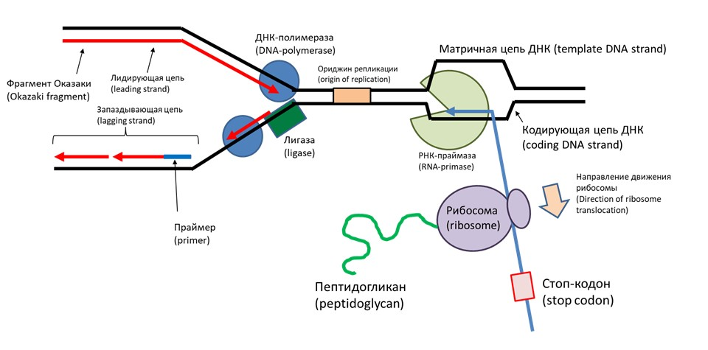Analyze this diagram and find errors in it. Select the correctly noticed errors from the list:

Variant 1:
  - The student confused the designations of the leading and lagging chains;
  - Okazaki fragments must be marked on the lower (lagging) chain;
  - The student has incorrectly merked the primer (the arrow should point to the red part of the new DNA strand, not blue);
  - The enzyme designated by the student as "ligase" is actually helicase;
  - Since task is about an E. coli cell with one origin of replication, the origin cannot be located in front of the replication fork;
  - The student confused the designations of the template and coding DNA strands;

Variant 2:
  - The enzyme designated by the student as "RNA primase" is actually RNA polymerase;
  - The student has confused the direction of movement of the ribosome (it must move in the opposite direction);
  - The student designated the start codon as a "stop codon";
  - The ribosome must synthesize not a peptidoglycan, but a polypeptide (protein);
  - An enzyme labeled by the student as "DNA polymerase" is actually reverse transcriptase;
  - The student depicted the RNA synthesized during transcription as a continuous molecule, but in reality it is synthesized in short fragments;

Task 31 (ID 35) – 3 points
Common part of the question for all variants:
For dragons, coloration depends on the action of two enzymes, α and β, on the primary pigment. The scheme of their interaction looks like this.
The primary pigment (gray) is converted to red by the α enzyme.
Further, under the action of the β enzyme, the red pigment turns into black. Enzyme α is encoded by a gene that has two allelic variants A - a working enzyme capable of qualitatively catalyzing a biochemical reaction and a - an enzyme that has lost the ability to catalyze the reaction due to mutation. The β enzyme is encoded by a gene that also has two allelic variants B - a working enzyme capable of qualitatively catalyzing a biochemical reaction and b - an enzyme that has lost the ability to catalyze the reaction due to mutation. Black offspring were obtained from crossing a purebred red male and a purebred gray female.
Analyze the data provided and for each of the following statements, indicate whether it is true or false:

Variant 1:
- Genes A and B are alleles between themselves;
- A purebred red male has the genotype ААbb;
- A purebred gray female has the genotype aaBB;
- When crossing black descendants among themselves in F2, you can get black, red and gray dragons in a ratio of 9 : 3 : 4;
- When black descendants are crossed among themselves, you can get black and gray dragons in a ratio of 9 : 7;
- It is impossible to obtain gray offspring from backcrossing a black offspring with a red parent;

Variant 2:
- Genes A and B are alleles between themselves;
- Genes A and B are not alleles;
- A purebred red male has the genotype aaBB;
- When crossing black descendants among themselves in F2, you can get black, red and gray dragons in a ratio of 9 : 3 : 4;
- It is impossible to obtain gray offspring from backcrossing a black offspring with a red parent;
- Red offspring cannot be obtained from backcrossing a black offspring with a gray parent.

Task 32 (ID 36) – 3 points
Variant 1:
The table shows the changes in genotype frequencies in a certain population.

 |  | Genotype frequencies
 |  | AA | Aa | aa
1st  generation | Immature individuals | 0,49 | 0,42 | 0,09
 | Mature individuals | 0,36 | 0,52 | 0,12
2nd generation | Immature individuals | 0,12 | 0,56 | 0,32

Analyze presented table and determine which of the statements are true or false:
- There is a negative assortative crossing in the population;
- There is a positive assortative crossing in the population;
- Panmixia is observed in the population;
- There is selection for viability in favor of allele A in the population;
- There is selection for viability in favor of allele a in the population;
- There is a selectivity of crossing (sexual selection) in favor of allele a in the population.

Variant 2:
The table shows the changes in genotype frequencies in a certain population.

 |  | Genotype frequencies
 |  | AA | Aa | aa
1st  generation | Immature individuals | 0,46 | 0,48 | 0,06
 | Mature individuals | 0,36 | 0,52 | 0,12
2nd generation | Immature individuals | 0,2 | 0,4 | 0,4

Analyze presented table and determine which of the statements are true or false:
- There is selection for viability in favor of allele A in the population;
- There is selection for viability in favor of allele a in the population;
- There is a negative assortative crossing in the population;
- There is a positive assortative crossing in the population;
- There is a selectivity of crossing (sexual selection) in favor of allele A in the population;
- There is a selectivity of crossing (sexual selection) in favor of allele a in the population.

Part C: Matching Questions

In the tasks of this part, the participants need to analyze various photographs, drawings, diagrams (marked with Arabic numerals) and compare them with elements from the two lists below (marked with Latin letters and Roman numerals). As an answer in each task, the participants must draw arrows between the elements being compared.

Grading system:
For each correctly indicated match between elements of 1 and 2 rows or 1 and 3 rows, the participant receives 0.5 points.
For each incorrect match - 0 points.

Task 33 (ID 38) – 5 points
Variant 1
The photographs show algae.
Define a systematic category for each of the objects presented, according to modern concepts, and correlate the alga with a suitable functional characteristic from the list.

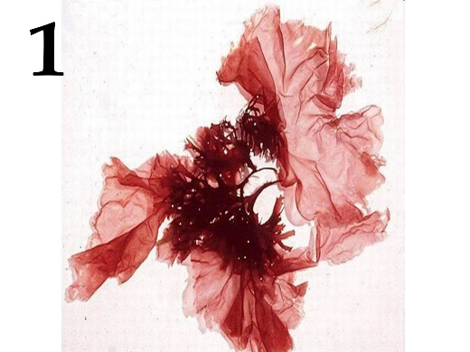 | 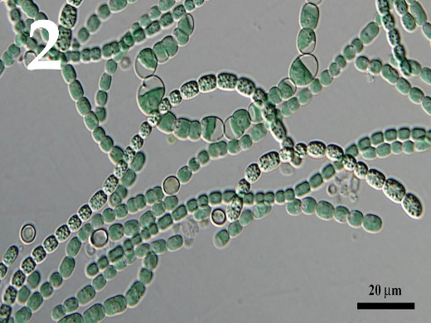 | 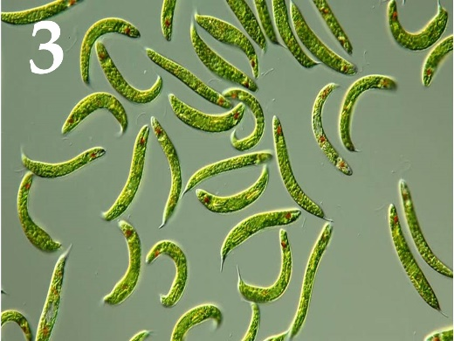
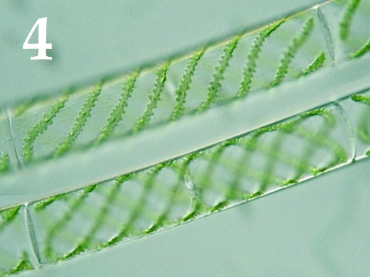 | 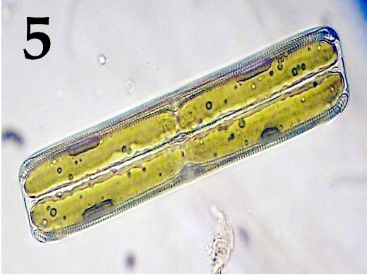

Systematic category (the list is redundant - it contains unnecessary taxons):
- Chlorophyta (green algae);
- Dinophyta;
- Rhodophyta (red algae);
- Charophyta;
- Ochrophyta;
- Cryptophyta;
- Euglenophyta;
- Cyanophyta (blue-green algae).

List of characteristics:
- Cells are composed of epithecus and hypotheca.
- A light-sensitive eye is developed in the cell (stigma).
- Sexual reproduction type is lateral or scalariform conjugation.
- There are akinets, specialized cells for experiencing an unfavorable period.
- They have a pseudoparenchymal (false tissue) type of thallus.

Answer:
Variant 1

Photograph | 1 | 2 | 3 | 4 | 5
Systematic category | C | H | G | D | E
Characteristic | V | IV | II | III | I

Task 33 (ID 38) – 5 points
Variant 2.
The photographs show algae.
Define a systematic category for each of the objects presented, according to modern concepts, and correlate the alga with a suitable functional characteristic from the list.

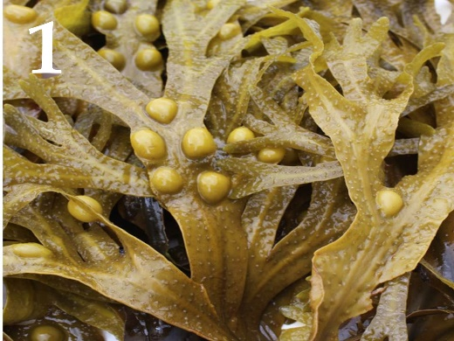 | 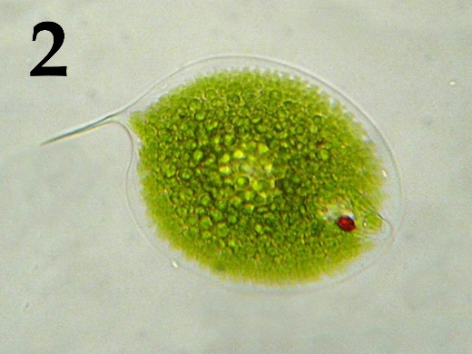 | 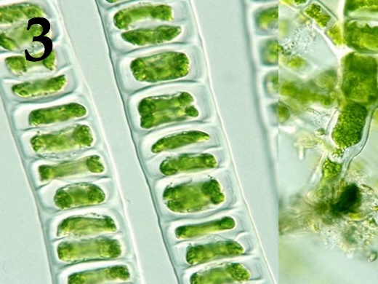
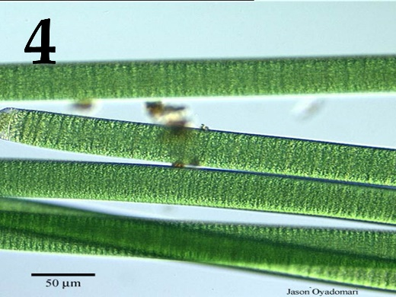 | 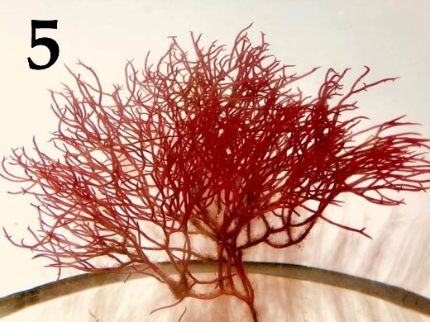

Systematic category (the list is redundant - it contains unnecessary taxons):
- Chlorophyta (green algae);
- Dinophyta;
- Rhodophyta (red algae);
- Charophyta;
- Ochrophyta;
- Cryptophyta;
- Euglenophyta;
- Cyanophyta (blue-green algae).

List of characteristics:
- They are characterized by the creation of agar.
- Vegetative reproduction is carried out by parts of the thallus (hormogonies).
- By the type of food they are mixotrophs.
- Sexual reproduction is of the isogamy type.
- Air bubbles form on the thallus, which help maintain the body in the aquatic environment.

Answer:
Variant 2

Photograph | 1 | 2 | 3 | 4 | 5
Systematic category | E | G | A | H | C
Characteristic | V | III | IV | II | I

Task 34 (ID 39) – 5 points
Variant 1
The beaks of birds are extremely diverse and reflect their adaptation to feeding on certain food items.
This task provides images of different types of beaks in birds. In this task, it is necessary to compare each of the types of beaks shown in the pictures with the species name of the bird and a possible food item from the list.

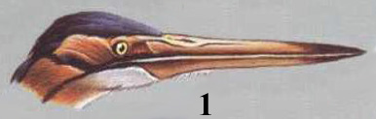 | 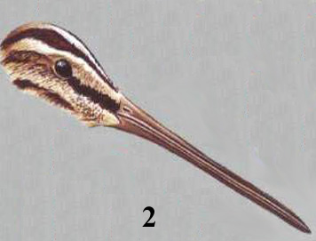 | 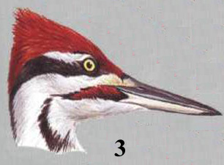
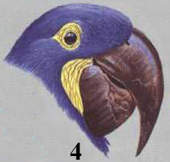 | 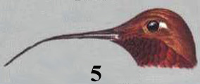

List of species (the list is redundant - it contains unnecessary names):
- Red heron;
- Hummingbird;
- Snipe;
- Parrot Macaw;
- Woodpecker;
- Dubonos;
- Pelican;
- Black Swift;
- Common spoonbill;
- Flamingo pink.

List of characteristics (food objects):
- Hunting of aquatic vertebrates, especially amphibians;
- Extraction of insects and their larvae from wood, or extraction of coniferous seeds;
- Sounding the soil in search of invertebrates;
- Collecting the nectar of flowers of some tropical plants;
- Tropical fruits, usually with very dense shells.

Answer:
Variant 1
Pictures | 1 | 2 | 3 | 4 | 5
Species | A | С | Е | D | B
Food objects | I | III | II | V | IV

Task 34 (ID 39) – 5 points
Variant 2
The beaks of birds are extremely diverse and reflect their adaptation to feeding on certain food items.
This task provides images of different types of beaks in birds. In this task, it is necessary to compare each of the types of beaks shown in the pictures with the species name of the bird and a possible food item from the list.

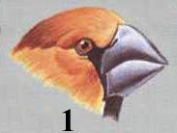 | 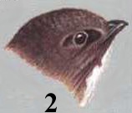 | 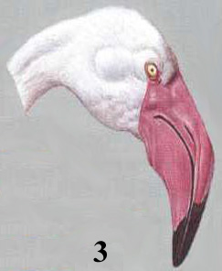
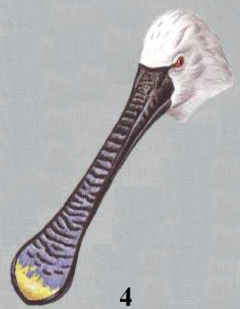 | 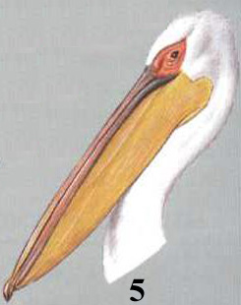

List of species (the list is redundant - it contains unnecessary names):
- Red heron;
- Hummingbird;
- Snipe;
- Parrot Macaw;
- Woodpecker;
- Dubonos;
- Pelican;
- Black Swift;
- Common spoonbill;
- Flamingo pink.

List of characteristics (food objects):
- It feeds exclusively on flying insects;
- Long-legged bird, feeding on phyto and zooplankton in shallow waters;
- Between the branches of the lower jaw there is a fold that serves as a bag. The diet is dominated by fish;
- The beak is short and high at the base. It feeds on hard seeds;
- The beak is flattened at the end. The diet is dominated by planktonic organisms.

Answer:
Variant 2

Pictures | 1 | 2 | 3 | 4 | 5
Species | F | H | J | I | G
Food objects | IV | I | II | V | III

Task 35 (ID 40) – 4 points
Variant 1
This task contains micrographs of tissues of various human endocrine organs. You need to determine which endocrine gland is depicted in each micrograph, and correlate them with the hormones they produce and the functional characteristics of the hormones from the list.

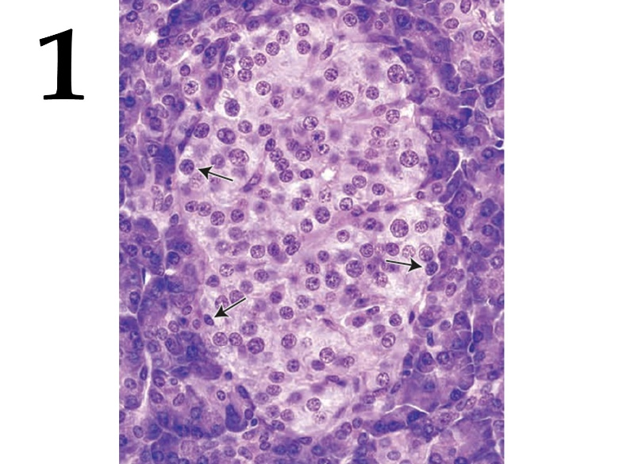 | 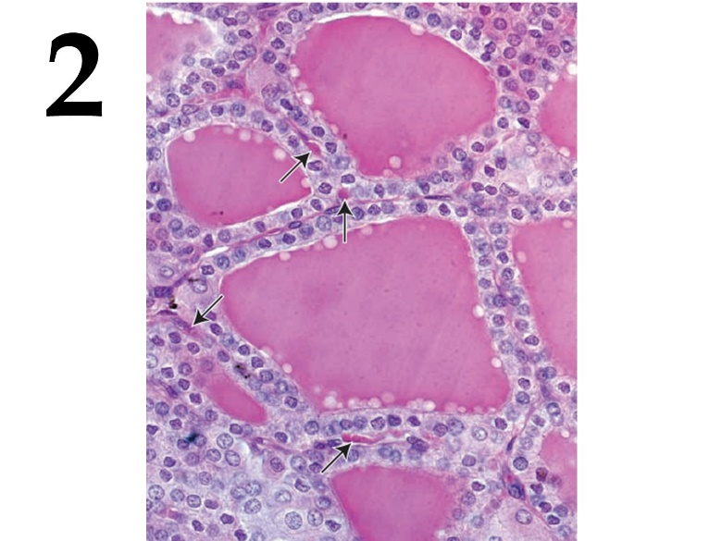
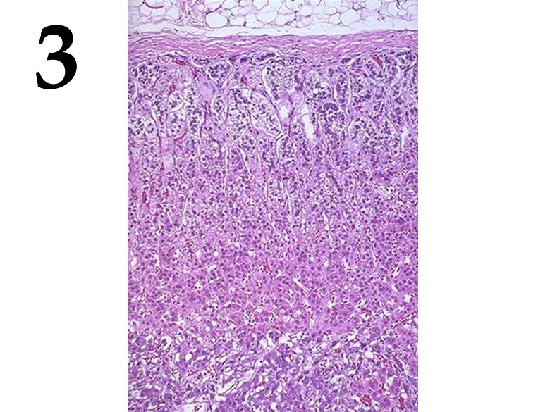 | 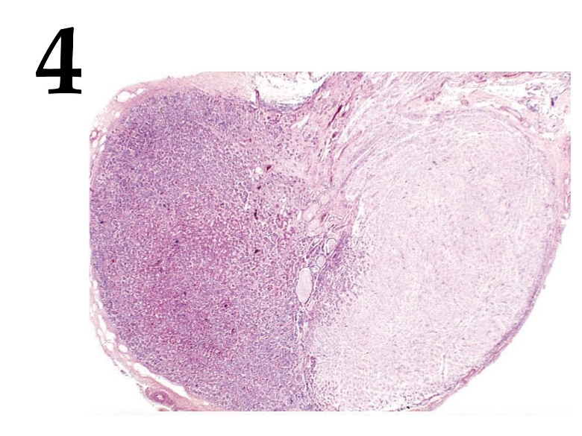

List of hormones (the list is redundant - it contains unnecessary names):
- Melatonin;
- Parathyroid hormone;
- Thymosin;
- Thyroxine;
- Vasopressin;
- Adrenocorticotropin;
- Insulin;
- Cortisol;
- Testosterone;
- Progesterone.

List of hormone characteristics:
- Peptide hormone produced by basophilic cells of the anterior lobe of one of the most important human endocrine glands, which has a stimulating effect on the adrenal glands;
- Glucocorticoid hormone of steroid nature;
- Iodine-containing hormone, which plays an important role in the regulation of metabolism;
- The main function is the utilization of glucose by the tissues of the body.

Answer:
Variant 1

Micrograph | 1 | 2 | 3 | 4
Hormone | G | D | H | F
Hormone characteristic | IV | III | II | I

Task 35 (ID 40) – 4 points
Variant 2
This task contains micrographs of tissues of various human endocrine organs. You need to determine which endocrine gland is depicted in each micrograph, and correlate them with the hormones they produce and the functional characteristics of the hormones from the list.

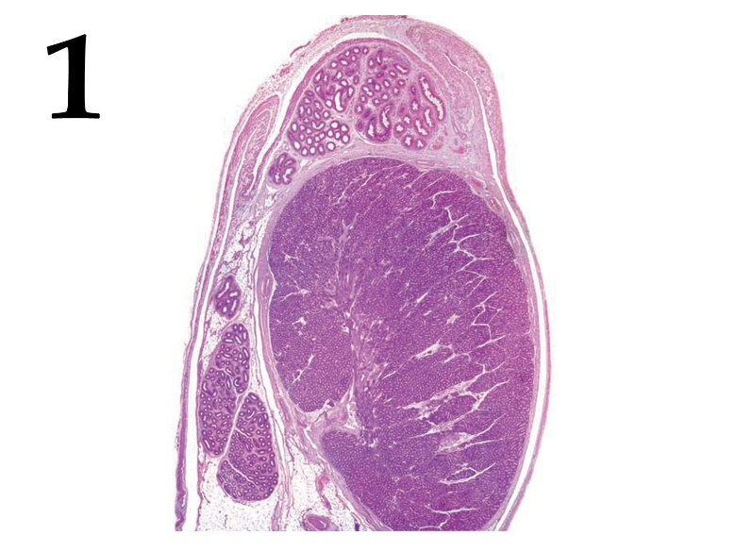 | 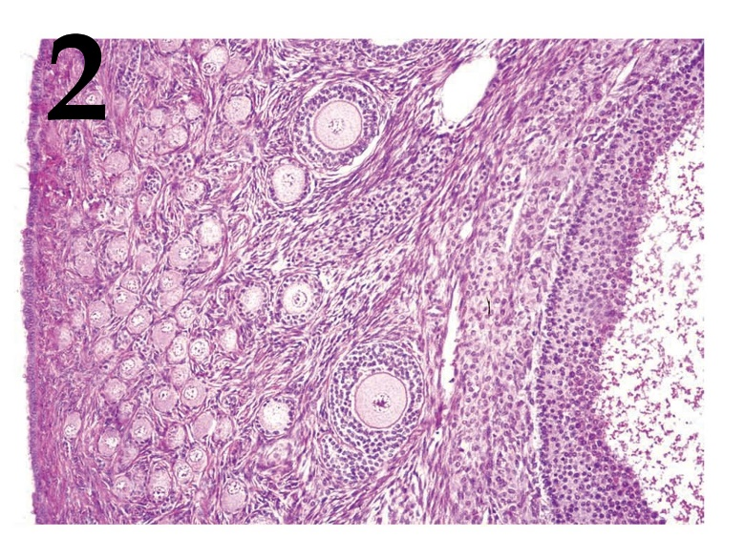
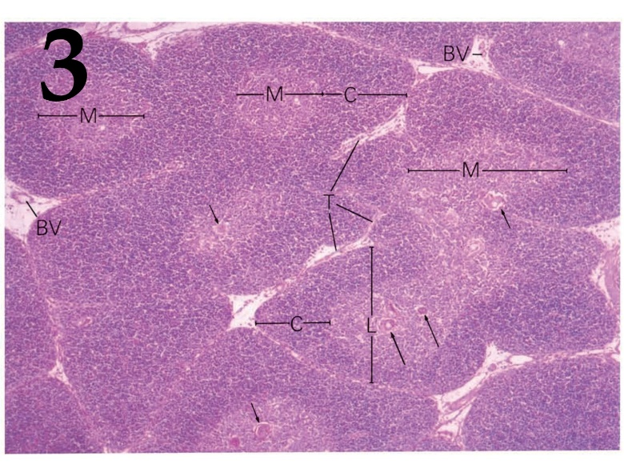 | 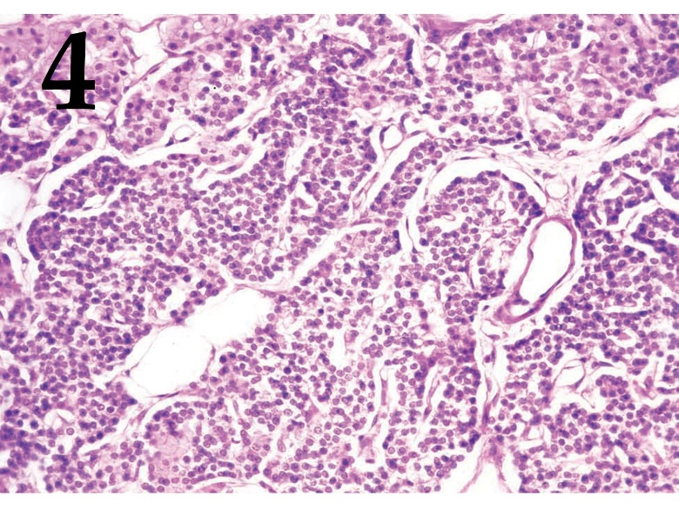

List of hormones (the list is redundant - it contains unnecessary names):
- Melatonin;
- Parathyroid hormone;
- Thymosin;
- Thyroxine;
- Vasopressin;
- Adrenocorticotropin;
- Insulin;
- Cortisol;
- Testosterone;
- Progesterone.

List of hormone characteristics:
- The main male sex hormone.
- The hormone that prepares the uterus for implantation.
- The stimulus for the secretion of this hormone is a decrease in the concentration of calcium cations in the blood.
- Peptide hormone that stimulates the body's immune system.

Answer:
Variant 2

Micrograph | 1 | 2 | 3 | 4
Hormone | I | J | С | B
Hormone characteristic | I | II | IV | III

Task 36 (ID 41) – 5 points
Variant 1
There are group of cells inside human organism, which regulates water, acid and electrolyte balance of internal and secreted fluids. Determine cell type and cell function using pictures with different distribution of membrane transport proteins.

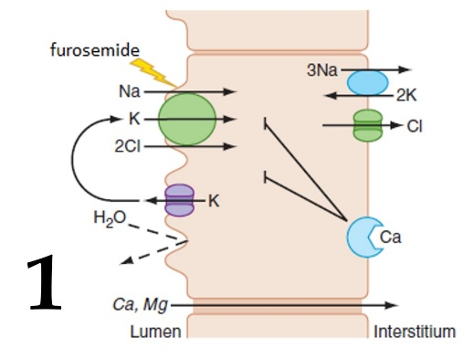 | 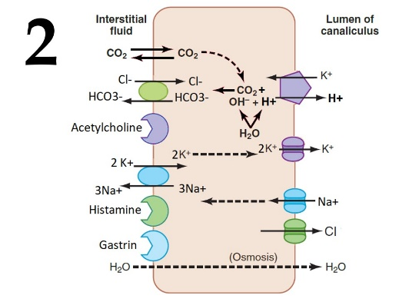 | 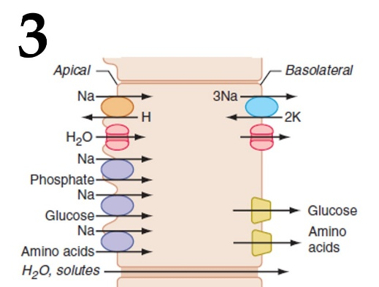
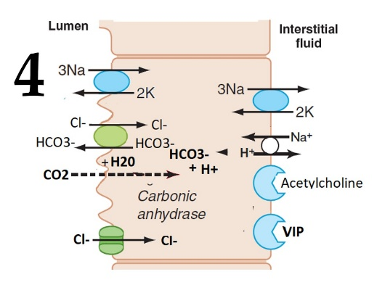 | 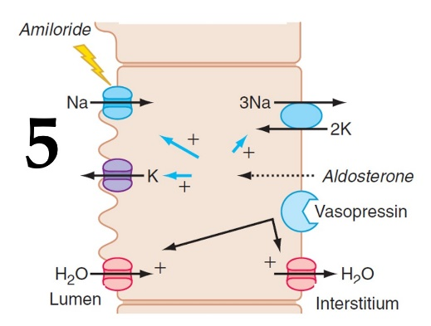

List of cell types (the list is redundant - it contains unnecessary names):
- Cell of the distal convoluted tubule;
- Cell of the salivary ductal epithelium;
- A parietal cell of the gastric mucosa;
- Cell of the proximal convoluted tubule;
- Cell of the pancreatic ductal epithelium;
- Cell of the cortical collecting duct;
- Cell of the medullary collecting duct;
- Cell of the intestinal epithelium;
- Cell of the thick ascending part of Henle's loop;
- Cell of the descending part of Henle's loop.

List of cell functions (the list is redundant):
- Active HCl secretion into the lumen;
- Isotonic bicarbonate secretion into the lumen;
- Reabsorption of amino acids and glucose with pH decreasing in the lumen;
- Hypotonic bicarbonate secretion into the lumen (with NaCl reabsorption);
- Reabsorption of amino acids and glucose with pH increasing in the lumen;
- Creation of a hypotonic environment in the lumen and paracellular calcium reabsorption;
- Creation of increased osmolarity of the interstitium and hormone-dependent water reabsorption;
- Hormone-dependent water reabsorption and secretion of protons and potassium into the lumen;
- Creation of a hypotonic environment in the lumen and transcellular calcium reabsorption;

Answer:
Variant 1

Picture | 1 | 2 | 3 | 4 | 5
Cell type | I | C | D | B | F
Cell function | VI | I | III | IV | VIII

Task 36 (ID 41) – 5 points
Variant 2
There are group of cells inside human organism, which regulates water, acid and electrolyte balance of internal and secreted fluids. Determine cell type and cell function using pictures with different distribution of membrane transport proteins.

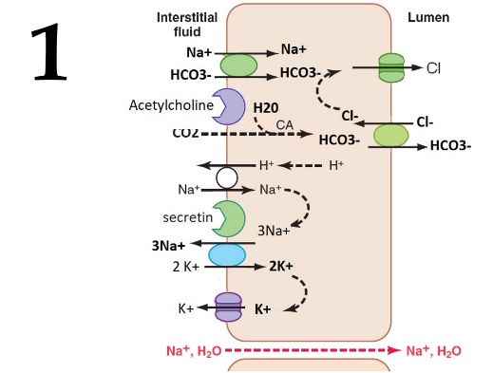 | 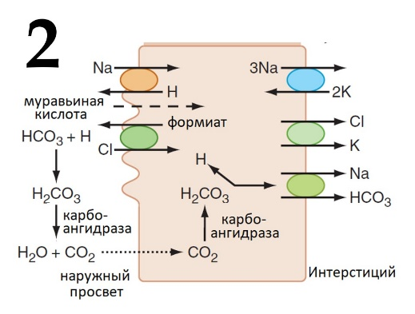 | 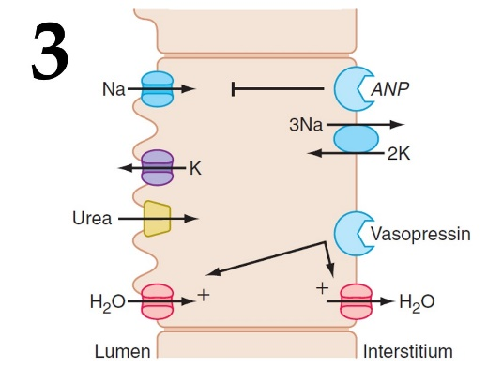
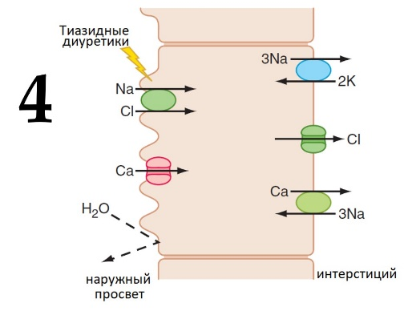 | 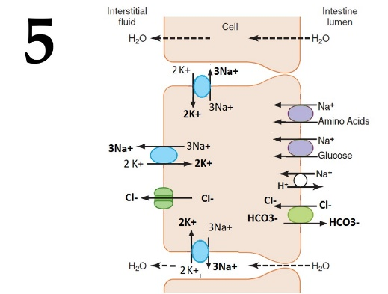

List of cell types (the list is redundant - it contains unnecessary names):
- Cell of the distal convoluted tubule;
- Cell of the salivary ductal epithelium;
- A parietal cell of the gastric mucosa;
- Cell of the proximal convoluted tubule;
- Cell of the pancreatic ductal epithelium;
- Cell of the cortical collecting duct;
- Cell of the medullary collecting duct;
- Cell of the intestinal epithelium;
- Cell of the thick ascending part of Henle's loop;
- Cell of the descending part of Henle's loop.

List of cell functions (the list is redundant):
- Active HCl secretion into the lumen;
- Isotonic bicarbonate secretion into the lumen;
- Reabsorption of amino acids and glucose with pH decreasing in the lumen;
- Hypotonic bicarbonate secretion into the lumen (with NaCl reabsorption);
- Reabsorption of amino acids and glucose with pH increasing in the lumen;
- Creation of a hypotonic environment in the lumen and paracellular calcium reabsorption;
- Creation of increased osmolarity of the interstitium and hormone-dependent water reabsorption;
- Hormone-dependent water reabsorption and secretion of protons and potassium into the lumen;
- Creation of a hypotonic environment in the lumen and transcellular calcium reabsorption;

Answer:
Variant 2

Picture | 1 | 2 | 3 | 4 | 5
Cell type | E | D | G | A | H
Cell function | II | III | VII | IX | V

Task 37 (ID 42) – 5 points
Variant 1
Many human diseases are associated with impaired functioning of a certain enzyme, which leads to metabolic disorders. You are presented with the names of enzymes (A-H), mutations in which often cause human disease. You need to determine the formula for their main substrate (1-5), and choose a description of the symptoms that appear in individuals with the mutant form of the enzyme (I-VI).

List of enzymes (the list is redundant - it contains unnecessary ones):
- Hypoxanthine-guanine phosphoribosyltransferase;
- Phenylalanine-4-hydroxylase;
- Branched-chain keto acid dehydrogenase complex;
- Amylo-1,6 glucosidase;
- Lysosomal sphingomyelinase;
- Carbamoyl phosphate synthetase I;
- Porphobilinogen deaminase;
- Medium-chain acyl-CoA dehydrogenase.

List of symptoms associated with the mutant enzyme (the list is redundant - there are unnecessary ones):
- Excessive accumulation of the substrate, and as a consequence, a wide violation of lipid metabolism, including the accumulation of cholesterol and other cell lipids. It is characterized by enlargement of the liver, spleen and progressive damage to the nervous system. Moreover, children do not experience the early childhood period.
- Accumulation of large amounts of ammonia in the blood. This causes problems with the nervous system. Hemodialysis therapy required.
- The accumulation of dextrin (branched oligosaccharide from glucose) aggregates in the cells of the liver, heart, muscles, which are inaccessible for metabolism. It manifests itself in infancy with hypoglycemia and a violation of normal development. Further, pathologies of muscles, liver, heart develop.
- Deficiency of purine nucleotides and accumulation of uric acid in all tissues and blood. A characteristic feature of the disease is auto-aggressive actions, while pain sensitivity remains.
- The accumulation of the substrate and its toxic products, normally synthesized in a minor way, leads to severe damage to the central nervous system, which manifests itself, in particular, in the form of impaired mental development. The disease begins to manifest itself at the beginning of breast milk containing proteins. Patients are characterized by an abnormal composition of urine and sweat with a characteristic "mouse" odor associated with aromatic products. One of the few hereditary diseases that can be successfully treated with a low protein diet.
- The accumulation of the substrate and δ-aminolevulinic acid in the cytpolasm, which leads to a violation of the synthesis of blood pigments. Against this background, demyelination of neurons develops, which leads to damage to the peripheral and central nervous systems.

Answer:
Variant 1

Formula | 1 | 2 | 3 | 4 | 5
Enzyme | F | B | G | A | E
Symptoms | II | V | VI | IV | I

Task 37 (ID 42) – 5 points
Variant 2
Many human diseases are associated with impaired functioning of a certain enzyme, which leads to metabolic disorders. You are presented with the names of enzymes (A-H), mutations in which often cause human disease. You need to determine the formula for their main substrate (1-5), and choose a description of the symptoms that appear in individuals with the mutant form of the enzyme (I-VI).

List of enzymes (the list is redundant - it contains unnecessary ones):
- Hypoxanthine-guanine phosphoribosyltransferase;
- Phenylalanine-4-hydroxylase;
- Branched-chain keto acid dehydrogenase complex;
- Amylo-1,6 glucosidase;
- Lysosomal sphingomyelinase;
- Carbamoyl phosphate synthetase I;
- Porphobilinogen deaminase;
- Medium-chain acyl-CoA dehydrogenase.

List of symptoms associated with the mutant enzyme (the list is redundant - there are unnecessary ones):
- Accumulation of large amounts of ammonia in the blood. This causes problems with the nervous system. Hemodialysis therapy required.
- The accumulation of dextrin (branched oligosaccharide from glucose) aggregates in the cells of the liver, heart, muscles, which are inaccessible for metabolism. It manifests itself in infancy with hypoglycemia and a violation of normal development. Further, pathologies of muscles, liver, heart develop.
- Deficiency of purine nucleotides and accumulation of uric acid in all tissues and blood. A characteristic feature of the disease is auto-aggressive actions, while pain sensitivity remains.
- The accumulation of the substrate and δ-aminolevulinic acid in the cytpolasm, which leads to a violation of the synthesis of blood pigments. Against this background, demyelination of neurons develops, which leads to damage to the peripheral and central nervous systems.
- Accumulation of substrates and their precursors. There is a developmental delay, depression of the central nervous system. Hypoglycemia and hypotension are characteristic, there is ketoacidosis, vomiting. The urine of patients acquires the characteristic smell of maple syrup, rich in aliphatic amino acids.
- Accumulation of caprylic acid in cells, deficiency of free carnitine. Sudden infant death developing against the background of abundant glucose utilization.

Answer:
Variant 2

Formula | 1 | 2 | 3 | 4 | 5
Enzyme | H | C | D | G | F
Symptoms | VI | V | II | IV | I

Task 38 (ID 43) – 5 points
Variant 1
Here are several figures illustrating different stages of a particular process. You need to arrange these stages in order, matching the numbers from the list (A-E) to the images, and also select from the list (I-XV, the list is redundant - it contains unnecessary terms) the most accurate term indicated in the corresponding figure with the letter X. Please note, that one of the figures is excess (it needs to be matched with E ("-") from the first list). For the excess figure, however, you also need to choose the term denoted by the letter X:

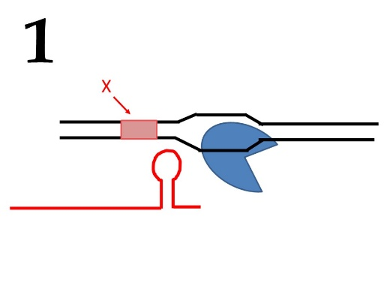 | 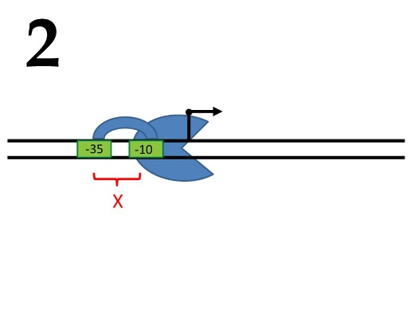 | 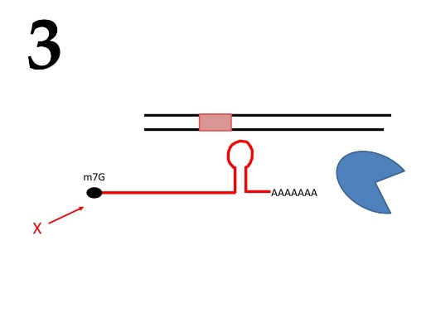
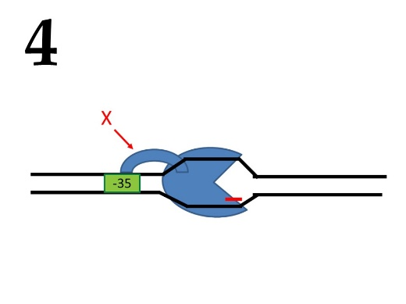 | 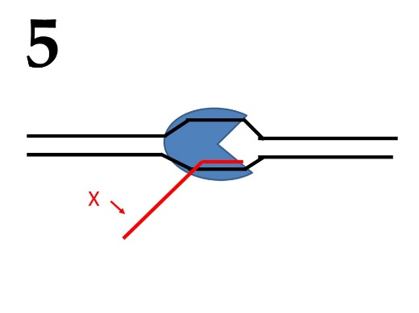

Order of stages:
- I;
- II;
- III;
- IV;
- -;

Terms (this list is redundant - it contains unnecessary terms):
- Origin of replication;
- Replisome;
- Ribosome small subunit;
- Terminator;
- Promoter;
- tRNA;
- Helicase;
- А-site;
- DNA;
- DNA polymerase;
- Growing polypeptide;
- Cap;
- Stop codon;
- Growing RNA chain;
- Sigma subunit;

Answer:
Variant 1

Figure | 1 | 2 | 3 | 4 | 5
Order | D | A | E | B | C
Terms | IV | V | XII | XV | XIV

Task 38 (ID 43) – 5 points
Variant 2:
Here are several figures illustrating different stages of a particular process. You need to arrange these stages in order, matching the numbers from the list (A-E) to the images, and also select from the list (I-XV, the list is redundant - it contains unnecessary terms) the most accurate term indicated in the corresponding figure with the letter X. Please note, that one of the figures is excess (it needs to be matched with E ("-") from the first list). For the excess figure, however, you also need to choose the term denoted by the letter X:

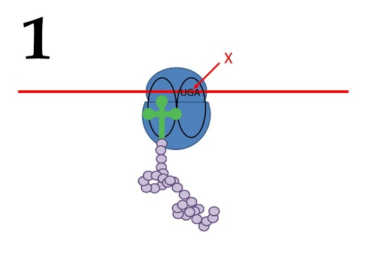 | 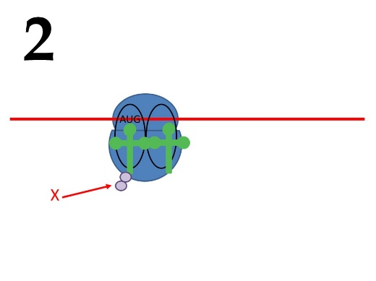 | 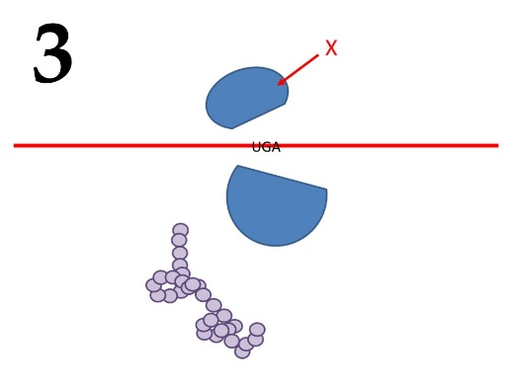
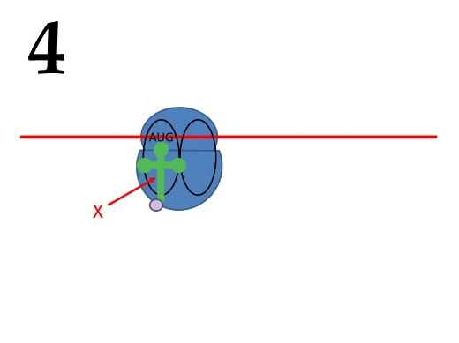 | 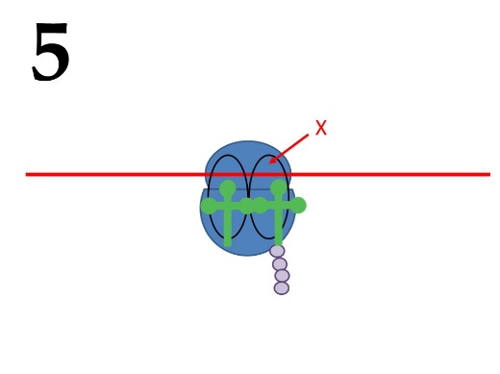

Order of stages:
- I;
- II;
- III;
- IV;
- -;

Terms (this list is redundant - it contains unnecessary terms):
- Origin of replication;
- Replisome;
- Ribosome small subunit;
- Terminator;
- Promoter;
- tRNA;
- Helicase;
- А-site;
- DNA;
- DNA polymerase;
- Growing polypeptide;
- Cap;
- Stop codon;
- Growing RNA chain;
- Sigma subunit;

Answer:
Variant 2

Figure | 1 | 2 | 3 | 4 | 5
Order | C | E | D | A | B
Terms | XIII | XI | III | VI | VIII

Task 39 (ID 44) – 5 points
Variant 1
Correlate the phenotypic splitting of F1 hybrids with the genotypes of the parents and the inheritance patterns under which this splitting can be expected.

- Uniformity of hybrids (monohybrid crossing)
- 3 : 1 (dihybrid crossing)
- 1 : 1 (monohybrid crossing)
- 9 : 3 : 4 (dihybrid crossing)
- 1 : 2 : 1 (monohybrid crossing)

Genotypes of parents (the list is redundant):
- АА × аа;
- АаВв × АаВв;
- ААвв × aaBB;
- Аа × аа;
- I^{A}i⁰ × I^{B}i⁰;
- АаВв × аавв;
- Аа × Аа.

Conditions under which this splitting can be obtained (the list is redundant):
- Genes interact like non-cumulative polymery;
- Epistatic interaction of genes;
- Parents are homozygous for this gene;
- Incomplete dominance;
- Analyzing heterozygote crossing;
- Codominance;
- Parents are double homozygotes.

Answer:
Variant 1
Вариант 1
Phenotypic splitting | 1 | 2 | 3 | 4 | 5
Genotypes of parents | А | F | D | B | G
Conditions | III | I | V | II | IV

Task 39 (ID 44) – 5 points
Variant 2
Correlate the phenotypic splitting of F1 hybrids with the genotypes of the parents and the inheritance patterns under which this splitting can be expected.

- Uniformity of hybrids (monohybrid crossing)
- 1: 2 : 1 (monohybrid crossing)
- 9 : 3 : 4 (dihybrid crossing)
- 1 : 1 (monohybrid crossing)
- 1 : 1 : 1 :1 (monohybrid crossing)

Genotypes of parents (the list is redundant):
- АА × аа;
- АаВв × АаВв;
- ААвв × aaBB;
- Аа × аа;
- I^{A}i⁰ × I^{B}i⁰;
- АаВв × аавв;
- Аа × Аа.

Conditions under which this splitting can be obtained (the list is redundant):
- Genes interact like non-cumulative polymery;
- Epistatic interaction of genes;
- Parents are homozygous for this gene;
- Incomplete dominance;
- Analyzing heterozygote crossing;
- Codominance;
- Parents are double homozygotes.

Answer:
Variant 2

Phenotypic splitting | 1 | 2 | 3 | 4 | 5
Genotypes of parents | C | G | B | D | E
Conditions | VII | IV | II | V | VI

Task 40 (ID 45) – 5 points
Variant 1
Determine which group of organisms this fossil belongs to and indicate the approximate period of existence of this group:

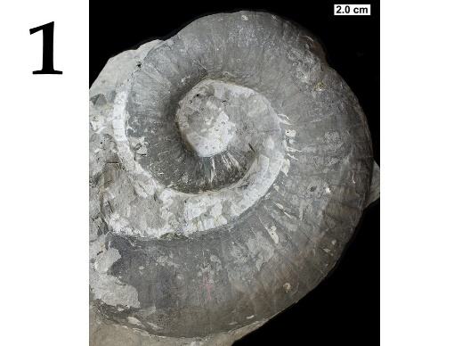 | 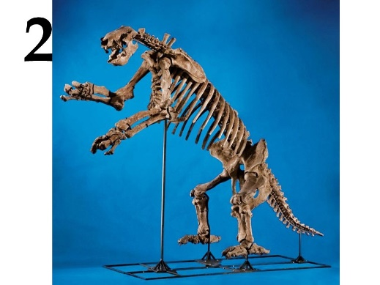 | 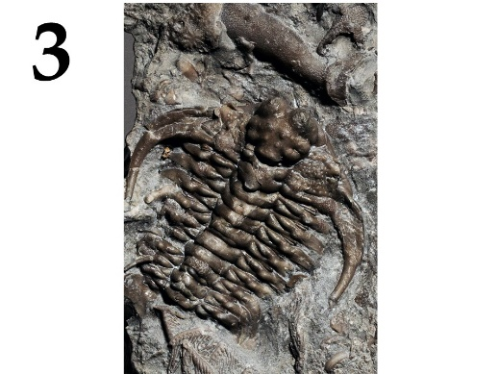
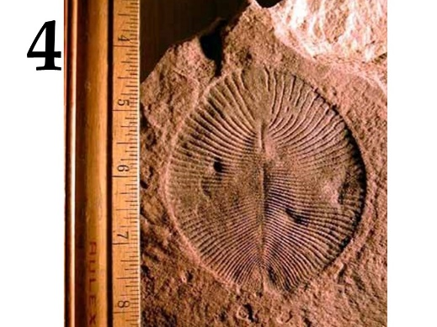 | 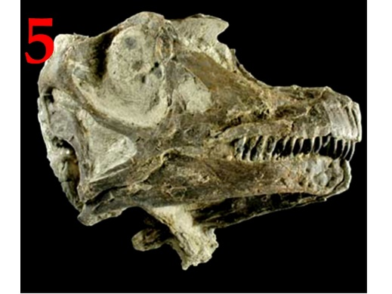

Group of organisms (this list is redundant - it contains unnecessary groups):
- Ammonites (Ammonoidea);
- Ichthyosauria;
- Ediacaran (Vendian) biota;
- Trilobites (Trilobita);
- Belemnites (Belemnitida);
- Dinosaurs (Dinosauria);
- Brachiopoda (Brachiopoda);
- Placental mammals (Eutheria).

Period of existence (this list is redundant):
- 1.8 - 1.2 billion years ago;
- 525 - 255 million years ago;
- 400 - 70 million years ago;
- 230 - 66 million years ago;
- 125 million years ago - now;
- 575 – 543 million years ago;
- 500 - 25 thousand years ago.

Answer:
Variant 1

Picture | 1 | 2 | 3 | 4 | 5
Group of organisms | A | H | D | C | F
Period of existence | III | V | II | VI | IV

Task 40 (ID 45) – 5 points
Variant 2
Determine which group of organisms this fossil belongs to and indicate the approximate period of existence of this group:

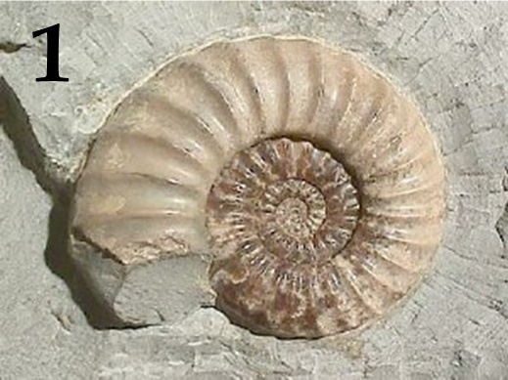 | 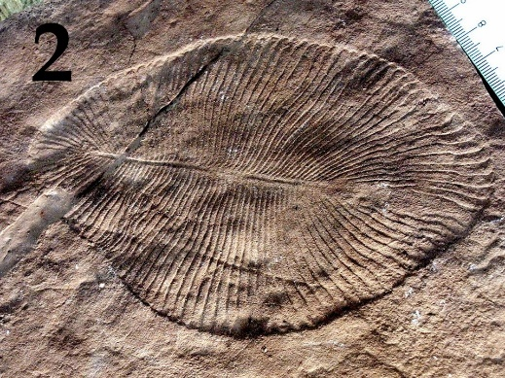 | 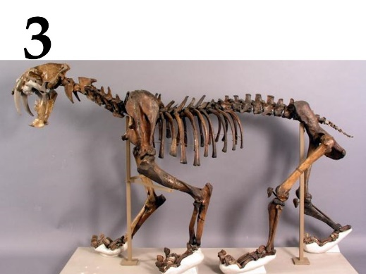
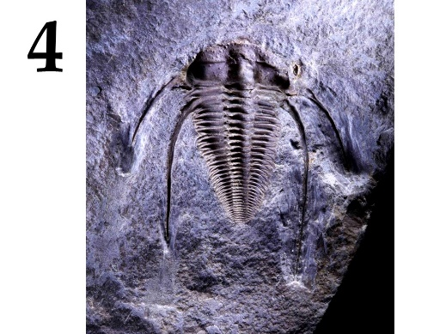 | 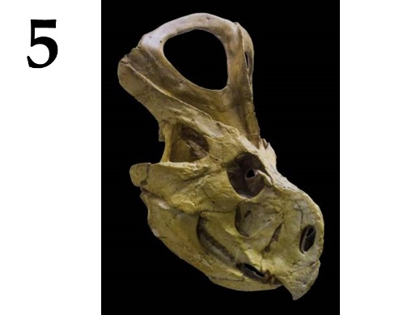

Group of organisms (this list is redundant - it contains unnecessary groups):
- Ammonites (Ammonoidea);
- Ichthyosauria;
- Ediacaran (Vendian) biota;
- Trilobites (Trilobita);
- Belemnites (Belemnitida);
- Dinosaurs (Dinosauria);
- Brachiopoda (Brachiopoda);
- Placental mammals (Eutheria).

Period of existence (this list is redundant):
- 1.8 - 1.2 billion years ago;
- 525 - 255 million years ago;
- 400 - 70 million years ago;
- 230 - 66 million years ago;
- 125 million years ago - now;
- 575 – 543 million years ago;
- 500 - 25 thousand years ago.

Answer:
Variant 2

Picture | 1 | 2 | 3 | 4 | 5
Group of organisms | A | C | H | D | F
Period of existence | III | VI | V | II | IV

